URBAN PLANNİNG AND URBAN STRUCTURE İN LATE OTTOMAN PALESTİNE

ABDURRAHMAN MOHAMED
Abdurrahman Mohamed, Associate Professor, Antalya Bilim University.

Abstract
The Ottomans stayed in Palestine around 400 years characterized by great changes and developments. They significantly impinged the life of the Palestinians with numerous effects from language to the urban style and architecture. The Ottoman government controls depended upon the Islamic law and included several regulations for the built environment and the urban structure. The main government systems that included such laws and regulations are the administrative, judicial and land systems. This article depends on historical research to dig through these systems in order to explore the different controls they used over the Palestinian urban structures and to what extent did they established a comprehensive framework for the control and management of urban structures in Palestine. It was discovered that these systems did not establish such a framework which also did not exist outside the Ottoman Empire. Never the less, the dependance of these systems on Islamic laws provided them a unique and distinguished mechanisms that did not exist in other non-Ottoman systems. They also are considered significant developments in Islamic government systems and contributed positively to the development of Palestinian urban structures.
Keywords: urban planning, system, urban structure, Ottoman, Palestine

Introduction
This research aims at exploring the Ottoman urban planning system in Palestine from the late 19th century to 1918 and its effects on the urban structure in Palestine which includes the structures of Palestinian cities, towns and villages. Since a comprehensive urban planning system did not exist in Ottoman Palestine, the concern here is to explore the different means by which the Ottoman authorities influenced the development and growth of the Palestinian urban structure. The Ottoman municipal and statutory regulations exerted some control over the construction and alignment of buildings and roads (Goadby and Daukhan, 1991). Since 1877, some Palestinian municipalities had some powers to control the construction of buildings and streets, and to expropriate land for public use. There also were several special regulations for the construction and alignment of roads like those of 1868 and 1891 (Goadby and Daukhan, 1991). Some scholars pretends that such regulations never existed (Biger., 1984). Others argue that several systems were affecting the development of the Palestinian urban structure (El –Nahal, 1979). These systems were the administrative, judicial and fiscal systems. Within the interrelationships between these three systems, the land system had special importance (Biger., 1984).
This article uses historical research in an attempt to understand the general systems of the Ottoman Empire which had affected the Palestinian urban structures. The administrative system maintained the Ottoman supremacy over their territories. The main feature of this control which had direct relevance to the control of the Palestinian urban structure was the administrative hierarchy. At the same time the, Ottoman judicial system dealt with all aspects of everyday life of the community including the mediation of the urban change and resolving the conflicts over the use of land. The Ottoman Civil Code was one of the most important judicial tools affected all aspects of the everyday life in the Palestine including land use and development.
The Ottoman land system, on the other hand, constituted a very important factor of control and change in the Palestinian cities, towns and villages (Granott, 1952; Arraf, 1986).

Ottoman administrative system
By the mid nineteenth century the Ottoman provincial administration system was in effect in Palestine (Figure 1), and it consisted of the following elements (Turkish terms are used in Italic. Arabic terms are used in Italic between [ ] for first time only and if they are different than the Turkish terms. Chicago transliteration style is followed):
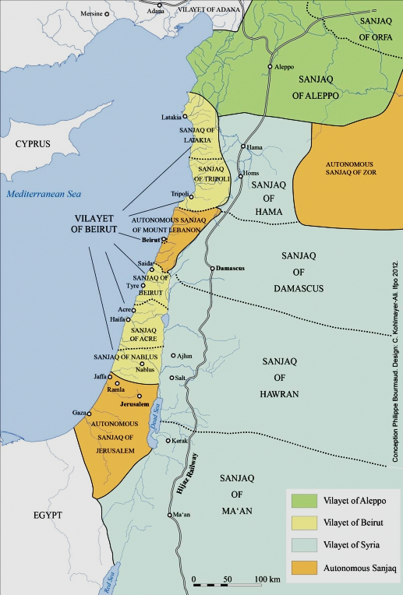
Figure 1: Ottoman administrative division in 1914
Source: Neveu, 2013.

Vilayet or Eyalet [wilayah] (province)
A basic administrative division in Ottoman Empire since 1861. It was governed by a Vali [wali] (general governor)
The Vali who directly subordinated the Minister of the Interior in Istanbul, and he was empowered to appoint several officers and to establish a Provincial Administrative Council (Al-Dabbag, 1982).
Vilayet Meclis i Umumi [Majlis al-wilayah al-omomi] (Provincial General Assembly)
The provincial Administration Law, 1871 introduced the establishment of Provincial General Assemblies in the provinces (Al-Nimir, 1975). The Provincial General Assembly met in the provincial center every year to discuss a wide range of issues including plans for development projects such as roads and public buildings, ways of developing trade, industry, agriculture, education, the purchase of land for public use and any other issues suggested by the General Governor or the Sublime Porte (Findley, 1986).
Sancak [Liwa] (county)
Each province was divided into counties. Each county was governed by a Mutasarrif (Lieutenant governor) who subordinated the General Governor of his province (Al-Nimir, 1975).
Kaza [Kada] (district)
Counties consisted of districts with a Kaimakam (Lieutenant colonel) governing each district. The Kaimakam subordinated the Mutasarrif yet there was no administrative council in the district (Findley, 1986).
Nahiye [Nahiyah] (subdistrict)
The district was divided into subdistricts each was governed by a Müdür [Modir] (director) who was normally appointed by the Kaimakam. He was responsible for observing order and security in his sub-district, looking into the needs of the population, safeguarding tax collection and keeping roads safe and convenient (Findley, 1986).
Belediye [Baladiyah] (municipality)
The provincial Administration Law, 1867 introduced the establishment of municipal councils in the main towns. A municipal council was established in Nablus in 1868 (Al-Nimir, 1975). The municipalities were separate and independent judicial bodies which were considered one of the revolutionary developments within the traditional system of the Ottoman administration.
Köy [Karyah] (village)
The sub-districts were divided into smaller echelons of administrative divisions. These were villages, hamlets and farms. Each was governed by its own chief. To control these chiefs, the Ottoman authorities appointed a government-supervisor called Muhtar [Mukhtar] (Gerber, 1986).
Mahalle [Mahallah] (quarter or neighborhood)
The Provincial Administration Law, 1887 divided towns and cities into neighborhoods. The neighborhood should contain at least fifty houses and it had the administrative level of a village (Findley, 1986). Each neighborhood had its own Muhtar or chief and its own services like small shops, a mosque and a bath (El –Nahal, 1979).
The administration of Palestinian towns and villages continued to develop on its own path until the provincial administration law of 1913 which altered some of the above regulations. It insisted that all public projects like roads, drainage works, irrigation canals, tram and bus lanes in the towns and cities should be the responsibility of the Vali. This responsibility also included lighting and water projects, the development of agriculture, trade and industry, and the establishment of public institutions (Findley , 1986).

Ottoman administrative system and the Palestinian urban structure
The provincial administration was influential through the building of government buildings, mosques, clocktowers, public parks and fountains (Kark, 1986). Although the Ottoman administrative system has its own hierarchy, it did not form any hierarchical institutional framework for the control and management of the urban structures in Palestine. The different components of this system provided general and indirect tools that helped the development of the Palestinian towns and cities in a non-systematic way. The municipality was the only institution directly linked to the control and management of urban change in terms of municipal services but without any pre-determined plans. One example is the dvelopment of Jerusalem from a small town at the turn of the 18th century to a large provincial center by the end of the 19th century. This came as a result of the continuous Ottoman administration decisions and the transformation of it into an independent district (mutaṣṣarıflık) in 1872–74 (Dimitriadis, 2018). During this period, many development plans were prepared as project plans without any comprehensive planning framework. One example is the tram projects proposed for Jaffa and Jerusalem but were excuted (Figure 2).

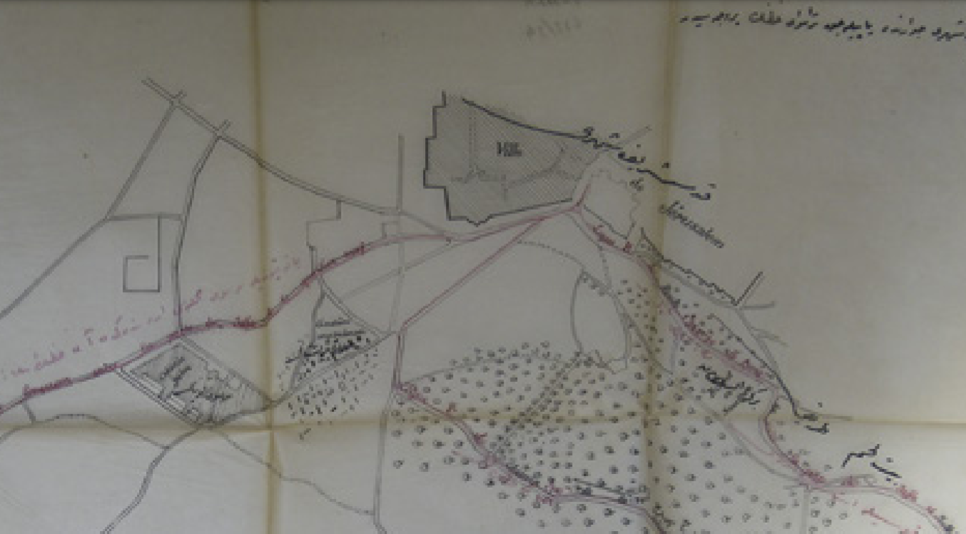
Figure 2: Tram project for the suburbs of Jerusalem.
Source: Dimitriadis, 2018.

Another example is the dvelopment of te Bosian quarter in the town of Caesarea at the mediterrainian shores north of Palestine. The central government in Istanbul ordered the allotment of the land and the building of the quarter and its services like a mosque, caravansary and the house of the Bosnian governor. A plan was prepared in 1888 for it (Figure 3).

Figure 3: Bosian quarter in the town of Caesarea in 1888.
Source: Bıger, 2013.

Ottoman judicial system
The Ottoman Empire was an Islamic Caliphate where the whole system of the Empire was based on the Şeriat (Eisenman, 1979). During the second half of the 19th century and with the growth of the reform movement, the kanun increasingly began to play a more important role. Nizamiye mahkemeleri [Mahakim nithamiyah] (civil courts) were introduced in 1864 and the Mecelle-i Ahkâm-ı Adliyye [Majallato al-ahkam al-adliyah] (the Ottoman Civil Code) appeared afterwards (Findley, 1986).

Mecelle-i Ahkâm-ı Adliyye [Majallato al-ahkam al-adliyah] (Ottoman Civil Code- Mecelle hereinafter)
Although the Islamic legislations concerning the built environment are numerous, they are still generally distributed within the books of Şeriat. A good account of this legislation is provided by Hakim (1986) and Salagoor (1990). The first attempt to codify the Şeriat was the Mecelle which appeared in 1869 as a response to the establishment of civil courts. It was intended to be a reference for the judges of these courts who had less knowledge of the Islamic Şeriat and Arabic language. The Mecelle is considered “a legislative milestone” which was the first to undertake the codifying of pure Islamic law (Eisenman, 1986).

The Mecelle as an instrument for control and development of Palestinian urban structure:
The main book of the Mecelle relating to the built environment is the book of Şirket Ortaklık Kitabı [Kitabo al-sherikat] (Company Partnership Book) (Salagoor., 1990). The built environment was included within the division of partnerships because the building process was seen as a partnership between people in light, air and land. The main concepts of Şeriat relating to the built environment and considered by articles of the Mecelle are briefly listed below (Salagoor., 1990).
The harm: The concept of not to cause harm nor to reciprocate harm is a fundamental rule of Şeriat which aims at maintaining the satisfaction and justice within the Moslem community (art. 19). In the built environment, this rule means that no private or public development should cause harm, either to public or private interests and if any harm results in, it should be removed (art. 20).
The Old: In the built environment, this concept means that existing conditions should be left unchanged unless they cause harm (arts. 6 and 7).
Ownership: Every owner of a property also owns what is above and beneath it, and he has the right to act freely in his property. Yet this action should not cause any harm to others, either on the property or adjacent to it. If any harm is caused, the owner should resolve any disputes with the parties (private or public) which are affected. If no agreement is reached, either the harm should be removed or the action should be prevented (arts. 1192, 1194, 1197).
Neighboring rights: Observing the rights of neighbors is an important Islamic conduct. Although the general rule of harm governs the behavior towards neighbors, the Mecelle allocates several points which control neighboring behavior affecting the built environment.
These points include:
Height of development: Every person has the right to raise his building and a wall around or on the top of a building according to his needs as far as no harm will be inflicted on the neighbors.
Usage of development: Every person has the right to use his development in the way which satisfies his needs. However, he could be prevented from so doing if an enormous harm affects the privacy of others, the safety of the building or quality of the surrounding environment.
Private and public roads: The Mecelle differentiated between public roads which are thoroughfare roads and private roads which are cul-de-sac lanes or alleyways serving certain groups of people and houses. The private cul-de-sac road is a joint property of the people who live around it. No one can construct anything in it without the permission of other holders. Yet closing the mouth of such a road is prohibited even if all the holders agree upon it. The person who has a wall on a private road but not the right to pass through it has no right to open a door onto the road (arts. 1119-1120). Every person has the right to use the public road as long as he does not cause harm to others. Yet certain uses like opening a door onto the public road or selling and purchasing in it need the permission of the governor.
From the above articles of the Mecelle, it is obvious that they are much more general guidelines than detailed and definite rules. The Mecelle did not form a special comprehensive tool of urban planning. It did not connect to a hierarchical institutional framework that has its own regulations and rules. Nor did it formulate any ordained system of regulations for the control of urban change. This does not overlook its importance for the judicial system in Palestine in general and the different general contributions it had for the control of Palestinian urban structure.

Ottoman land system
The Land system which mainly refers to land tenure and distribution is considered one of the main factors affecting urban structure. Granott (1952) denotes that land in the Islamic world has, more than any other place on the earth, attained the situation of a strong conservative religious institution which gave all regulations and laws of land a theocratic form. Land ownership in Islam is part of the general ownership which is “the legal rule established by the lawgiver (Allah) who confirms the ways of acquiring ownership” (Salagoor, 1990). Depending on the general rules of land ownership in Islam, the Ottomans issued in 1856 a special code to regulate for land ownership and development in the Empire.

1858 Osmanlı Arazi Kanunnâmesi [Kanon al-aradi al-othmani 1858] (Ottoman Land Code, 1856)
The Land Code aimed at reorganizing the ownership of Land and redistributing it in order to produce more effective use and better revenues. The Land Code classified land ownership into several types, the main of which are the following five types (Stein, 1984):
Mulk Arazi [Aradi mulk] (freehold ownership land)
This type mainly existed in the built-up areas and the green land on their fringes. After the Land Code, the Ottomans began to give title deeds of full freehold ownership for this type of land.
Mîri Arazi [Aradi amiriyah] (Government ownership land)
This land was not owned by a title deed but rather by a usufruct which enabled the holder to use the land and benefit from it while its ownership was retained by the state. The holder was to pay for the title of this land but at the same time, he was prevented from using the soils of such land for non-agricultural purposes. Miri land mostly constituted the open agricultural land beyond the fringes of the villages and towns. The Land Code aimed at preserving the agricultural land and maintaining its produce.
Vakif Arazi [Aradi wakf] (Endowment land)
This type refers to “an estate donated to provide revenues for a beneficent or pious purpose within the Moslem community and aside perpetuity (usually for a family and its heirs) which was regarded as inalienable “ (Khalidi., 1992).
Mevat Arazi [Aradi mawat] (dead land)
This land represented those parts of miri land which were unsettled, unused and had no title deeds. It was possible to give such land a title (e.g., to make it mulk land) by paying its existing value. This provided for the expansion of many villages and towns either in their built-up areas or agricultural land.
Metruk Arazi [Aradi matrokah] (derelict land)
This land mainly constituted lands which were left for public use like roads, public spaces, worship areas, common pasture lands and common woodlands. The ownership of such land was only in the hands of the state which prevented the transfer of ownership of such land.
Ottoman Land Code as an instrument for the control of Palestinian urban structure
Several points in the Land Code generally referred to the control of the built environment. They are explored down here in order to understand the effects of this code on Palestinian urban structure (Makam, 2021).
Art. 12 insisted that nobody could use the soil of his land for making bricks and tiles without the consent of the land’s Memur [Mamor] (director of land).
Art. 28 prohibited the cutting of natural trees in any land.
Art 31 prevented the construction of any new buildings on meri land without the consent of the Memur who could order the demolition of the buildings which did not have permission.
Art. 32 determined the nature of the buildings which could be erected on meri land. These buildings included mills, stores, stables and the like for agricultural uses.
Art. 93 insisted that no one could erect any buildings or plant any trees in a public road. If he did, these had to be removed immediately.
Art. 94 insisted that no building could be constructed, nor any trees planted in the open public spaces and outdoor prayer spaces. These spaces together with the public roads were not available for sale or purchase.
Arts. 95, 96 and 97 gave the position described above for the markets, threshing floors and pastures.
Art. 103 restricted the revivification of Mevat land for agricultural uses, yet it was ruled out in 1911 that the construction of buildings was also a revival for Mevat land. Supervision of the Memur was the only means to control this development.
Art. 132 prevented the filling with earth of any part of the sea without the consent of the Sultan.

Ottoman land system and the urban structure of Palestinian cities
Since the mid-19th century, the Ottoman land system was the main factor shaping the urban structure of Palestinian cities, towns and villages (Granott, 1952). Boundaries of the urban structures became identifiable with their urban spatial layouts. By encouraging the people to register their holdings, the individual holdings increased and the general space of the settlement became more divided (Solomonovich and Kark, 2015), (Figure 4).
Adding the inheritance effect to this factor, parcels continued to be divided producing a mosaic like structure.
The Ottoman land system was the only system in Palestine which differentiated between the open land beyond the fringe of the city and other elements of its physical built up areas. It differentiated between mulk and miri land. The open land beyond the fringe of the city was classified miri while other elements of the built-up areas occupied mulk land.
Although the construction of buildings on miri land was prohibited, the increase in the individual holdings encouraged the expansion of the built-up areas providing more dispersed patterns of the built-up areas (Grossman, 1980). The Ottoman land system in Palestine was the first to recognize the official reservation of roads, open spaces and public squares for the benefit of the public.
Vakif land institution became one of the important tools to supplement the Palestinian urban structure with many building types from mosques to clinics, schools and shelters. It also provided vast green agricultural land the revenue of which is directed to cover the running costs and maintenance of those buildings. In addition, it provided a family represented a family protection tool through the endowment of its land to the benefit of its generation and protecting it from being sliced among them (Dumper, 1992).

Figure 4: Land divisions in Jaffa in 1878.
Source: Solomonovich and Kark, 2015.

Conclusion
the urban planning system in Ottoman Palestine worked through several institutions within the general system of the Ottoman administration. An influential institution which directly related to the urban structures in Palestine was the municipality. Other institutions, from the Sublime Porte to the muhtar of the village, influenced the Palestinian urban structure. At the same time, several tools in the form of laws and regulations related indirectly to the control and management of urban change and development in Palestinian cities, towns and villages. The municipal law for example was strongly affecting the Palestinian urban structures. Unfortunately, other tools in the form of maps and plans were not commonly used by the Ottoman administration in Palestine. One important finding shows that the Ottoman systems referred significantly to several elements of the urban spatial structure. Moreover, the neighborhoods were represented in the administrative system as separate independent identities. the roads, built up areas, fringes and open land beyond the fringe all were also recognized by the Ottoman land system. However, these systems could not create a formidable and coherent urban planning framework for control and management of urban change and development in Palestinian urban structures. Finally, these systems provided unique and distinguished urban management and control frameworks that were significantly advanced and theoretically efficient compared with the general trends and attitudes available outside the Ottoman Empire at that time.

References
Al-Dabbag, Mustafa, 1982. Al-Mojaz fi Tarikh Al-duwal Al-Islamiya fi biladina Filistin [A brief history of Islamic states in our country Palestine] Beirut, Dar AI-Tali'ah.
Al-Nimr, E. 1975. The history of Nablus Mount and the Balka. Nablus, Ehsan Al-Nimr.
Arraf, Shukri, 1986. Al-Karya Al-Arabiya Al-Filistiniya [The Arab Palestinian village] Jerusalem, Arab Studies Society.
Aytek, Attila, 2005. “Hukuk, Tarih ve Tarihyaz›m›: 1858 Osmanl› Arazi Kanunnamesi’ne Yönelik Yaklafl›mlar”, Türkiye Araştırmalar Literatür Dergisi, Cilt 3, Say› 5(2005) 723-744, https://dergipark.org.tr/tr/download/article-file/652399
Biger, Gideon, 1984. “European influences on town planning and town building In Palestine 1850-1920”. Urbanism; Past and Present, 9 no. 17, 30-35.
Cin, Halil, “Arazi”, Islam Ansiklopedesi, Cilt 3, Turkiye Diyanet Vakfi, accessed August 29, 2021 https://islamansiklopedisi.org.tr/arazi
Coon, A. 1991. Urban planning in the West Bank under military occupation, Ramallah, Al-Haq.
Dimitriadis, Sotirios. 2018. The Tramway Concession of Jerusalem, 1908–1914: Elite Citizenship, Urban Infrastructure, and the Abortive Modernization of a Late Ottoman City, In, Ordinary Jerusalem, 1840-1940: Opening New Archives, Revisiting a Global City. Edited byAngelos Dalachanis and Vincent Lemire, Leiden, Brill, 2018.
Dumper, Michle Dumper, 1994. Islam and Israel: Muslim Religious Endowments and the Jewish State, Beirut, Institute for Palestinian Studies.
Eisenman, Robert H, 1979. Islamic Law in Palestine and Israel. Leiden, E. J. Brill.
El -Nahal, Galal H, 1979. The Judicial administration of Ottoman Egypt in the seventeenth century. Chicago, Bibliotheca Islamica.
Findley, C. V., 1986. The evolution of the system of provincial administration as viewed from the center. in Palestine in the late Ottoman period: political, social and economic transformation, edited by David Kushner, Jerusalem, Yad Izhak Ben-Zui Press.
Gerber, H. 1986. A new look at the Tanzemat: the case of the province of Jerusalem. in Palestine in the late Ottoman period: political, social and economic transformation, edited by David Kushner Jerusalem, Yad Izhak Ben-Zui Press.
Gıdeon Bıger, 2013. Ottoman Town Planning in Late 19th and Early 20th Century Palestine, 3rd International Geography Symposium - GEOMED 2013, Antalya, Turkey.
Goadby, Frederic and Moses Daukhan, 1935. The Land Law of Palestine, Tel-Aviv, Palestine.
Graham, G. Politics in its place 1986. Oxford, Caledonian Press.
Granott, A. 1952. The land system in Palestine: history and structure, London. Eyre and Spottiswood.
Grossman, D. 1980. “Satellite settlements in Western Samaria”. Geographical Review 70 no. 4, 446-461.
Hakim, Basim, 1986. Arabic - Islamic cities: building and planning principles. London, KPI Ltd.
Kark, Ruth. 1986. The contribution of the Ottoman regime to the development of Jaffa and Jerusalem 1840- 1917, in Palestine in the late Ottoman period: political, social and economic transformation, edited by David Kushner Jerusalem, Yad Izhak Ben-Zui Press.
Khalidi, W. ed. 1992. All that remain: the Palestinian villages occupied and depopulated by Israel in 1948. Washington, Institute for Palestinian Studies.
Kushner, David ed. 1986. Palestine in the late Ottoman period: political, social and economic transformation. Jerusalem, Yad Izhak Ben-Zui Press.
Makam: encyclopedia of laws and ruling of Palestinian courts, 2021. The Ottoman Land Law 1858 (Nablus, An-Najah National University, 2021), https://maqam.najah.edu/legislation/169/.
Neveu, Norig, 2013. The Impact of Ottoman Reforms, in Atlas of Jordan, edited by Myriam Ababsa. Beirut, Presses de l’Ifpo, Institut français du Proche-Orient. https://books.openedition.org/ifpo/5002#text
Salagoor, J.Y., 1990. The Influence of Building Regulations on Urban Dwelling in Jeddah. Unpublished Ph.D. thesis University of New Castle Upon Tyne.
Scargill, D. L., 1979. The form of cities. London, Bell & Hyman.
Solomonovich, Nadav and Ruth Kark, 2015. “Land Privatization in Nineteenth-century Ottoman Palestine”. Islamic Law and Society, 22/3, 221-252.
Stein, K. W., 1984. The land question in Palestine 1917-1939. The University of North Carolina Press, Chapel Hill and London.

