T.C.
ANTALYA BILIM UNIVERSITY
INSTITUTE OF POSTGRDUATE EDUCATION
DISSERTATION MASTER’S PROGRAM OF ELECTRICAL AND COMPUTER ENGINEERING

A PIEZOELECTRIC ENERGY HARVESTER FOR POWER GENERATION AROUND WAISTLINE

DISSERTATION

Prepared By
NAVEED AHMED

ANTALYA ‒ 2021

T.C.
ANTALYA BILIM UNIVERSITY
INSTITUTE OF POSTGRDUATE EDUCATION
DISSERTATION MASTER’S PROGRAM OF ELECTRICAL AND COMPUTER ENGINEERING

A PIEZOELECTRIC ENERGY HARVESTER FOR POWER GENERATION AROUND WAISTLINE

DISSERTATION

Prepared By
Naveed AHMED
181212011

Dissertation Advisor
Asst. Prof. Dr. Mustafa İlker BEYAZ

ANTALYA ‒ 2021

INSTITUTE OF POSTGRDUATE EDUCATION
ELECTRICAL AND COMPUTER ENGINEERING
MASTER PROGRAM WITH THESIS

ACADEMIC DECLARATION

I hereby declare that this master’s thesis titled “A Piezoelectric Energy Harvester for Power Generation around Waistline” has been written by me under the academic rules and ethical conduct of the Antalya Bilim University.
I also declare that the work attached to this declaration complies with the university requirements and my work.
I also declare all materials used in this thesis consist of the mentioned resources in the reference list. I verify all these with my honor.

… / … / 2020
Naveed Ahmed

APPROVAL/NOTIFICATION FORM
ANTALYA BİLİM UNIVERSİTY
INSTITUTE OF POST-GRADUATE EDUCATION

NAVEED AHMED, a master student of Antalya Bilim University, Institute of Post Graduate Education, Electrical and Computer Engineering with student ID 181212011, successfully defended the thesis/dissertation entitled “A PIEZOELECTRIC ENERGY HARVESTER FOR POWER GENERATION AROUND WAISTLINE”, which he prepared after fulfilling the requirements specified in the associated legislations, before the jury whose signatures are below.

Academic Tittle, Name-Surname, Signature

Jury Member (Chairman) : …………………………………………….., ………………

Jury Member :......................................................................, ……………….

Jury Member : ......................................................................, ………………
Thesis Submission Date : ………………..
Thesis Defence Exam Date : ………………..

Director of the Institute : …………………………………………….., ………………

ÖZET
A PIEZOELECTRIC ENERGY HARVESTER FOR POWER
GENERATION AROUND WAISTLINE

Bu tez, piezoelektrik bileşenler kullanarak insan belinden enerji hasadı rapor etmektedir. Normal bir insan günde 1,5 ila 2 mil yürür ve gün boyu nefes alır. Bu faaliyetler, elektrik enerjisi üretmek için faydalı olabilir. İnsan vücudundan enerji hasadı daha önce araştırılmıştı, ancak bel çevresinde enerji toplama, güç çekmeyi zorlaştıran insan belinin oldukça düşük karakteristik frekansları nedeniyle ihmal edildi. Bildiğimiz kadarıyla bu, belden enerji hasadı gerçekleştirmek için piezoelektrik bir tasarım kullanan ilk çalışmadır. Piezoelektrik bileşenler, fiziksel ve kozmetik olarak rahatsız edici olmayacak şekilde kayışa iyi entegre edilmiştir. Bir gün boyunca giyebilir ve enerji toplayabilir. Solunum sırasında maksimum performansı ortaya çıkarmak için COMSOL üzerinde simülasyonlar yapılmıştır. Piezoelektrik bileşenler, bir denek tarafından giyilen bir bel kemerine yerleştirildi ve voltaj ve güç üretimi için karakterize edildi. Solunum sırasında maksimum açık devre voltajı ve rms gücü sırasıyla 1,6 V ve 1,90 µW olarak ölçüldü. Bu değerlerin yürüyüş sırasında 8,60 V ve 1,98 µW'a, koşu aktivitesi sırasında 20,2 V ve 14,65 µW'a kadar yükseldiği görülmüştür. AC gücünü doğrultulmuş DC güce dönüştürmek için tam dalgalı bir köprü doğrultucu kullanıldı, ardından biçerdöver tarafından üretilen elektrik gücünü depolamak için yeniden şarj edilebilir bir 1.2V NiMH pil doğrultucuya bağlandı. Pilin gücü daha sonra bir sıcaklık sensörünü çalıştırmak için kullanıldı. Sıcaklık sensörünü çalıştırırken, piezoelektrik enerji toplayıcı pili sürekli olarak yeniden şarj eder. Bu, gelecekteki giyilebilir elektronik cihazlar için pil değiştirme ihtiyacını ortadan kaldırmak için önemli bir adımdır.
Anahtar kelime: Enerji hasadı, güç üretimi, piezoelektrik dönüştürücüler, kendi kendine güç sağlayan, insan yürüyüşü, nefes alma, vücut hareketi, bel kemeri.

ABSTRACT

A PIEZOELECTRIC ENERGY HARVESTER FOR POWER
GENERATION AROUND WAISTLINE

This thesis reports energy harvesting from human waistline by using piezoelectric components. A normal person walks 1.5 to 2 miles a day and breathes all day long. These activities can be useful to generate electrical power. Energy harvesting from human body has been investigated previously, but harvesting energy around waistline has been neglected due to the rather low characteristic frequencies of human waistline that makes it difficult to extract power. To the best of our knowledge, this is the first study that utilizes a piezoelectric design to perform energy harvesting from waistline. The piezoelectric components are well integrated within the belt in such a way that they are not physically and cosmetically discomforting. One can wear it and harvest energy throughout a day. Simulations were performed on COMSOL to reveal maximum performance during breathing. The piezoelectric components were inserted in a waist belt worn by a subject, and were characterized for voltage and power generation. During breathing, the maximum open circuit voltage and rms power were measured to be 1.6 V and 1.90 µW, respectively. These values were observed to increase up to 8.60 V and 1.98 µW during walking and 20.2 V and 14.65 µW during running activity. A full wave bridge rectifier was used to convert AC power to rectified DC power, then a rechargeable 1.2V NiMH battery was connected to the rectifier to store the electrical power generated by the harvester. The power of the battery was then used to operate a temperature sensor. While operating the temperature sensor, the piezoelectric energy harvester continuously recharges the battery. This is an important step forward to eliminate the need for battery replacement for future wearable electronics.
Keywords: Energy harvesting, power generation, piezoelectric transducers, self-powered, human gait, breathing, body motion, waistline belt.

DEDICATION AND ACKNOWLEDGMENT

I dedicate this thesis to my late father, mother and brother , who made me proudly, come to these days, and of course, to my dear friend Ahmed who always support and help me during my thesis.
I am grateful to my advisor Asst. Prof. Mustafa İlker BEYAZ, who introduced me to MEMS design, guided and encouraged me throughout my thesis, and trusted me by providing me the access and opportunity to work in the MEMS Technology Lab.

LIST OF FIGURES

Figure 1: Direct piezoelectric effect [39] 3
Figure 2: Forward And Reverse Mechanisms [4] 4
Figure 3: Piezo Transducer [2] 5
Figure 4: Energy Harvesting Sources [7] 6
Figure 5: Schematic view of a solar energy harvesting system [13] 7
Figure 6: Thermal Energy Harvesting Subsystem [19] 8
Figure 7: Schematic view of a RF energy harvesting system [22] 8
Figure 8: Radiation driven piezoelectric generator [15] 9
Figure 9: Piezoelectric power generation in tires [17] 10
Figure 10: The multi-functional shoe [61] 11
Figure 11: Heel cross sectional view [61] 11
Figure 12: Smart Shoes Energy Harvesting [25] 14
Figure 13: (a) Prototype of the proposed PEH and (b) experimental setup [26] 14
Figure 14: LED shoe harvester components [27] 15
Figure 15: Piezoelectric Floor Tiles [28] 16
Figure 16: Piezoelectric Energy Harvesting Through Knee Joint [29] 17
Figure 17: Piezoelectric energy harvesting From a Backpack [30] 18
Figure 18: Power output for a PVDF backpack [30] 19
Figure 19: Jaw movement energy harvester [31] 20
Figure 20: Voltage generation from the jaw movement [31] 20
Figure 21: Piezoelectric shell structure embedded [32] 21
Figure 22: Peak voltage generation using shell structure [32] 21
Figure 23: Wrist-worn PEH-based piezoelectric harvester [33] 22
Figure 24: Piezo glasses energy harvester [34] 23
Figure 25: Piezo glasses Experimental setup [34] 23
Figure 26: Piezoelectric generators for the computer mouse [35] 24
Figure 27: Piezoelectric generators on the computer keyboard [35] 25
Figure 28: Ankle energy harvester [36] 26
Figure 29: Shoulder strap Energy harvester [37] 27
Figure 30: lower limb-driven energy harvester [38] 28
Figure 31: AC / DC full bridge Rectifier [40] 32
Figure 32: Rectified And Unrectified AC [42] 32
Figure 33: Charging Effect of a Capacitor [42] 33
Figure 34: Piezoelectric Equivalent Circuit Schematic [63] 35
Figure 35: Thermistor Equivalent Circuit Schematic [43] 36
Figure 36: Simulation Setup for Breathing 38
Figure 37: Meshed geometry of the harvester belt 39
Figure 38: A-P (anterior-posterior) movement during Breathing 40
Figure 39: Simulated Voltage across Terminals during Moderate Breathing 41
Figure 40: PZT-5J type piezoelectric material 42
Figure 41: piezoelectric harvester belt circuit 43
Figure 42: Harvester Belt Components 43
Figure 43: piezoelectric harvester integrated on waist belt during breathing activity 44
Figure 44: Open Circuit Voltage (Normal breathing) 45
Figure 45: Open Circuit Voltage (deep breathing) 45
Figure 46: Open Circuit Voltage (deep fast breathing) 46
Figure 47: Piezo harvester integrated on waist belt during walking and running activities 47
Figure 48: Open Circuit Voltage (walking 1 m/s) 47
Figure 49: Open Circuit Voltage (walking 2 m/s) 48
Figure 50: Open Circuit Voltage (running 2 m/s) 49
Figure 51: DC Voltage (Normal breathing) 51
Figure 52: DC Voltage (deep breathing) 51
Figure 53: DC Voltage (deep fast breathing) 52
Figure 54: DC Voltage (walking 1 m/s) 52
Figure 55: DC Voltage (walking 2 m/s) 53
Figure 56: DC Voltage (running 2 m/s) 53
Figure 57: Battery voltage during breathing Activity 54
Figure 58: Battery voltage during all activities 55
Figure 59: Thermistor voltages without harvester connected 56
Figure 60: Thermistor voltages with harvester connected 56

LIST OF TABLES

Table 1: Transducer Specifications and Piezoelectric Characteristics [62] 34
Table 2: Properties of Skin and Belt [55-56] 38
Table 3: Harvester belt meshing parameters 39
Table 4: Instantaneous Maximum Power of single piezoelectric buzzer 49
Table 5: RMS power of single piezoelectric buzzer 50

ABBREVIATIONS

EH : Energy harvesting
PZT : Lead zirconium titanate
PEH : Piezoelectric energy harvester
TEC : Thermoelectric cooler
TEG : Thermoelectric generator
PV : Photovoltaic
RF : Radio frequency
LED : Light emitting diode
PVDF : Polymer polyvinylidene fluoride
PFC : Piezoelectric fiber composites
RMS : Root-mean-square
NiMH : Nickel metal hydride
NTC : Negative temperature coefficient
FEM : Finite element method
AC : Alternating current
DC : Direct current
A-P : Anterior-posterior

INDEX

ÖZET v
ABSTRACT vi
LIST OF FIGURES viii
LIST OF TABLES x
ABBREVIATIONS xi
CHAPTER ONE 1
INTRODUCTION 1
1.1. Overview 1
1.2. Motivation 2
1.3. Organization of Thesis 2
1.4. History of Piezoelectric Materials 3
1.5. History of Energy Harvesting 5
1.5.1. Solar Energy Harvesting 6
1.5.2. Thermal Energy Harvesting 7
1.5.3. RF Energy Harvesting 8
1.5.4. Kinetic Energy Harvesting 9
1.6. Contribution 12
CHAPTER TWO 13
LITRATURE REVIEW 13
2.1. Different Methods of Piezoelectric Energy Harvesting 13
2.1.1. Energy Harvesting From Smart Shoes 13
2.1.2. Led Shoes Piezoelectric Harvester and Sensor 15
2.1.3. Piezoelectric Floor Tiles 16
2.1.4. Piezoelectric Energy Harvesting Through Knee Joint 17
2.1.5. Energy Harvesting From a Backpack 17
2.1.6. Flexible Piezoelectric Energy Harvesting From Jaw Movements 19
2.1.7. Efficient Energy Harvesting From Elbow Joint 20
2.1.8. Energy Harvesting From Wrist-Wearable Systems 22
2.1.9. Energy Harvesting From Head Movement 23
2.1.10. Energy Harvesting From Fingers Motions 24
2.1.11. Smart Energy Harvesting From Human Ankle 25
2.1.12. Energy Harvesting with a Piezoelectric Shoulder Strap 26
2.1.13. Energy Harvesting From Lower Limb 27
CHAPTER THREE 29
THEORETICAL STUDIES AND SIMULATIONS RESULTS 29
3.1. Piezoelectric Parameters 29
3.1.1. Piezoelectric Charge Constant 29
3.1.2. Voltage Constant of Piezoelectric 30
3.1.3. Coupling coefficient 30
3.1.4. Piezoelectric Constitutive Equations 31
3.2. AC-DC Rectification 31
3.3. Piezoelectric Material Properties 34
3.4. Circuit Design 35
3.4.1. NiMH battery circuit design 35
3.4.2. Thermistor Circuit Design 35
3.5. Simulations 36
3.5.1. COMSOL Software 36
3.5.2. Solid Mechanics 37
3.5.3. Electrostatics 37
3.5.4. Piezoelectric Energy Harvester Belt 37
3.5.5. Skin and Leather Belt Properties 38
3.5.6. Meshing 38
3.5.7. Breathing Tests Simulation 40
CHAPTER FOUR 42
EXPERIMENTAL STUDIES 42
4.1. Experimental Setup 42
4.2. Open Circuit Voltage 44
4.2.1. Breathing OC Voltage Tests 44
4.2.2. Walking and Running OC Voltage Tests 46
4.3. AC Power Measurement Test 49
4.4. DC Voltage Tests 50
4.4.1. Breathing DC Voltage Tests 50
4.4.2. Walking and Running DC Voltage Tests 52
4.5. Battery Charging 54
4.5.1. Battery Charging During Breathing 54
4.5.2. Battery Charging During Breathing, Walking and Running 54
4.5.3. Temperature Sensor Battery Recharging Test 55
CHAPTER FIVE 57
CONCLUSION AND FUTURE WORK 57
5.1. Conclusion 57
5.2. Future Work 58
REFERENCES 60

CHAPTER ONE

INTRODUCTION

1.1. Overview
Energy harvesting is the conversion of energy extracted from ambient sources to useful forms like electrical energy. These sources of energy include wind, geothermal energy, vibrations, human motion, electromagnetic sources, etc. As humans are generally becoming increasingly mobile, there is a need for portable electrical energy generators that do not depend on traditional fuels, can work in any environment, and don’t effect the natural environment. Piezoelectric materials are capable of generating electrical energy from mechanical vibration. When dielectric materials are subjected to mechanical strain piezoelectricity is induced. Mechanical energy harvesting from human body motion is an effective approach to obtaining clean and renewable electrical energy to power wearable electronic devices, which are often used for health monitoring and body motion sensing. This research studies a piezoelectric energy harvester to convert mechanical energy to electricity using human motions. Energy harvesting from human waistline has been neglected due to lower values of available energy. In this thesis first of all, single piezoelectric disc is used along with the circuitry to generate electrical power. To improve the output voltage and power, multiple disks are connected in series. The electrical energy which produced around waistline while walking, breathing and running activity stored in a battery and used to operate a temperature sensor. The major objective of this thesis is to find out the nature and amplitude of produced voltage signal waveform from waistline during breathing, walking and running and make it storable. In the light of all these developments, it is obvious that energy harvesting from human body using piezoelectric material is an important future for the next generation technology.

1.2. Motivation
The main motivation of this thesis was to design a piezoelectric energy harvesting belt that can generate electrical power from breathing, walking and running around the waistline, and power wearable electronic devices to eliminate the need for frequent battery replacements. This piezoelectric energy harvesting belt will enable an alternative means to generate electrical power. The piezoelectric belt is easy to wear all day long. Movement during these physical activities are good sources of mechanical energy, therefore the goal of this work was to utilize that movement of body during these physical activities to generate electrical power using piezoelectric materials. The main advantage of this waist belt is that the person who is wearing this belt will not need to change or charge the battery separately because it will get continuous supply of electrical power from the harvester to recharge the battery during all the physical activities. This piezoelectric energy harvesting belt enables an alternative method to obtain continuous and sustainable energy all day long.

1.3. Organization of Thesis
This thesis describes the energy harvesting from human waistline by using piezoelectric components during different physical activities (breathing, walking and running). Before going on to the experimental and simulation parts, Chapter 1 briefly discusses the history of piezoelectric materials and energy harvesting. In Chapter 2, the literature review of energy harvesting from human body and how one can utilized the mechanical energy of the human body motions to generate electrical power was discussed. In Chapter 3, the simulations and theoretical studies were discussed. In the first part of Chapter 3, piezoelectric material parameters were defined. Afterwards, the full wave bridge rectifier was explained and how it converts AC power into DC. In the last part of the chapter 3 the harvester belt simulation was discussed. Chapter 4 consists of experimental parts. In Chapter 4, experimental setup, open circuit voltage and DC voltage tests for different physical activities around waistline and the results obtained were discussed. At the end of chapter 4, battery charging from harvester belt during different physical activities was discussed. Finally, chapter five summarizes conclusion of this thesis work.

1.4. History of Piezoelectric Materials
Materials that have the capacity to produce internal electrical charge from applied mechanical stress are piezoelectric materials. "Piezo" is a Greek term that means "to squeeze." Pierre Curie and Jacques Curie first discovered the effect in 1880. They found that piezo materials were electrically polarized and the degree of polarization was proportional to the applied strain. Both scientists also found that when piezo materials were exposed to an electric field, those same materials deformed. This has become known as the piezoelectric inverse effect. The piezoelectric material which is pressed together can be thought of as a battery with a positive end and a negative end. If one connected the two faces of the battery into an electric circuit the current flows [1].

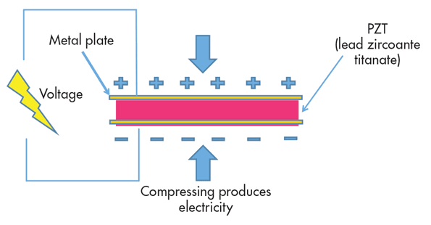

Figure 1: Direct piezoelectric effect [39]

Piezoelectric transducers are usually manufactured in such a way that two sides of the piezoelectric material are coated with metal plates. This setup generates voltage due to piezoelectric effect when the material is pushed together. Electricity produced due to this mechanical push force. The opposite is feasible as well. If one were to induce voltage across the material, it would undergo a mechanical tension, known as the reverse piezoelectric effect, would force itself together, and both forward and reverse mechanisms are used in piezoelectric sensors [3].

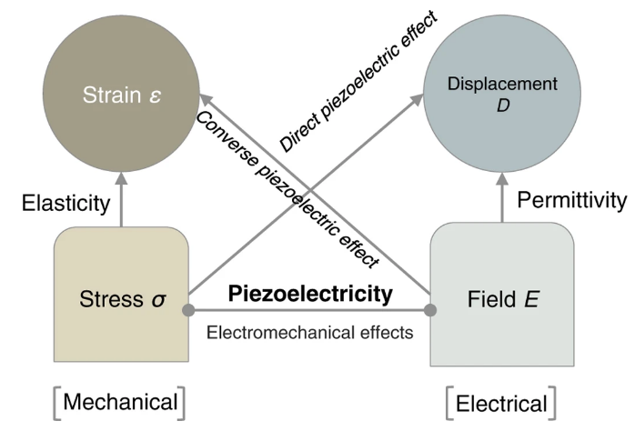

Figure 2: Forward And Reverse Mechanisms [4]
Single crystal, piezoceramics, thin film piezoelectrics, composites, and polymers can be categorized as piezoelectric materials. The spontaneously polarized, naturally occurring materials such as quartz and tourmaline, come under single crystal. Piezoceramics are made in a process called sintering in which the powders of the target materials are heated at a high temperature. They are polycrystalline, that is, a mixture of several different crystal and domain orientations. On a macroscopic scale, they are not piezoelectric. During a mechanism called poling, this is induced by polarization. Many cells like structures can be observed while studying a piezoceramic substance under an electron microscope. Such single unit cells structure are called domains. Each domain is oriented in various dipole directions. A strong electrical field is applied during poling and the dipoles orientate along the direction of the field applied. Even after the elimination of the electrical field, these dipoles remain in this direction. Now, these materials show piezoelectric properties. Lead Zirconium Titanate (PZT) is the most commonly used piezoceramic. A thinner and flexible material like the thin film piezoelectric is needed in an environment that includes mechanical stress. There are thin layers of piezoelectric materials deposited on a substrate. They are also used in energy harvesting on a micro scale.

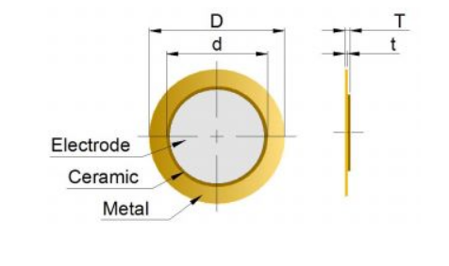
Figure 3: Piezo Transducer [2]

1.5. History of Energy Harvesting
The process of transforming ambient waste energy such as solar, thermal, and vibration energy, into usable electrical energy is known as energy harvesting. Many portable electronic devices currently use technology with low power consumption, which can be handled by energy harvester devices. Small amounts of energy that would otherwise be lost can be collected by energy harvesting technology [5]. It uses this captured energy to increase performance. For example, if waste heat is collected and used to power the device, computing costs would be significantly reduced.
For energy storage applications, analog devices offer a large range of ultra-low power ICs. These devices are used to store energy from sources such as vibration (piezoelectric), photovoltaic (solar) and thermal (TEC, TEG, thermocouples, thermocouples), then the energy is utilized to charge batteries and super capacitors [6].

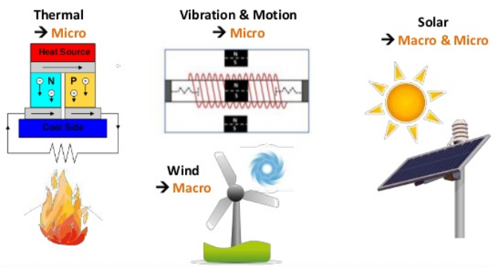

Figure 4: Energy Harvesting Sources [7]

There are many advantages of energy harvesting technologies; they are maintenance free and environmentally friendly [8]. Due to energy harvesting there is no need to replace the batteries. This technology opens up new applications for tracking remote or underwater sites, due to the deployment of energy harvesting sensors.
The successful implementation of technology for energy harvesting needs knowledge from all areas of physics, including: energy capture, energy storage, materials science, systems engineering [9]. Few common sources of ambient energy are as follow; solar, light, kinetic, thermal and RF energy [10].

1.5.1. Solar Energy Harvesting
It is the process of capturing and storing solar energy which is radiated from the sun. Then it is converted to electrical energy from light or heat energy. Using photovoltaic cells (PV cells), solar energy is harvested. Using a theory known as the 'photovoltaic effect', PV cells transform light energy from the sun directly into electrical energy. In general, the photovoltaic effect is the mechanism in which photons (light energy units) excite electrons into a higher energy state generating the electric power [12]. There are four different types of PV cells: single and multi-joint cells, thin film cells, crystalline SI cells, and new PV technologies.
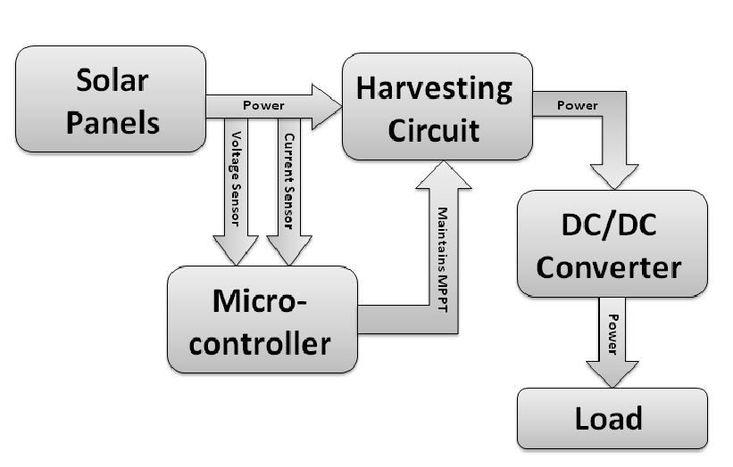
Figure 5: Schematic view of a solar energy harvesting system [13]
In many places around the world, solar energy is fairly available. The sun can provide the world with 15,000 times more energy in just 1 year than atomic energy and fuel energy. Solar cells can provide power to the satellites, electricity for street lights, Television, and wrist watches [14]. PV cells are used in agriculture to pump water and power lighting. The cleanest source of energy is solar energy. No environmental pollution is caused by it. All governments in the world should promote its use, so technology should be installed to harvest this form of free available energy.

1.5.2. Thermal Energy Harvesting
Heat is emitted by almost all electrical systems. This accounts for a large proportion of dissipated energy. Thermoelectric energy harvesting is based on the Seebeck effect theory, in which the temperature difference gives rise to a voltage at the terminals between two semiconductors or conductors. A thermoelectric harvesting device is made up of a thermoelectric generator (TEG) consisting of many thermocouples linked to a common heat source in series. The amount of energy emitted is directly proportional to the difference in temperature and to the size of the TEG [19].
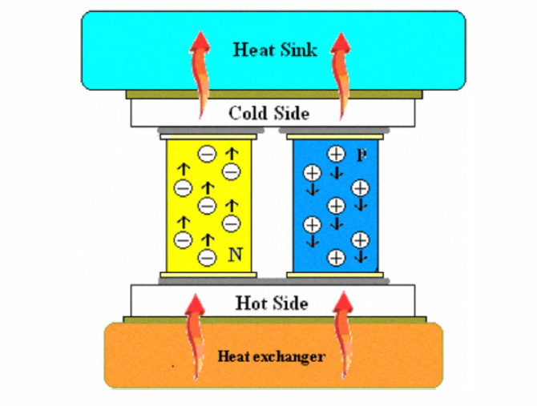
Figure 6: Thermal Energy Harvesting Subsystem [19]
Thermoelectric harvesting can be used to power wireless sensor nodes in industrial settings where large amounts of heat are lost [20].

1.5.3. RF Energy Harvesting
RF energy is all around us. Cell phones have become such an integral part of daily lives are continuously transmitting RF waves into the atmosphere [21]. RF waves are basically “free energy" available for energy harvesting. The New York-based ABI market intelligence analysis company reports that the number of subscriptions to mobile phones has surpassed 5 billion [22]. The numbers of RF energy sources such as Wi-Fi routers and microwave ovens are also rising to this already alarming figure.

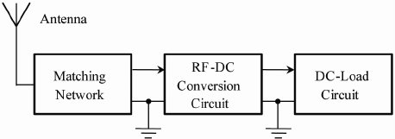

Figure 7: Schematic view of a RF energy harvesting system [22]

Because of the RF energy simplicity and ease of implementation, wireless energy harvesting has become one of the most used harvesting technologies. RF waves are picked up by an antenna, creating a potential difference across its length. This potential difference causes carriers of charge to travel along the antenna length [23]. The integrated RF-DC circuit can then transform the energy from this motion into a stable DC current that is then used to power a sensor or stored in a capacitor.
RF harvesting has a variety of applications - RF energy can be used in wearable battery-free sensors and for wireless charging of low-power consumer electronics [24]. This technology can be used for other applications.

1.5.4. Kinetic Energy Harvesting
Using piezoelectric transducers, kinetic energy can be harvested. Such as from vibrations, sounds or movements, piezoelectric transducers generate electricity from kinetic energy [15]. When a piezoelectric material is subjected to tensile stress, an electric field is produced due to the asymmetric nature of its unit cell. The tension and pressure on piezo materials leads to voltage, induction, etc. [16].

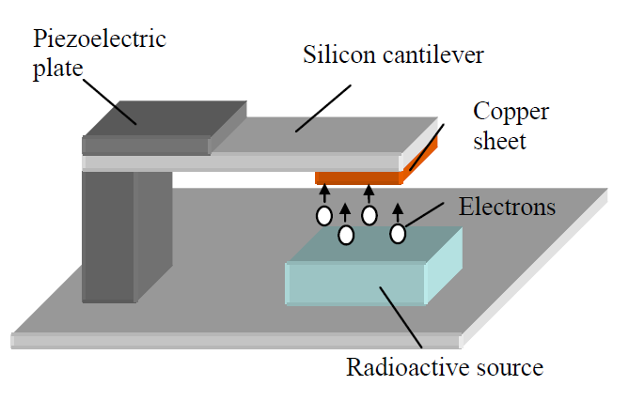

Figure 8: Radiation driven piezoelectric generator [15]
To make the vehicle move, today's electric vehicles use batteries to deliver power. The problem is that the batteries have little capacity, meaning that it is only possible to use battery-powered vehicles for short trips. There is also a need to produce more power that allows the vehicle’s to reach their maximum range. A piezoelectric array is mounted on one or more tires of the vehicle to do this. During each revolution, as the vehicle drives down the lane, the tire is flexed to distort the piezoelectric elements and produce electricity. The electrical circuit supplies electricity to the vehicle's electrical system. [17].
Similar attempts have been made, such as mounting electrical generators on the axles of the vehicle to produce electricity during braking, motor vehicle shock absorbers, etc. [18].
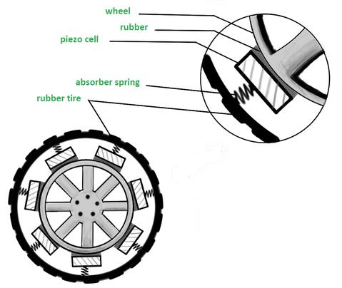

Figure 9: Piezoelectric power generation in tires [17]

One more example of kinetic energy harvesting is the generation of electrical power from a human foot. The piezoelectric material is placed in the energy harvesting shoes where stress and strain, such as soles and heels, are created by walking. The key purpose of this harvester shoes is to constantly generate electrical energy during the walking process of the person who wear this shoe, while maintaining the comfort of people walking.
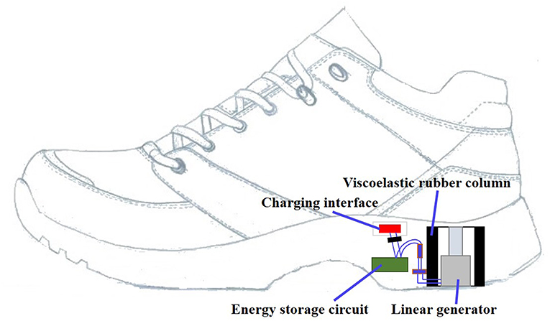

Figure 10: The multi-functional shoe [61]

The harvester shoe consists of rubber column and the power unit, which consists of a power generator and electrical circuit as shown in figure 10. A ring shaped rubber is mounted at the heel of the shoe, a linear generator is placed. The solid insole is positioned on the rubber column and is directly linked to the rubber column as shown in figure 11.

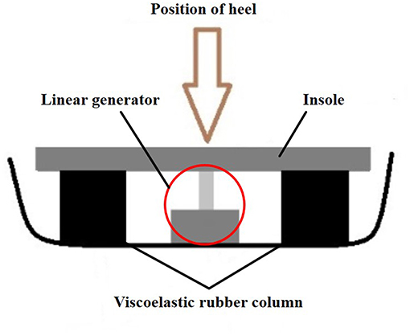
Figure 11: Heel cross sectional view [61]

1.6. Contribution
From a variety of different sources piezoelectric materials have been used for energy harvesting. They are however, not used around the waistline for energy harvesting. In fact, the waistline of the body was not utilized much for power generation. To the best of our knowledge, this is the first piezoelectric device that can harvest power from waistline. The harvester devices were designed, simulated and tested. The results show that it is possible to achieve substantial voltages and microwatt-level power. In addition the battery-operated temperature sensor was constantly recharged by the power produced from harvester device. These results show the feasibility and functionality of the piezoelectric energy harvester reported in this thesis.

CHAPTER TWO

LITRATURE REVIEW

2.1. Different Methods of Piezoelectric Energy Harvesting
In response to applied mechanical stress, piezoelectric materials have the ability to produce an electric potential. New applications of piezoelectric materials have increased over the years as research progressed. Piezoelectric materials are currently used in different capacities, such as sensors, actuators, frequency references, piezo motors, vibration/noise dampers, and now voltage/power sources [60]. Different methods of harvesting electrical energy from piezoelectric materials are as follows.

2.1.1. Energy Harvesting From Smart Shoes
The harvesting of energy from human body is an effective approach to the acquisition of renewable electricity to power sensors, commonly used for health tracking and gait analysis. A piezoelectric energy harvester for the mechanical energy of shoes derived from human body movement was studied in this paper by Zhao et al. The energy harvester develops on a sandwich frame specially crafted with a small thickness, making it easily compatible with a shoe. In addition, both high performance and excellent reliability are given consideration. At a frequency of approximately 1 Hz, the harvester generates an output power of 1 mW while walking [25]. In addition, by adding the harvester with a power management circuit, a direct current is produced. The DC power is tested by simulating a wireless transmitter, with an active time of 5 ms which is required to take 2-3 steps. As a result of this test 50 mW mean power is generated.
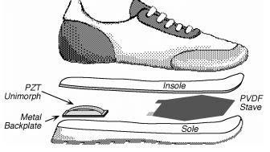
Figure 12: Smart Shoes Energy Harvesting [25]

Another shoe-mounted nonlinear piezoelectric energy harvester (PEH) is presented by Fan et al. in order to collect energy from human motions. The PEH has magnetically coupled piezoelectric beam with a ferromagnetic ball. A sleeve to direct the ball's travel is included. Experiments and simulations show that this design can generate power from various sources of excitation produced by the foot. The ball and the crossbeam, respectively, sense the swing motion and the compressive force, and then operate the piezoelectric beam to function. The vibration along the tibial axis is detected by the piezoelectric beam and produces electrical energy. The suggested PEH within one gait cycle generates voltage. At walking speed of 2 km/h and 8 km/h the output power produced from the prototype is 0.03 mW to 0.35 mW.
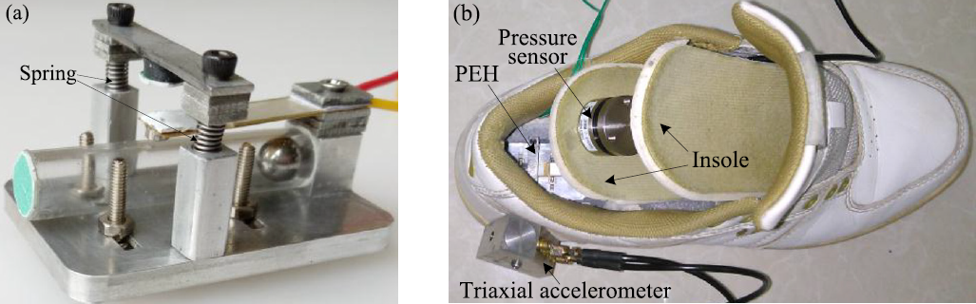
Figure 13: (a) Prototype of the proposed PEH and (b) experimental setup [26]

2.1.2. Led Shoes Piezoelectric Harvester and Sensor
There are several ways to minimize accident risks by using electronic technology. At night time more traffic collisions happens than the day time, due to less visibility at night. For this purpose, LED technology have been created to improve workers visibility at night; however all single-use or rechargeable batteries have been used so far by these items. Once batteries are fully discharged, removing or recharging them can be problematic. Furthermore the worker would be exposed to a risky condition if a battery is completely discharged. Research into less-power consumption devices is being conducted to improve the use time of devices.
Jeong et al. utilized a leadzirconate-titanate (PZT) piezoelectric device as a sensor that can sense stepping motion while generating power. The electrical energy generated replaces the energy that is used in sensors and driving circuits in traditional consumer goods. The output power of the rectifier, when PEH is under stress, was 800 μW. When PEH was released, the output power measured was 600 μW.

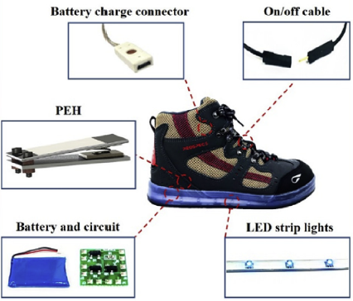

Figure 14: LED shoe harvester components [27]

When step movement is not observed, the device turns off the LEDs. Furthermore the small and light energy harvester does not cause any inconvenience to staff when placed into the shoe. It is designed to be sufficient for specific environments and to function efficiently, helping to address the social issue of low visibility.

2.1.3. Piezoelectric Floor Tiles
Chaturvedi et al. utilized piezoelectric sensors placed on a tile structure to explain the method of optimum energy harvesting. The generation of electric energy from piezo components depends on different factors such as the number of piezoelectric diaphragms, the piezoelectric sensor electromechanical coupling coefficient, the piezoelectric strain coefficient and the arrangement of piezo materials. For electricity generation, energy harvester floor tiles have been developed. An effective way to capture the generated energy a boost converter has been designed to get controlled output for charging the mobile batteries. The simulation and experimental studies were conducted successfully. The design and testing of the model was specifically for the study of energy generation.
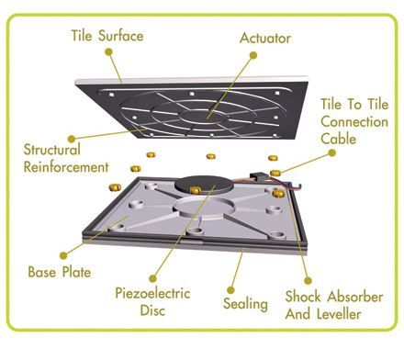
Figure 15: Piezoelectric Floor Tiles [28]
As shown in figure 15, the piezoelectric components are laid under pavements, sidewalks and highways for optimum voltage generation. The RMS value of the piezoelectric harvesting tile's AC output voltage was 1.58 V. The bridge rectifier's output was 1.8 V which based on the stress applied.

2.1.4. Piezoelectric Energy Harvesting Through Knee Joint
Beyaz et al. describes a piezoelectric energy harvesting device that generates electrical power from knee motion during human gait. The device is composed of two MEMS-based piezoelectric patch transducers optimized for placement around knee joints with minimal footprint as shown in figure 16. Simulations were performed on COMSOL software to reveal maximum performance that can be achieved under normal walking conditions. The internal capacitance of the patch transducers was measured to be 80 nF, while the resistance was on the order of 470 kΩ. The patch transducers were inserted in a knee brace worn by a volunteer subject, and were characterized for voltage and power generation. During walking, the maximum open circuit voltage and rms power were measured to be 14 V and 6.2 µW, respectively. These values were observed to increase up to 14.4 V and 12 µW during a moderate running activity. The level of power achieved in the experiments shows the potential of this device as an independent onboard power component and as a continuous battery charger for wearable electronic devices.
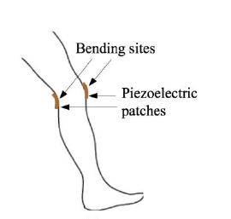
Figure 16: Piezoelectric Energy Harvesting Through Knee Joint [29]

2.1.5. Energy Harvesting From a Backpack
Sodano et al. presents a novel backpack collecting energy harvester that can produce power from the distinguishing forces between the subject and bag. Aim of this harvesting device is to make the energy harvesting device transparent to so that dexterity of user is not compromised. Polymer polyvinylidene fluoride (PVDF) is extremely versatile, enabling it to serve as the load bearing material effectively.
To maintain the efficiency of the user and backpack, the pack design should be kept as similar as possible to current systems by replacing the conventional backpack strap with one made of PVDF. Piezoelectric components have a structure such that a mechanical strain results from an applied electrical potential [30].

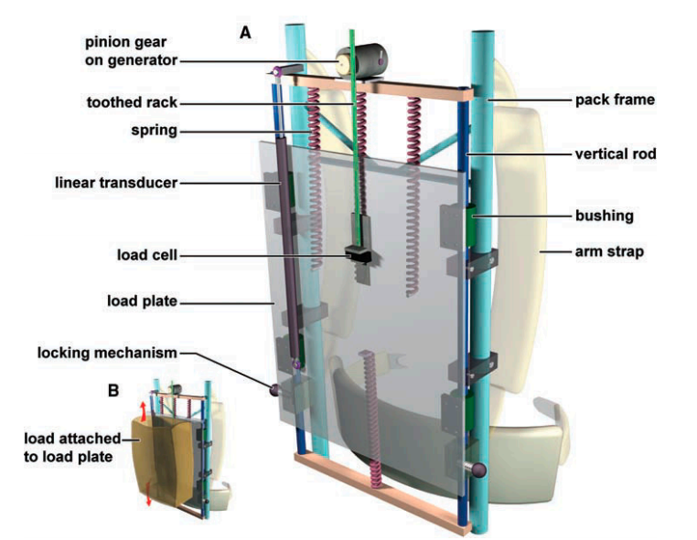
Figure 17: Piezoelectric energy harvesting From a Backpack [30]

The maximum instantaneous power over the course of the experiment is 0.345 W and average power is 45.6 mW as shown in figure 18. The thickness and number of the strap do not produce the highest energy, it only provide adequate strength to support the load.
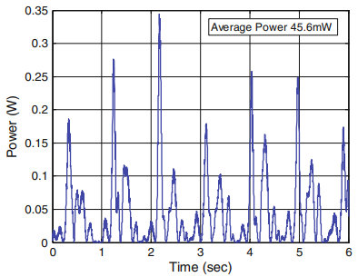
Figure 18: Power output for a PVDF backpack [30]

2.1.6. Flexible Piezoelectric Energy Harvesting From Jaw Movements
A significant numbers of smart materials that can be used as sensors, actuators and energy converters are piezoelectric fiber composites (PFC). PFC mechanisms have not been used much to capture the power of the human motions, considering their excellent capacity for energy harvesting. Delnavaz et al. gives a proof of concept for a PFC chin strap head-mounted system capable of extracting energy from jaw movements [31]. An electromechanical model is generated based on the bond graph technique. It also defines the optimum load resistance value and the best stretch ratio in the harness. The outputs of this device were compared to the predictions of the analytical model. The suggested piezoelectric strap mechanism can be used to charge small-scale electronic devices.
For 60 s of regular gum chewing, the voltage output of this harvester system was tested the results obtained are shown in figure 20. The estimated maximum power was about 7 μW. This harvester model shows the effectiveness of the proposed harvesting device to capture human power resources.

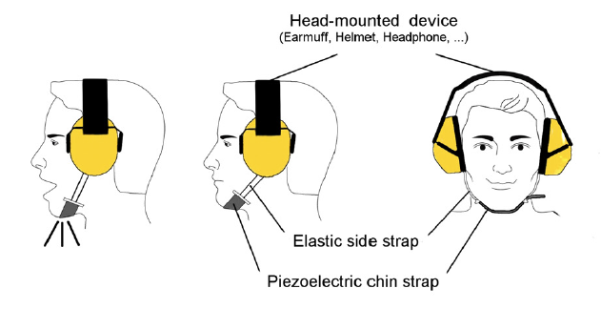
Figure 19: Jaw movement energy harvester [31]

Increasing the strap stretch can enhance output power. On the other hand the increased effort needed to chew may have a negative effect on power generation, according to the experimental findings. The need for energy generation from the jaw movement should be in acceptable limits in order to give priority to the wearer's comfort.
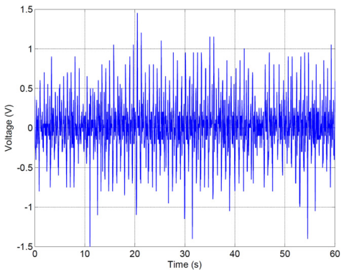
Figure 20: Voltage generation from the jaw movement [31]

2.1.7. Efficient Energy Harvesting From Elbow Joint
Arm swings and stretching were considered as potential sources for the energy harvester. The use of human motion is free of the constraints of location and other environmental circumstances. An elastic piezoelectric polymer in the shell structure was presented in this work, which allows a quick transition even with the small bending movement of the arm.

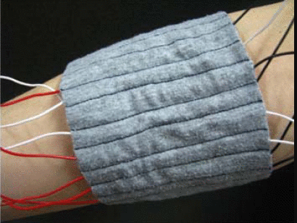
Figure 21: Piezoelectric shell structure embedded [32]
By using piezoelectric shell structures Yang et al. demonstrates an effective energy harvesting system from human motion. As human body movement is spontaneous and slow, the rapid transformation of the shell structure can effectively transform stress into electrical energy. A PVDF film was attached to the curved polymer created by heat to create the shell structure. The shell structure produces a much higher output voltage as compared to other structure [32]. For carrying a harvester, fabric is used. A slow motion of the human elbow joint generates much higher output power by using the proposed shell structures as shown in Figure 22.
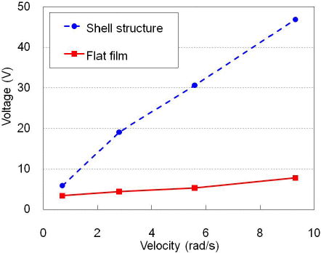
Figure 22: Peak voltage generation using shell structure [32]

2.1.8. Energy Harvesting From Wrist-Wearable Systems
In this paper, the results of the energy transfer from a wrist-worn harvester to a battery in a wearable device are presented by Manjarres et al. This approach is the continuation of their previous work in which Manjarres et al. introduced the harvester with a resistive load to achieve maximum power and measure the energy extracted while wrist movement. For the piezoelectric generator, these conditions are not ideal, but present a more precise analysis of the feasibility of a self-powered device. Tests shows those five minutes of arm motion exercises will provide energy between 1.75 mJ and 2.98 mJ, which can reflect an additional battery time of between 3.6 seconds and 6.2 seconds. These findings therefore provide an insight into the limitations and challenges that remain for wearable devices in the piezoelectric-based kinetic harvesting area.
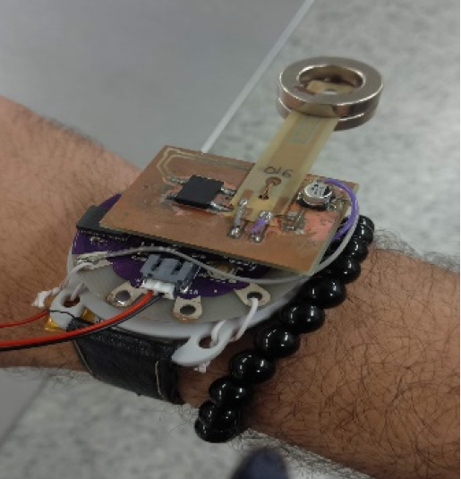
Figure 23: Wrist-worn PEH-based piezoelectric harvester [33]

In this wrist-worn device, the harvester implement as a battery charger. In this case, such a device operates as Bluetooth Low Energy-enabled harvested; this device can also be utilized as heart rate trackers and other applications for health care.

2.1.9. Energy Harvesting From Head Movement
The design of the piezo-magnetic harvester that converts the human head's non-harmonic motion into electricity is stated in this paper by Delnavaz et al. The rolling magnet and the device's double-clamped piezoelectric configuration make it effective to extract energy from the human head's small-amplitude and low-frequency. Furthermore, as shown in figure 24, the system can be inconspicuously combined with the glasses.
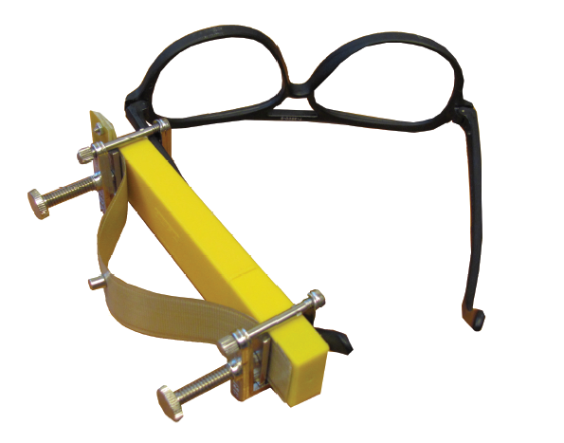
Figure 24: Piezo glasses energy harvester [34]

The results show that the maximum instantaneous power of 0.5 μW can be generated by this energy harvester. The human head does not have ability to move like arms and legs, for this obvious reason; it may be extremely beneficial to power head-mounted devices. Nodding of the head occurs during conversations and such movements can generate electrical power.
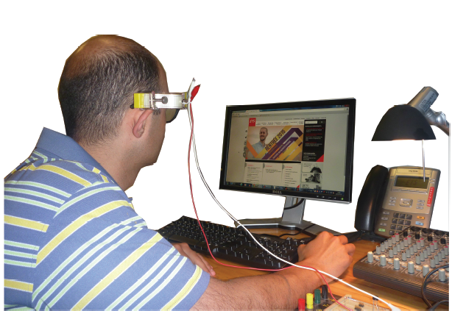
Figure 25: Piezo glasses Experimental setup [34]

2.1.10. Energy Harvesting From Fingers Motions
In this paper Méndez-Lira et al. presents the findings of the motion of the fingers for energy harvesting. In this research, when the piezo films are positioned on both the anterior and posterior side of the fingers, the amount of voltage produced is measured. To increase voltage generation, the aim is to determine the best position of the piezo films on the fingers. The results obtained in this study are the starting point to evaluate the best conditions for increasing energy harvesting from finger movements that allows supplying a less wearable battery system that detects cardiac activity in the wrist.
To determine the best conditions for energy harvesting an experimental study is presented. As piezoelectric generators, PVDF piezo films were used; they were placed on the glove to coincide with various joints on both sides of right hand fingers. For five minutes each, two scenarios were tested and RMS voltage of each piezo film was calculated. High rms voltage was generated by the use of the computer keyboard than by the use of the computer mouse. This is a predicted outcome since the number of keystrokes was greater than the number of clicks during the experiments. As shown in figure 26, scenario 1 consisted of the use of a computer mouse to search various websites on the internet; scenario 2 consisted of the use of a keyboard to write a text of 190 words, as shown in figure 27.

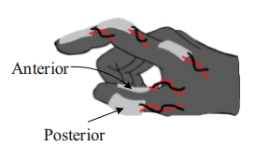
Figure 26: Piezoelectric generators for the computer mouse [35]

In Scenario 1, 0.834 volts were generated by the piezo film located on the back side of the index finger, while the voltage generated by the piezo film located on the anterior side was 0.847 V. The results show that there is no difference in voltage generation when the piezo films were placed on the anterior side and on the post. The higher voltage (1.218 V) was obtained from a piezoelectric component located on the back of the thumb, which is a finger that is not active in the computer mouse click action. This result can be due to the physical movement of the the mouse, where subtle wrist and ring and thumb finger movements are needed, the thumb being one of the most used fingers.

Figure 27: Piezoelectric generators on the computer keyboard [35]
In Scenario 2, 2.329 V was produced from the anterior-side piezo films and 1.180 V from the posterior-side piezo films of the thumb. In other words, 1.149 V was generated by changing the side of the piezo film position on the same finger. The highest voltage was generated with the piezo film placed on the small finger's proximal interphalangeal joint (3.044 V). Due to the design of the glove, the fact of mounting the piezo films on the fingertips makes it hard to accurate contact with the keyboard keys; thus, placing the piezo films on the back side of the fingers allows the subject more flexibility to use the keyboard with ease.

2.1.11. Smart Energy Harvesting From Human Ankle
Cai et al. designed an electromagnetic energy harvester to utilized human ankle’s dorsiflexion, during which ankle joint performs the negative work. Interestingly, as it dorsiflexes at the stance step, the ankle still performs negative work. This allows using of a one-way clutch to filter the ankle's plantarflexion and to prevent positive work mechanical touch transfer array is deployed while swinging step ankle dorsiflexes. The harvester becomes "smart" because of the one-way clutch as well as the mechanical contact switch array. A planetary gear train is used to accelerate the input ankle dorsiflexion to balance the low angular velocity characteristic of dorsiflexion. For the ease of the wearer, the harvester is placed in shoes as shown in figure 28.
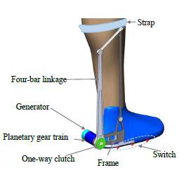
Figure 28: Ankle energy harvester [36]

A prototype is designed to measure the power and metabolic expenditure of users while walking. The process for extracting energy is also modeled and studied. The results indicate that at 4.9 km/h, the harvester generates an average power of 0.35 W. Although this work does not include piezoelectric components, but it is worth mentioning since it is a good example for innovative energy harvesting from body.

2.1.12. Energy Harvesting with a Piezoelectric Shoulder Strap
A 2.5 cm x 20 cm piece of textile was inserted into the strap of a laptop case to demonstrate a practical regular energy harvester, generating an electrical power of 4 μW, as shown in figure 29. Lund et al. demonstrate machine woven textile bands with a power-harvesting functionality, producing a voltage of 3.5 volts. Piezoelectric textiles under wet conditions, generates an output voltage of up to 8 V per step as water increases the electrical contact between the surface of the fibers [59]. The produced energy scales linearly with the area of the fibers. The piezoelectric textile laptop case (approximately 1000 cm²) generated power of approximately 0.1 mW, enough to power a wireless sensor.

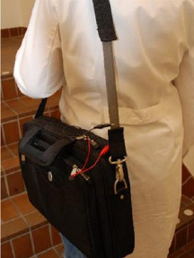
Figure 29: Shoulder strap Energy harvester [37]

Such e-textile formats, without loss of structural functionality, can be expected to generate relevant amounts of electrical energy. By exploiting the thermoelectric, piezoelectric effect, energy harvesters may draw energy from the body heat and motion. Textiles can then serve as a free source of power. Because of Piezoelectric polymers low weight they are the most acceptable choice for textile applications.

2.1.13. Energy Harvesting From Lower Limb
This energy harvester was designed by Shepertycky et al. that utilized the motions of the lower limbs of the user body with a single power generation unit. During swing phase, the cable length increases for a given leg and begins to decrease after heel-strike. The knee flexor muscles conduct negative function in the late swing process to decelerate the motion of the knee. The device captures the movement of two limbs as shown in figure 30.

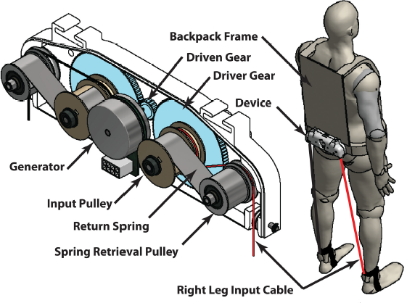

Figure 30: lower limb-driven energy harvester [38]

This design of the harvester has decreased the complexity of the unit. Since the mass position greatly influences the metabolic cost of carrying weight, the power generation unit was placed at the bottom of a backpack. The cables were connected to the lower shanks of the person. A constant force spring mechanism was developed to retrieve the cables. The spring mechanisms provided tension on the cables under 1N and therefore gave the user insignificant resistance during static conditions, such as the walking stance process. Using full bridge rectifier, the power produced from the generator was rectified. The total mass of the system is 2.66kg. Even though in this work metabolic power is converted into electricity which does not include piezoelectric components still it is worth mentioning. Because it is a good source to generate electrical power using human body motion.

Although there are many devices developed for energy harvesting from the body, the waist movement has not been adequately utilized so far. To the best of our knowledge this device is the first one that targets waist movement and utilizes piezoelectric materials to harvest energy.

CHAPTER THREE

THEORETICAL STUDIES AND SIMULATIONS RESULTS

3.1. Piezoelectric Parameters
The piezoelectric crystal produces a polarization when positioned under stress, proportional to the stress that created it. The polarization found in piezo materials is produced by small displacements of ions in the crystal lattice. This only happens in crystals without a symmetry point [39].The equation of piezoelectricity is as follow;

P = d σ (3.1)
Where σ is the applied stress, d is the piezoelectric coefficient, a factor that is unique to each piezoelectric material form. The piezoelectric and converse piezoelectric effect may be formed as following equations:
Direct Piezoelectric Effect:
𝐷=𝑑𝑇+ 𝜀^{𝑇}𝑇 (3.2)

Converse Piezoelectric Effect:
𝑆= 𝑠^{𝐸}𝑇+ 𝐷′𝐸 (3.3)
Where D is the dielectric displacement, d is piezoelectric charge constant, T is the applied stress, 𝜀𝑇 is the dielectric permittivity matrix, S is the strain vector, and ′ is the transpose of D vector.

3.1.1. Piezoelectric Charge Constant
The constant of piezoelectric charge (d) is the amount of electric displacement (D) induced under zero electric field (direct piezoelectric effect) in the material for applied mechanical stress (T).

D = dT (3.4)
Two subscripts denote the piezoelectric charging constant. The first subscript denotes the polarization of the electric displacement. The second subscript denotes the direction of mechanical stress that is applied. For uniformity, the z axis is selected as the polar axis. For example, d₃₁ indicates that when stress is applied along axis 1 then electric displacement is induced along axis 3. The most commonly used configuration is d₃₃. Piezoelectric materials made of ceramics are commonly used because they have high d₃₃ value [40].

3.1.2. Voltage Constant of Piezoelectric
The amount of electrical field (E) produced per unit of stress applied (T) is the piezoelectric voltage constant (g). Like the charge constant (d), subscripts also represent the voltage constant. For example, when a pressure is applied along axis 1, g₃₁ denotes the electric field which is induced along axis 3.

E = −gT (3.5)
As represented in the following equation, the piezoelectric charge and voltage constants are related to each other:
$g=\frac{d}{ε}=\frac{d}{ε_{r}ε_{0}}$ (3.6)
Where ε₀ is the free-space permittivity, and ε_{r} is the relative permittivity. These constants are both dependent on temperature. With the increase in temperature, the piezoelectric charge constant increases.

3.1.3. Coupling coefficient
Another relevant parameter of piezoelectric components is the coupling coefficient. This provides the relationship between the amounts of electrical/mechanical energy converted into electrical/mechanical energy.
k² = $\frac{Electrical Energy Produced}{Input Mechanical Energy }$ (3.7)

In energy harvesting application, the product charge and voltage constant of the piezoelectric plays a vital role. It denotes a piezoelectric material's energy density. The higher product value of these two constants means that the substance has a higher density of energy.
The piezoelectric material generates a charge, Q, under compression. In the piezoelectric capacitor, this charge is stored. This voltage is in the direction of polarization. The material expands if the stress is released and produces a charge in the opposite direction. The piezoelectric material creates an AC output as a consequence. This output of AC is proportional to the material stress applied. The energy harvested is often used by an embedded system. To work, these devices require DC.

3.1.4. Piezoelectric Constitutive Equations
Initial stress, initial strain for models, can be described using the features available under the piezoelectric material feature and solid mechanics interface. These additions occur in the stress-charge formulation in the constitutive relationship of piezoelectric material: the software does not view these fields as a constant initial state when solving the model, but they work as additional fields that are continuously evaluated.
The relationship between stress and strain can be expressed in COMSOL in either a stress-charge form or a strain-charge form. The equations of Piezoelectricity with Electrostatics' charge conservation equation are:
$∇∙D=ρ$_{V} (3.8)
“$ρ$_{V}” is the concentration of electrical charge. From the electric potential V, the electric field is determined as
$E=-∇V$ (3.9)

3.2. AC-DC Rectification
According to the theoretically analysis the electrical power produced by piezoelectric material due to the movement of the piezoelectric plates (mechanical strain) is in AC source. Through using rectifier circuits, the AC is converted to DC. The diode bridge is the rectifying part most widely used. In the pattern as shown in Figure 31, four diodes are arranged. This pattern is called the bridge rectifier. Two kinds of bridge rectifiers are available - half and full wave rectifiers. The full wave rectifier is the rectifier under consideration in this thesis.

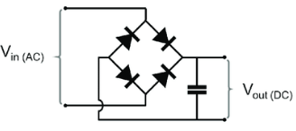
Figure 31: AC / DC full bridge Rectifier [40]

In this type of rectifier, only two diodes conduct during one half of the cycle. In the positive half diodes D₁ and D₂ conduct, and in the negative half, diode D3 and D4 conducts.
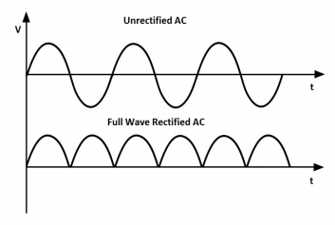
Figure 32: Rectified And Unrectified AC [42]

There is only a positive half-cycle of the output shown in figure 32. This is not a signal of DC. In order to get a DC signal (a flat signal), this positive signal have to be smoothen. For this purpose capacitors are used. The purpose of a capacitor is to storage electrical charge. Two parallel conducting plates, separated by a dielectric are composed in capacitors. For example, the dielectric material is charged when a voltage is applied between the two plates. Until the voltage around the capacitor is equal to the applied voltage, the charges begin to accumulate. This is the capacitor's charging process. A capacitor is a passive component that does not produce electricity. The capacitor is discharged when a load is attached to the capacitor.

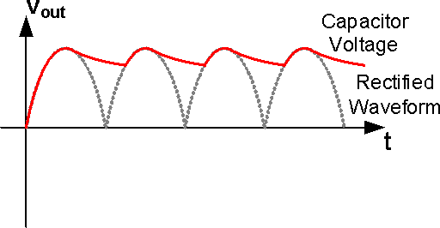
Figure 33: Charging Effect of a Capacitor [42]

Figure 33 shows a capacitor's charging result. There are only positive cycles in the signal from the rectifier. The capacitor is charged and discharged by these positive cycles. The time of charging and discharging depends on the signal frequency. As shown in figure 33, the next voltage pulse is applied when the capacitor is in the discharge phase and thus begins to charge again. The output is therefore going to be a ripple. The ripple frequency depends on the AC input signal frequency. The time taken to charge the capacitor increases if the capacitance increases. So in selecting the capacitor, there is a trade-off.

3.3. Piezoelectric Material Properties
The piezoelectric material that was chosen for this device is PI Ceramic, PZT-5J (27mm piezoelectric transducer). The specifications of the product are shown in Table 1.
Table 1: Transducer Specifications and Piezoelectric Characteristics [62]
 | Value | Unit
  Property
Device Size | 27 | mm(diameter)
Material Type | PZT-5J | _
Density | 7700 | Kg/m³
Poisson’s ratio | 0.34 | _
Young's modulus | 5 | 10¹⁰ N/m
Dissipation factor | 0.5 | %
Dielectric constant | 2800 | Ɛ^{T}33/Ɛ₀
Piezoelectric charge constant |  | pC/N
  d33 | 550
  d31 | -210
Piezoelectric voltage constant |  | 10⁻³Vm/N
  g33 | 22.5
  g31 | -8
Coupling factor |  | _
  K33 | 0.72
  K31 | 0.3

3.4. Circuit Design

3.4.1. NiMH battery circuit design
The nickel metal hydride battery was selected for the battery charging experiments because rechargeable 1.2V NiMH battery does not require a specific battery charging circuitry [63]. It is connected parallel with the capacitor to store the electrical power generated by the piezoelectric components. It has a high charge density and does not need any voltage regulator to be integrated into the circuitry, unlike lithium ion batteries. Figure 34 shows the circuit design of the battery charger.
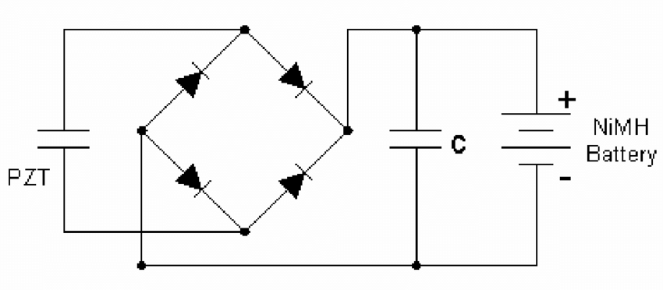
Figure 34: Piezoelectric Equivalent Circuit Schematic [63]

This circuit's simplicity allows it to be designed very compactly and without additional components.

3.4.2. Thermistor Circuit Design
Thermistors are thermally sensitive resistors whose primary role is when subjected to a corresponding change in body temperature, to exhibit a significant change in electrical resistance. Thermistors capable of working over the -100 ° to +600 ° Fahrenheit temperature range are usually produced. Thermistors are commonly recognized as the most advantageous sensor for temperature measurement, due to their very predictable characteristics and their excellent long-term stability. The most significant aspect of an NTC type thermistor is its exceptionally high resistance temperature coefficient. Modern thermistor technology contributes to the manufacture of devices with highly reliable temperature resistance characteristics.
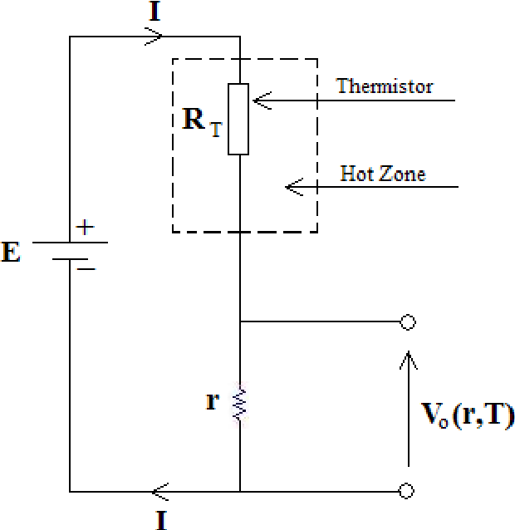
Figure 35: Thermistor Equivalent Circuit Schematic [43]

Thermistor's resistance depends on the ambient temperature. The sensor is mounted to human skin and the test is carried out with the assumption that the thermistor and skin temperatures are the same. This approach is good for individuals who need continuous temperature monitoring.

3.5. Simulations

3.5.1. COMSOL Software
COMSOL is an open platform for all sorts of scientific problems to model and solve. COMSOL 5.3 was used in this thesis. A Model Builder is provided by this software. This gives a complete model overview and access to all features [45]. Models can be constructed by specifying the necessary physical quantities, such as material properties [46]. Different types of studies could be conducted by using these physics interfaces: stationary, linear studies, eigenfrequency, modal and etc.
COMSOL uses the finite element method (FEM) when analyzing the models [47]. The studies could make use of cluster computing and multiprocessor systems; batch jobs and parametric sweeps could also be run. The basis of the science is partial differential equations which provide the basis for modeling a broad variety of scientific phenomena. In several fields of use, COMSOL Multiphysics could be used, such as: electrostatics, solid mechanics, acoustics, bioscience, fluid dynamics, heat transfer, particle tracing, semiconductor devices, etc. [48]. The electrostatics and solid mechanics modules are the frequently used interfaces in this research.

3.5.2. Solid Mechanics
In order to set up a model that requires piezoelectric material the solid mechanics module gives maximum flexibility. The COMSOL will take care of the displacement compatibility between the materials if the materials are geometrically touching each other. In the solid mechanics module, if there is an air gap which is not solid, one can deselect that part of the geometry. Any kind of constraints can be allocated to the model by using the solid mechanics module [49].

3.5.3. Electrostatics
The electrostatics module enables all information related to electrical components to the model which are grouped together. For example, this will include any electrical conditions, such as sources of voltage and charge. By implication, every geometric domain assigned to the solid mechanics > piezoelectric material branch is also assigned to the electrostatics > charge conservation, piezoelectric branch. If one has any other non-piezoelectric dielectric materials in the model, one could allocate them to the branch of electrostatics > charge conservation [50].

3.5.4. Piezoelectric Energy Harvester Belt
During the simulation of piezoelectric energy harvesting belt, the piezoelectric components were well integrated with in the belt. For designing the geometry, the parameters were set according to the waist size of a normal person. The circumference of the waistline of the subject was around 76 cm, while the thickness of the belt was around 5mm. The parameters were set according to these values during simulation. Figure 36 illustrates the geometry of the waist belt on human skin.

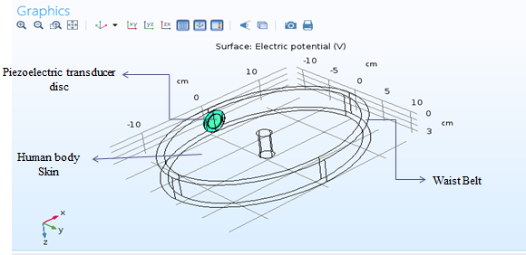
Figure 36: Simulation Setup for Breathing

3.5.5. Skin and Leather Belt Properties
The material properties of the body skin and harvester belt which were used for COMSOL simulation are shown in the following table [52-53-54].
Table 2: Properties of Skin and Belt [55-56]

Properties | Young Modulus  (Mpa) | Poisson's Ratio | Density  ( Kg/m³)
Skin | 1.1 | 0.47 | 1040
Waist Belt | 51 | 0.45 | 860

3.5.6. Meshing
Meshing is customizable and interactive, like many of the technologies available in COMSOL Multiphysics [57]. One can easily mesh individual faces or domains in just a couple of steps. In addition, the default physics-controlled meshing sequences generate meshes that consist of various element types and size characteristics, which can be used to add, transfer, disable, and remove meshing operations as a starting point. By controlling the number, form, and quality of components, customizing the meshing sequence can help reduce memory requirements, thereby providing an effective and accurate simulation. Figure 37 illustrates the meshing of the harvester belt.

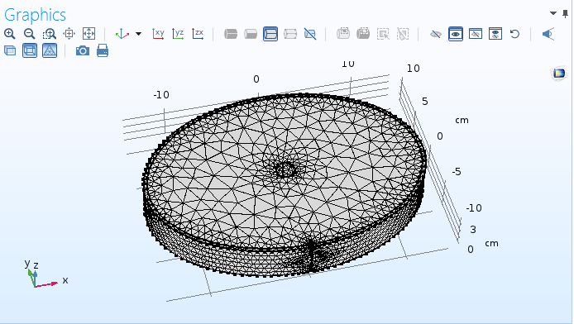
Figure 37: Meshed geometry of the harvester belt
The meshing parameters of the harvester belt during COMSOL simulations are shown in the following table.
Table 3: Harvester belt meshing parameters
Number of elements | 22674
Mesh volume | 1717 cm³
Average element quality | 0.5631
Minimum element quality | 0.001042
Mesh vertices | 4815
Triangular elements | 7410
Edge elements | 883
Vertex elements | 54

3.5.7. Breathing Tests Simulation
During breathing the amount of harvested energy depends highly on the movement of the lower abdomen. Average maximum displacement A-P (anterior-posterior) of the lower abdomen of any normal person is around 2.6 mm during moderate breathing [58]. During simulation the movement of the abdomen is shown in figure 38 which is around 2.6 mm.

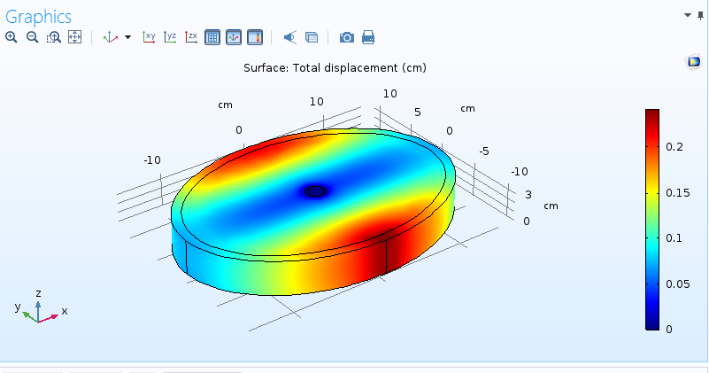
Figure 38: A-P (anterior-posterior) movement during Breathing

To get the 2.6 mm of displacement on waistline the force of 66000 N/m² was excreted on the belt during simulation. As a result the voltage measured across the terminals of the piezoelectric components was around 800mV for single piezoelectric disc shown in figure 39.

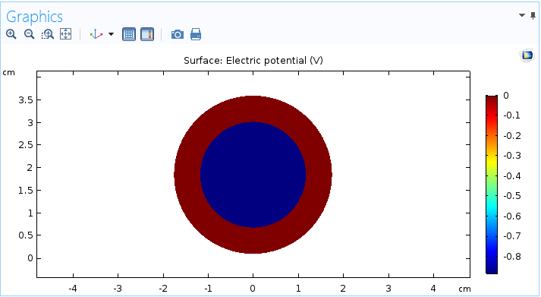
Figure 39: Simulated Voltage across Terminals during Moderate Breathing

This simulation shows that 0.8 V is expected during normal breathing. But this is subject to the varieties in piezoelectric disk placement, breathing extent, and the volunteer subject.

CHAPTER FOUR

EXPERIMENTAL STUDIES

4.1. Experimental Setup
Experimental setup and the implemented prototype of the piezoelectric harvester are described in this chapter. Tests were performed using off-the-shelf discs made of PZT-5J type piezoelectric material. In this harvester device two piezoelectric discs were connected in series and were placed on top of each other as shown in figure 40. These piezoelectric components were then integrated with in the harvester belt.
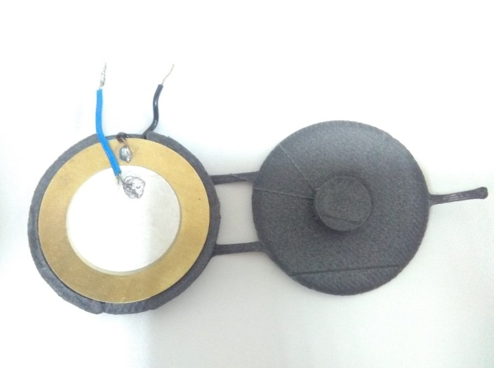
Figure 40: PZT-5J type piezoelectric material

In order to gain insight into the electrical properties of the piezoelectric components, the voltage patterns were observed that resulted from the movement of the piezo components during breathing, walking and running activities using a Tektronix Digital USB oscilloscope and UT131D - digital multimeter. During DC voltage tests the voltage was measured across a capacitor connected to a diode bridge rectifier. The PCB circuit board shown in figure 41 was used to gather data from the piezoelectric harvester belt.
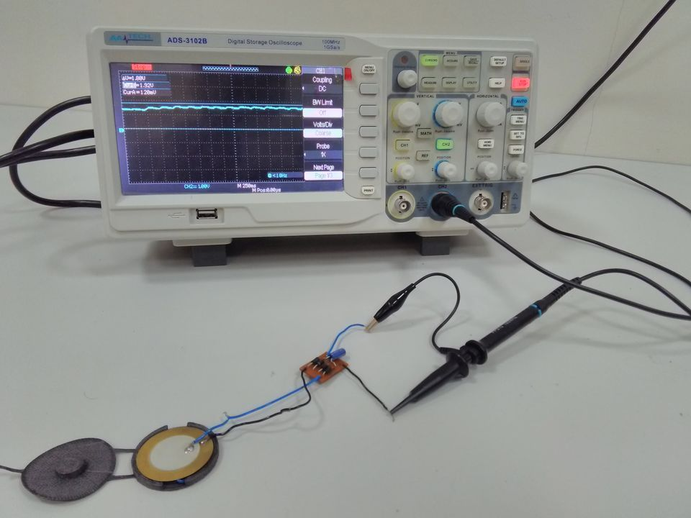
Figure 41: piezoelectric harvester belt circuit

The piezo components located on a belt are as shown in figure 42 (b). The piezo components were placed between the leather belt and the body of the person, while battery and circuitry box were placed on the opposite side of the piezo components on the belt to store the electrical power as shown in Figure 42 (a).
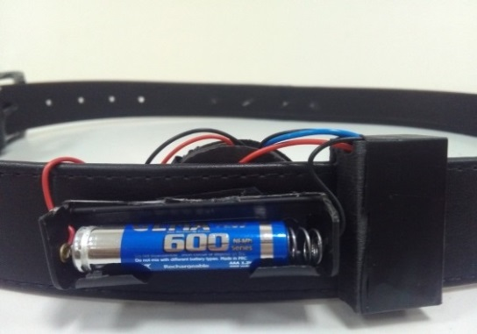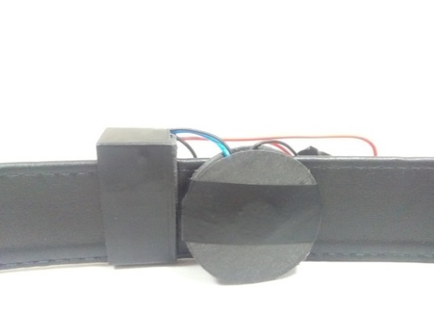
(a) Battery and circuitry box integrated in a belt (b) piezo disks integrated in a belt
Figure 42: Harvester Belt Components

4.2. Open Circuit Voltage
Open circuit voltage tests were performed for all three physical activities around the waist line. These three physical activities include breathing, walking and running. Open circuit voltage test for walking was performed at two different speeds, namely 1 m/s and 2 m/s. For running OC voltage test the speed of the running was 2m/s. Circuit was presumed to have high voltage and low current.

4.2.1. Breathing OC Voltage Tests
Breathing OC voltage tests were performed during normal (moderate) breathing, deep breathing, and deep fast breathing. Two piezoelectric components were connected in series and were placed on top of each other. The piezoelectric components were placed at the center front side of the waist line (lower abdomen) as shown in figure 43. At this position the piezoelectric components faces the maximum amount of force during breathing. Belt remained tight during all the breathing tests.
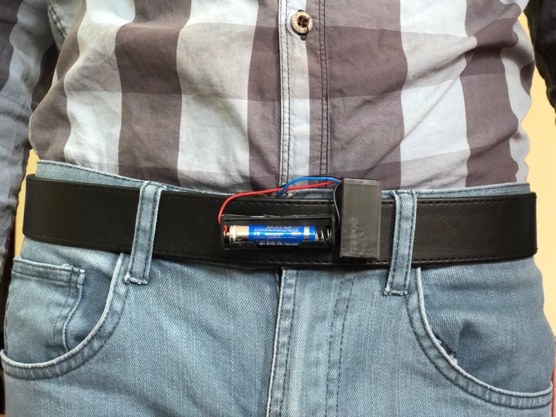
Figure 43: piezoelectric harvester integrated on waist belt during breathing activity

During normal breathing the output OC voltage was measured as 3.48 V_{pp} shown in figure 44. The output voltage measured for deep and fast deep breathing was higher than the normal breathing as 9.40 V_{pp} and 15.0 V_{pp} respectively as shown in figure 45 and 46.
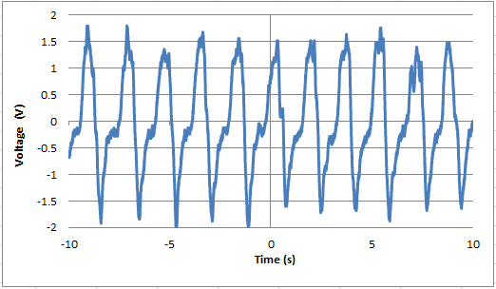
Figure 44: Open Circuit Voltage (Normal breathing)
During COMSOL simulation of the harvester belt the output peak voltage obtained was 0.8 volts as shown in figure 39, due to single piezoelectric component was used. On the other hand during experimental tests two piezo components were connected in series. The peak output voltage generated by the harvester belt was 1.6 volts during experimental tests. These simulation and experimental results imply that the voltage generated from single piezo component was same, which is around 800 mV.

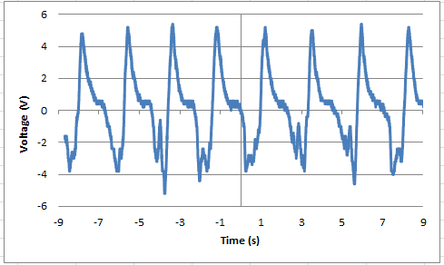
Figure 45: Open Circuit Voltage (deep breathing)

The results show that the deep breathing generates higher voltage than the normal breathing. This is because during deep breathing the displacement or movement of the piezo material is higher than the normal breathing. That means the applied force exerted from the body on the piezo components during deep breathing is greater, which leads to higher output voltages as expected.
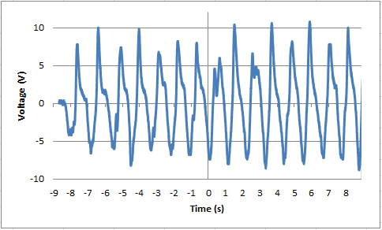
Figure 46: Open Circuit Voltage (deep fast breathing)

During deep fast breathing the frequency of the breathing activity is much higher than the normal and deep breathing. Due to high frequency the movement of the piezo components increases. Accordingly, piezoelectric components operate under higher stress and frequency, which results in elevated voltage levels. These results show that for high output voltage generation deep fast breathing activity is more effective than the normal and deep breathing.

4.2.2. Walking and Running OC Voltage Tests
Open circuit voltages tests for walking were performed for slow and fast walking i.e. walking at a speed of 1 m/s and 2 m/s. The running speed was also set at 2 m/s. Piezo components were excited on the right side of the waist as shown in figure 47. At this position during human gait cycle the piezoelectric discs faced maximum force from the body and generate maximum voltage during these physical activities. Two piezoelectric components were connected in a series, and were placed on top of each other.
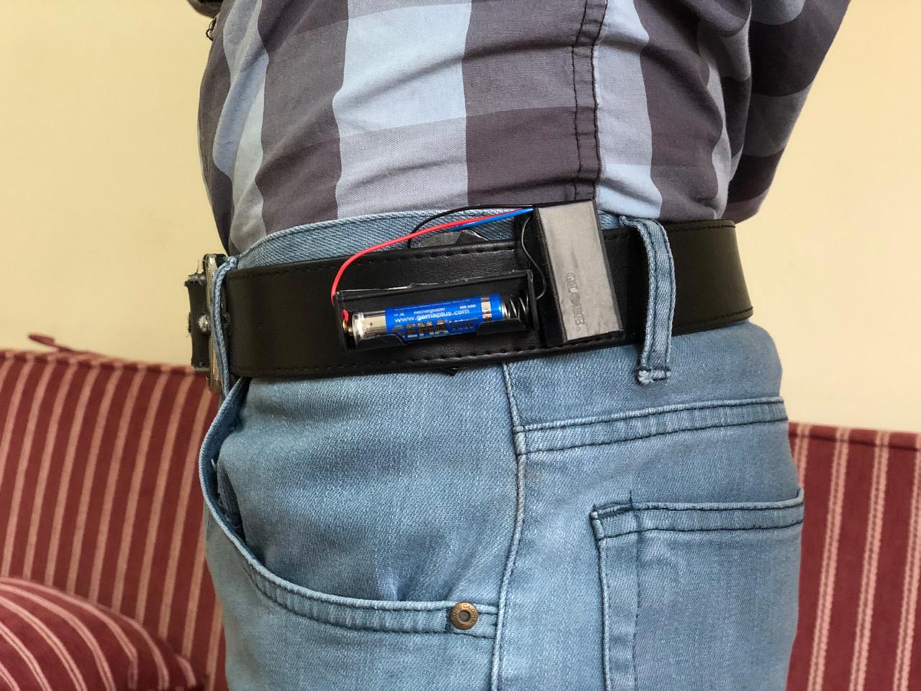
Figure 47: Piezo harvester integrated on waist belt during walking and running activities
During slow walking test, 6 meters distance was covered in 6 seconds, corresponding to a walking speed of 1 m/s. The OC voltage was measured as 8.60 V_{pp} as shown in figure 48.
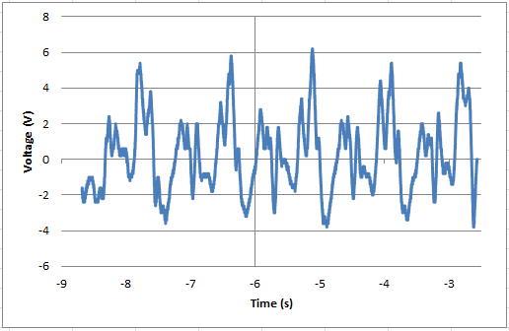
Figure 48: Open Circuit Voltage (walking 1 m/s)
During fast walking the speed of the walking was increased to 2 m/s. Time of the activity remains same as 6 seconds but the distance covered during this time period was 12 meters. The output voltage during fast walking was measured as 12.4 V_{pp}. This shows fast walking generates higher voltage as compared to slow walking. This is because during fast walking the movement of the hip of the body where piezo components were placed increased as compared to slow walking. That means the force exerted from the hip of the body on the piezo components during fast walking is greater, and as a result it generates higher output voltage. The OC voltage test result of the walking at 2 m/s is shown in figure 49.
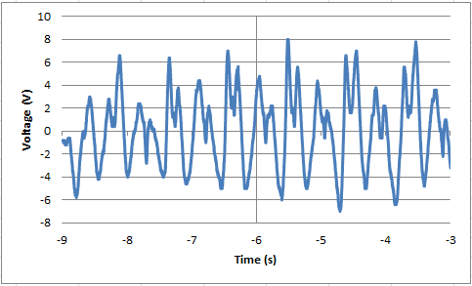
Figure 49: Open Circuit Voltage (walking 2 m/s)
OC voltage test for running was performed at a speed of 2 m/s. Running distance was 12 meters and was covered in 6 seconds of time. The voltage generated during running is higher than the both walking activities. The reason for high voltage generation is the high frequency and higher-amplitude movement of the hip. During running, the whole body of the person accelerates more as compared to walking. The output voltage was measured as 20.2 V_{pp} (figure 50).
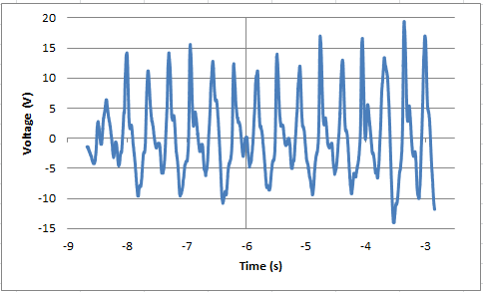
Figure 50: Open Circuit Voltage (running 2 m/s)

4.3. AC Power Measurement Test
In the experimental studies, the harvester was tested with a variable resistance load of 5 MΩ for power measurement test. Tests were conducted by regulating the resistance to obtain the optimum resistive load. The instantaneous output power was measured as voltage squared over the resistance, where the voltage was measured between resistor terminals. At 1.2 MΩ resistance the output power was maximum. Then by setting the variable resistor on this optimal resistance the output rms power and maximum instantaneous power of the one piezo disc were measured during all physical activities as shown in table 3 and table 4 respectively.
Table 4: Instantaneous Maximum Power of single piezoelectric buzzer
Instantaneous Maximum Power
Normal Breathing | 0.3202 μW
Deep Breathing | 3.33 μW
Deep Fast Breathing | 24.3 μW
Walking (1 m/s) | 4.48 μW
Walking (2 m/s) | 11.2853 μW
Running (2 m/s) | 38.53 μW

Table 5: RMS power of single piezoelectric buzzer
RMS power
Normal Breathing | 0.092 μW
Deep Breathing | 1.90 μW
Deep Fast Breathing | 9.25 μW
Walking (1 m/s) | 1.98 μW
Walking (2 m/s) | 2.92 μW
Running (2 m/s) | 14.65 μW

From the results it is clear that during running activity the output powers obtained was higher than the other activities including walking and breathing due to higher frequency. As a result of high frequency the acceleration of the discs increases which lead to high power generation.

4.4. DC Voltage Tests
The electrical power produced by piezoelectric material is in AC, but electrical loads generally require DC power. Thus, AC is converted to DC by using full wave rectifier circuit. Testing was carried out by changing the capacitor value until the desire voltage is reached and kept constant throughout the test period. As OC voltage tests DC voltage tests were also performed for all three physical activities around the waist line.

4.4.1. Breathing DC Voltage Tests
Piezo components were excited on center front side of the waist for all breathing activities (normal. deep. deep fast). The capacitor value set for all breathing tests was 4.7 μF. Capacitor of this value was chosen because it gives approximately pure DC and enough voltage to charge the battery. The tests were also performed with different values of capacitor. If the capacitor was less than 4.7 μF then the output voltage deviated more from DC form and if the capacitor was higher than 4.7 μF the voltage was much more constant, however not enough to charge the battery.
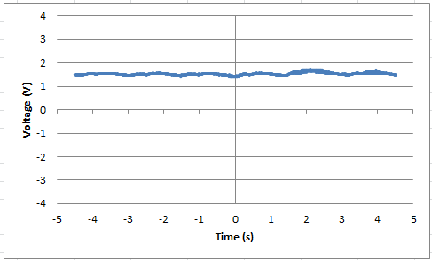
Figure 51: DC Voltage (Normal breathing)

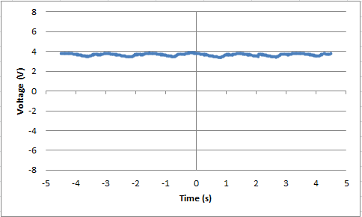
Figure 52: DC Voltage (deep breathing)

During normal breathing the output dc voltage was measured as 1.56 V_{dc} as shown in figure 51. The output voltage measured for deep and fast deep breathing was higher than the normal breathing as 3.76 V_{dc} and 5.12 V_{dc} respectively as shown in figure 52 and 53. This is because during deep fast breathing the frequency of the breathing activity, and the associated pressure values are much higher than the normal and deep breathing. Due to the deep fast breathing, the voltage level is higher as compared to normal and deep breathing.
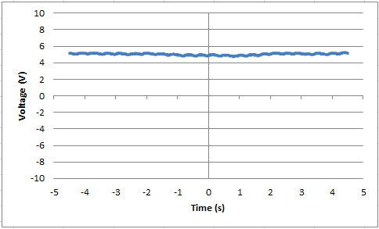
Figure 53: DC Voltage (deep fast breathing)

4.4.2. Walking and Running DC Voltage Tests
DC voltage tests for walking were performed at two different speeds that are 1 m/s and 2 m/s. For running DC voltage test, speed of the running was 2 m/s. Piezo components were excited on right side of the waist. Walking distance was 6 meter and was covered in 6 seconds. The output voltage was measured as 3.04 V_{dc}. The result of the walking at 1 m/s DC voltage is shown in figure 54.
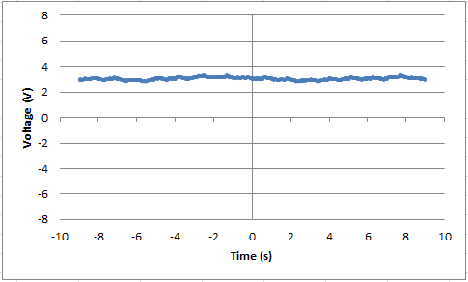
Figure 54: DC Voltage (walking 1 m/s)
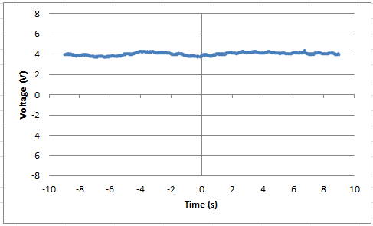
Figure 55: DC Voltage (walking 2 m/s)
During fast walking, the walking distance was increased to 12 meters and was covered in same time that was 6 seconds. The output voltage was measured as 4.16 V_{dc} and is shown in figure 55. The voltage measured during running was higher than the walking due to the high frequency. Accordingly, the capacitor was charging faster due to the fact that the discharging rate was same. Therefore it reaches the higher level as compared to the both walking activities. The running distance was same as fast walking, i.e. 12 meters and was covered in 6 seconds. The output voltage during running was measured as 6.24 V_{dc} (figure 56).
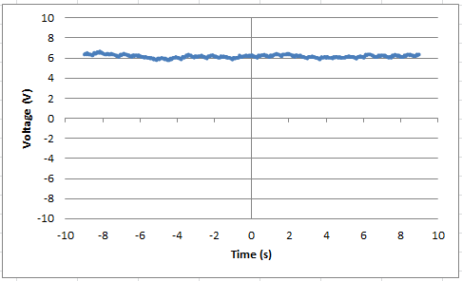
Figure 56: DC Voltage (running 2 m/s)

4.5. Battery Charging
NIMH 600mAh battery was used to store the harvested energy. The battery charging tests were performed for breathing as well as during all the activities combined that includes breathing at different rates (normal, deep, deep fast), walking (1 m/s, 2 m/s) and running (2 m/s).

4.5.1. Battery Charging During Breathing
In the first power storage test, the subject breathes normally for 8 hours. Breathing for 8 hours raises the battery voltage from 800 mV to 1.15 volts. The battery voltage was measured after every thirty minutes. Figure 57 shows the battery charging voltage with respect to time during the breathing. The slope of the charging curve decreases while the voltage reaches to the nominal 1.2 V.

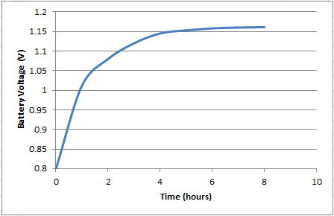
Figure 57: Battery voltage during breathing Activity

4.5.2. Battery Charging During Breathing, Walking and Running
In the second power storage test, the subject wore the belt for 8 hours and performed different physical activities like breathing, walking and running. These activities for 8 hours raised the battery voltage from 800 mV to 1.19 volts while the battery voltage was measured after every thirty minutes. Figure 58 shows the battery charging curve with respect to time during these activities. The slope of the charging curve decreases while the voltage reaches to the nominal 1.2 V battery voltage.

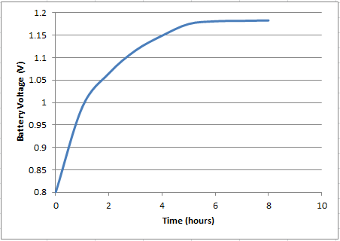
Figure 58: Battery voltage during all activities
Figure 56 shows that the voltage of the battery reached to 1.19 volts, which is closer to the maximum battery voltage i.e. 1.2 volts as compared to the breathing battery charging test where the battery voltage reached to 1.15 volts.. This is due to the involvement of the other higher power generation activities (running and walking).

4.5.3. Temperature Sensor Battery Recharging Test
The electrical power generated from the piezo components stored in a NiMH battery is then utilized to measure the temperature of the body by using NTC type thermistor [44]. A 100 kΩ value of thermistor was chosen for this body temperature sensing test. Harvester belt was continuously charging the rechargeable battery. Two body temperature sensing tests were performed i.e. with and without harvester belt connected with the battery. The duration of the tests was four hours each. Figure 59 shows the voltage drop when the 100 kΩ thermistor was connected with the battery.
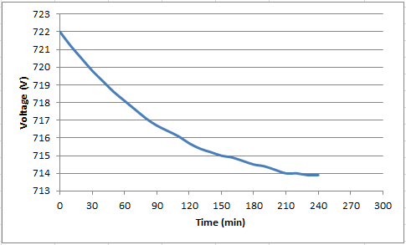
Figure 59: Thermistor voltages without harvester connected
The harvester belt is then connected with the battery to continuously recharge it by utilizing the electrical energy which was generated during breathing activity. During this body temperature sensing test, the voltage decay across the resistor significantly slowed down due to the continuous supply of power to the battery by the harvester belt as shown in figure 60. These results show that the voltage drop decreases substantially when harvester belt connected with the battery.
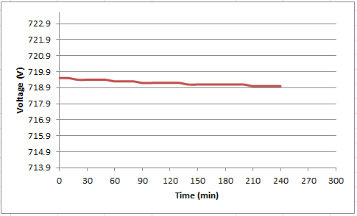
Figure 60: Thermistor voltages with harvester connected

CHAPTER FIVE

CONCLUSION AND FUTURE WORK

5.1. Conclusion
The limited lifetime of batteries and their impact on the environment during production and recycling, ignites the search for alternatives. Energy harvesting systems are designed to generate power from the ambient sources. Solar, radio frequency and motion are examples of sources that can generate the power. Among these sources, human body waist motion is one of the useful source that can be utilized to generate electrical power, specifically for wearable electronic devices.
In this thesis, a piezoelectric energy harvester belt is developed that converts the kinetic energy of people's physical activities into electricity. Using this harvester belt, electricity is generated by means of piezoelectric components during breathing, walking and running activities, stored in an internal battery. The piezoelectric harvester belt was first simulated by using COMSOL software for moderate breathing. The piezoelectric disc was well integrated in the waist belt while simulations. Throughout the moderate breathing simulation the output voltage generated was around 0.8 volts. At the time of experimental tests two piezo components were connected in series to generate higher voltage. While performing breathing tests the piezo components were excited on the front center side of the waist where the the piezos faced maximum force from the body. The tests were performed during normal, deep and deep fast breathing. Normal breathing activity generated 3.48 V_{pp} output voltage. The Output voltage generated for deep and fast deep breathing was higher than the normal breathing as 9.40 V_{pp} and 15.0 V_{pp} due to high frequency and force exerted from the body. While walking and running tests piezo components were excited on the right side of the waist. At this position in the course of human gait cycle, the discs encountered maximum force from the body and generate maximum voltage. The output voltage generated during walking and running was measured as 8.60 V_{pp} and 20.2 V_{pp} respectively. The harvested energy was stored in a 1.2 V NiMH 600mAh battery. Two tests were performed for battery charging. In the first battery charging test, the subject breathes normally for 8 hours, which increased the battery voltage from 800 mV to 1.15 volts. In the second battery charging test, the subject wore the belt for 8 hours and performed different physical activities like breathing, walking and running. The battery voltage increased from 800 mV to 1.19 volts. The electrical energy is then utilized to run a temperature sensor to measure the temperature of the body of the person who wear this harvester belt.
To develop the functionality of this piezoelectric energy harvester in a majority of self-powered devices, its output power has to be enhanced. There are several ways that this can be achieved. By using more optimized piezo geometry instead of the circular discs such as rectangular and square shaped piezo components can possibly enhanced the output power. By increasing the thickness of the piezo film, it can possibly provide more advantage of obtaining higher voltage amount. The size of the piezo components can be further minimized for a more seamless integration with the belt. Packaging of the piezo components can be enhanced in such a way that it can transfer maximum force from the body to piezoelectric disks. More compact piezo size and more piezo components connected in series can play a key role in enhancing the output power. Higher voltage and power generation will enable the use advanced DC/DC converters to charge higher capacity batteries such as Li-ion batteries. Implementing these enhancements in the design, one can harvest a significant portion of the energy needed by their electronic devices without any limitations in the daily lives. Even though this work has a lot of room for improvement, this thesis have proven that usable amounts of power have been generated by using waist movement.

5.2. Future Work
This thesis demonstrated that this harvester belt can be used to continuously recharge a sensor. Further development of this technology will pave the way for developing future wearable electronics that do not need any battery replacement, or even that do not involve any batteries.
The practice of using sensors for intraoperative and postoperative sensing has become a subject of growing interest in the field of biomedical research in recent years, particularly in the field of orthopedics. This device can also be used for orthopedic sensing or prognostic purposes. As it generate sufficient electrical energy to operate low power microprocessors for diagnostic and monitoring applications. A major limitation to widespread, clinical use of embedded sensors is the lack of a long-term self-contained power supply. By using this piezoelectric harvester, a sufficient amount of the mechanical energy generated during normal physical activities can be converted into useful electrical energy.

REFERENCES

[1]. Fukada, E. (2000). History and recent progress in piezoelectric polymers. IEEE Transactions on ultrasonics, ferroelectrics, and frequency control, 47(6), 1277-1290.
[2]. Mishra, R., Jain, S., & Durgaprasad, C. (2016, March). Analysis of piezoelectric buzzers as vibration energy harvesters. In 2016 3rd International Conference on Computing for Sustainable Global Development (INDIACom) (pp. 1660-1664). IEEE.
[3]. Sodano, H. A., Inman, D. J., & Park, G. (2005). Comparison of piezoelectric energy harvesting devices for recharging batteries. Journal of intelligent material systems and structures, 16(10), 799-807.
[4]. Lu, L., Ding, W., Liu, J., & Yang, B. (2020). Flexible PVDF based piezoelectric nanogenerators. Nano Energy, 105251.
[5]. Bai, Y., Jantunen, H., & Juuti, J. (2018). Energy harvesting research: the road from single source to multisource. Advanced materials, 30(34), 1707271.
[6]. Wang, W., Cionca, V., Wang, N., Hayes, M., O'Flynn, B., & O'Mathuna, C. (2013). Thermoelectric energy harvesting for building energy management wireless sensor networks. International journal of distributed sensor networks, 9(6), 232438.
[7]. Zhang, Y., Xie, M., Adamaki, V., Khanbareh, H., & Bowen, C. R. (2017). Control of electro-chemical processes using energy harvesting materials and devices. Chemical Society Reviews, 46(24), 7757-7786.
[8]. Yilmaz, M. (2013). Passive full-wave MOSFET rectifiers for electromagnetic harvesting (Master's thesis, University of Waterloo).
[9]. Joseph, A. D. (2005). Energy harvesting projects. IEEE Pervasive Computing, 4(1), 69-71.
[10]. Mo, C., & Davidson, J. (2013, August). Energy harvesting technologies for structural health monitoring applications. In 2013 1st IEEE conference on technologies for sustainability (SusTech) (pp. 192-198). IEEE.
[11]. Wong, W. Y., & Ho, C. L. (2010). Organometallic photovoltaics: a new and versatile approach for harvesting solar energy using conjugated polymetallaynes. Accounts of chemical research, 43(9), 1246-1256.
[12]. Alippi, C., & Galperti, C. (2008). An adaptive system for optimal solar energy harvesting in wireless sensor network nodes. IEEE Transactions on Circuits and Systems I: Regular Papers, 55(6), 1742-1750.
[13]. Guilar, N. J., Kleeburg, T. J., Chen, A., Yankelevich, D. R., & Amirtharajah, R. (2009). Integrated solar energy harvesting and storage. IEEE Transactions on Very Large Scale Integration (VLSI) Systems, 17(5), 627-637.
[14]. Jones, K. (2009). Harvesting energy from the sun: solar photovoltaics. Consumer series. Energy; no. 10.624.
[15]. Beeby, S. P., Torah, R. N., & Tudor, M. J. (2008). Kinetic energy harvesting.
[16]. Panda, P. K. (2017). Piezoceramic materials and devices for aerospace applications. In Aerospace Materials and Material Technologies (pp. 501-518). Springer, Singapore.
[17]. Anil, K., & Sreekanth, N. (2014). Piezoelectric power generation in tires. no, 2, 11-16.
[18]. Aksu, U., & Halicioglu, R. (2018). A review study on energy harvesting systems for vehicles. Tehnički glasnik, 12(4), 251-259.
[19]. Lu, X., & Yang, S. H. (2010, October). Thermal energy harvesting for WSNs. In 2010 IEEE International Conference on Systems, Man and Cybernetics (pp. 3045-3052). IEEE.
[20]. Hoang, D. C., Tan, Y. K., Chng, H. B., & Panda, S. K. (2009, November). Thermal energy harvesting from human warmth for wireless body area network in medical healthcare system. In 2009 International conference on power electronics and drive systems (PEDS) (pp. 1277-1282). IEEE.
[21]. Lu, X., Wang, P., Niyato, D., Kim, D. I., & Han, Z. (2014). Wireless networks with RF energy harvesting: A contemporary survey. IEEE Communications Surveys & Tutorials, 17(2), 757-789.
[22]. Jabbar, H., Song, Y. S., & Jeong, T. T. (2010). RF energy harvesting system and circuits for charging of mobile devices. IEEE Transactions on Consumer Electronics, 56(1), 247-253.
[23]. Yang, Y., Lee, S. W., Ghasemi, H., Loomis, J., Li, X., Kraemer, D., ... & Chen, G. (2014). Charging-free electrochemical system for harvesting low-grade thermal energy. Proceedings of the National Academy of Sciences, 111(48), 17011-17016.
[24]. Cansiz, M., Altinel, D., & Kurt, G. K. (2019). Efficiency in RF energy harvesting systems: A comprehensive review. Energy, 174, 292-309.
[25]. Zhao, J., & You, Z. (2014). A shoe-embedded piezoelectric energy harvester for wearable sensors. Sensors, 14(7), 12497-12510.
[26]. Fan, K., Liu, Z., Liu, H., Wang, L., Zhu, Y., & Yu, B. (2017). Scavenging energy from human walking through a shoe-mounted piezoelectric harvester. Applied Physics Letters, 110(14), 143902.
[27]. Jeong, S. Y., Hwang, W. S., Cho, J. Y., Jeong, J. C., Ahn, J. H., Kim, K. B., ... & Sung, T. H. (2019). Piezoelectric device operating as sensor and harvester to drive switching circuit in LED shoes. Energy, 177, 87-93.
[28]. Kumar, D., Chaturvedi, P., & Jejurikar, N. (2014, March). Piezoelectric energy harvester design and power conditioning. In 2014 IEEE Students' Conference on Electrical, Electronics and Computer Science (pp. 1-6). IEEE.
[29]. Beyaz, M. (2019). Energy harvesting from knee motion using piezoelectric patch transducers. Akademik Platform Mühendislik ve Fen Bilimleri Dergisi, 7(2), 255-260.
[30]. Sodano, H. A. (2009). Harvesting energy from the straps of a backpack using piezoelectric materials. In Energy Harvesting Technologies (pp. 431-458). Springer, Boston, MA.
[31]. Delnavaz, A., & Voix, J. (2014). Flexible piezoelectric energy harvesting from jaw movements. Smart Materials and Structures, 23(10), 105020.
[32]. Yang, B., & Yun, K. S. (2011, June). Efficient energy harvesting from human motion using wearable piezoelectric shell structures. In 2011 16th International Solid-State Sensors, Actuators and Microsystems Conference (pp. 2646-2649). IEEE.
[33]. Manjarres, J., & Pardo, M. (2020). An Energy Logger for Kinetic-Powered Wrist-Wearable Systems. Electronics, 9(3), 487.
[34]. Delnavaz, A., & Voix, J. (2015). Piezo-magnetic energy harvesting from movement of the head. In Journal of Physics: Conference Series (Vol. 660, No. 1, p. 012120). IOP Publishing.
[35]. Méndez-Lira, O., Sifuentes, E., & González-Landaeta, R. (2019, October). Energy Harvesting from Fingers Motions Using a Wearable System: An Experimental Analysis. In Latin American Conference on Biomedical Engineering (pp. 866-873). Springer, Cham.
[36]. Cai, M., Liao, W. H., & Cao, J. (2018). A smart harvester for capturing energy from human ankle dorsiflexion with reduced user effort. Smart Materials and Structures, 28(1), 015026..
[37]. Lund, A., Rundqvist, K., Nilsson, E., Yu, L., Hagström, B., & Müller, C. (2018). Energy harvesting textiles for a rainy day: woven piezoelectrics based on melt-spun PVDF microfibres with a conducting core. npj Flexible Electronics, 2(1), 1-9..
[38]. Shepertycky, M., & Li, Q. (2015). Generating electricity during walking with a lower limb-driven energy harvester: Targeting a minimum user effort. PloS one, 10(6), e0127635.
[39]. Erturk, A., & Inman, D. J. (2011). Piezoelectric energy harvesting. John Wiley & Sons.
[40]. Gupta, A., & Sharma, A. (2015). Piezoelectric energy harvesting via shoe sole. International Journal of New Technology and Research, 1(6).
[41]. Ballato, A. (1996, November). Piezoelectricity: history and new thrusts. In 1996 IEEE Ultrasonics Symposium. Proceedings (Vol. 1, pp. 575-583). IEEE.
[42]. Kim, H. S., Kim, J. H., & Kim, J. (2011). A review of piezoelectric energy harvesting based on vibration. International journal of precision engineering and manufacturing, 12(6), 1129-1141.
[43]. Park, G., Rosing, T., Todd, M. D., Farrar, C. R., & Hodgkiss, W. (2008). Energy harvesting for structural health monitoring sensor networks. Journal of Infrastructure Systems, 14(1), 64-79.
[44]. Malmberg, P. R., & Matland, C. G. (1956). Thermistor Temperature Control. Review of Scientific Instruments.
[45]. Multiphysics, C. O. M. S. O. L. (1998). Introduction to COMSOL multiphysics®. COMSOL Multiphysics, Burlington, MA, accessed Feb, 9, 2018.
[46]. Wang, X., Yue, H., Liu, G., & Zhao, Z. (2011). The application of COMSOL multiphysics in direct current method forward modeling. Procedia Earth and Planetary Science, 3, 266-272.
[47]. Microstructural model in COMSOL packages with simulation to aging behavior of paper materials by Fuze Jiang, Jiajia Weng, Xiaogang Zhang.
[48]. Kehileche, B., Chiba, Y., Henini, N., Tlemçani, A., & Mimene, B. (2018, April). Numerical Modeling of a Multilayer Electrocaloric Refrigeration System Using CFD Comsol Multiphysics. In 2nd National Conference on Computational Fluid Dynamics & Technology.
[49]. Multiphysics, C. O. M. S. O. L. Structural Mechanics Module User’s Guide; 2013. UM, CNRS UMR.
[50]. Butler, S. L., & Sinha, G. (2012). Forward modeling of applied geophysics methods using Comsol and comparison with analytical and laboratory analog models. Computers & geosciences, 42.
[51]. Behera, M. M., Mishra, A., Purushottam, P., & Rout, S. Design and Simulation of Model for Energy Harvesting from Vehicle Tires Using Piezoelectric Modules.
[52]. Li, C., Guan, G., Reif, R., Huang, Z., & Wang, R. K. (2012). Determining elastic properties of skin by measuring surface waves from an impulse mechanical stimulus using phase-sensitive optical coherence tomography. Journal of The Royal Society Interface, 9(70), 831-841.
[53]. Geerligs, M. (2010). Skin layer mechanics. Eindhoven: TU Eindhoven.
[54]. Pawlaczyk, M., Lelonkiewicz, M., & Wieczorowski, M. (2013). Age-dependent biomechanical properties of the skin. Advances in Dermatology and Allergology/Postȩpy Dermatologii i Alergologii, 30(5), 302.
[55]. Joodaki, H., & Panzer, M. B. (2018). Skin mechanical properties and modeling: A review. Proceedings of the Institution of Mechanical Engineers, Part H: Journal of Engineering in Medicine, 232(4), 323-343.
[56]. Lengyel, B. C., Cernescu, A., Voiconi, T., & Ducan, D. (2016). Analytical and Experimental Determination of Elastic Properties for Synthetic Leather. Materiale Plastice, 53(2), 283-286. [57]. Efficiently Mesh Your Model Geometry with Meshing Sequences by Caty Fairclough.
[58]. Spinczyk, D., Karwan, A., & Copik, M. (2014). Methods for abdominal respiratory motion tracking. Computer Aided Surgery, 19(1-3), 34-47.
[59]. Zheng, L., Lin, Z. H., Cheng, G., Wu, W., Wen, X., Lee, S., & Wang, Z. L. (2014). Silicon-based hybrid cell for harvesting solar energy and raindrop electrostatic energy. Nano Energy, 9, 291-300.
[60]. Goldschmidtboeing, F., & Woias, P. (2008). Characterization of different beam shapes for piezoelectric energy harvesting. Journal of micromechanics and microengineering, 18(10), 104013.
[61]. Xu, B., & Li, Y. (2019). Force Analysis and Energy Harvesting for Innovative Multi-functional Shoes. Frontiers in Materials, 6, 221.
[62]. Anthati, Bt, Bagusetty, A., Basavaraj, R., Shivarajaiah, Rb, Bhandari, Aa, & Chagalamarri, Sn Energy Harvesting System Using Piezoelectric Transducers.
[63]. Sodano, H. A., Inman, D. J., & Park, G. (2005). Comparison of piezoelectric energy harvesting devices for recharging batteries. Journal of intelligent material systems and structures, 16(10), 799-807.
[64]. Li, H., Tian, C., & Deng, Z. D. (2014). Energy harvesting from low frequency applications using piezoelectric materials.
[65]. Khullar, V., Tyagi, H., Phelan, P. E., Otanicar, T. P., Singh, H., & Taylor, R. A. (2012). Solar energy harvesting using Nano fluids-based concentrating solar collector. Journal of Nanotechnology in Engineering and Medicine.

