T.R.
ANTALYA BİLİM UNIVERSITY
INSTITUTE OF POSTGRADUATE EDUCATION
DISSERTATION MASTER’S PROGRAM OF ELECTRICAL AND COMPUTER ENGINEERING

A HYBRID RECOMMENDER SYSTEM

DISSERTATION

Prepared By
Muhammad SANWAL

ANTALYA – 2020

T.R.
ANTALYA BILIM UNIVERSITY
INSTITUTE OF POSTGRADUATE EDUCATION
DISSERTATION MASTER’S PROGRAM OF ELECTRICAL AND COMPUTER ENGINEERING

A HYBRID RECOMMENDER SYSTEM

DISSERTATION

Prepared By
Muhammad SANWAL

Dissertation Advisor
Prof. Dr. Cafer ÇALIŞKAN

ANTALYA – 2020

APPROVAL/NOTIFICATION FORM
ANTALYA BİLİM UNIVERSİTY
INSTITUTE OF POST-GRADUATE EDUCATION

MUHAMMAD SANWAL, a M.Sc. student of Antalya Bılım University, Institute of Post Graduate Education, Electrical and Computer Engineering owning student ID 181212014, successfully defended the thesis/dissertation entitled “A HYBRID RECOMMENDER SYSTEM”, which he prepared after fulfilling the requirements specified in the associated legislations, before the jury whose signatures are below.

Academic Tittle, Name-Surname, Signature ts) Prof. Dr. Name SURNAME ..............................

Thesis Advisor : Prof. Dr. Cafer ÇALIŞKAN, …………….………………

Jury Member : Asst. Prof. Dr. Orhan Deniz GENÇAĞA, ………………..

Jury Member : Asst. Prof. Dr. Murat AK, ………………………………..
Director of The Institute : Prof. Dr. İbrahim Sani MERT……..…….. ………………

Date of Submission: 23/06/2020
Date of Defence: 30/06/2020
ABSTRACT

A HYBRID RECOMMENDER SYSTEM

In the current era, the rapid pace of data volume is producing redundant information on the internet. Predicting the appropriate item for users has been a great challenge in information systems. As a result, recommender systems have emerged in this decade to resolve such problems. Many e-commerce platforms such as Amazon and Netflix are using some decent recommender systems to recommend their items to the users. Previously in the literature, multiple methods such as Matrix Factorization, Collaborative Filtering have been implemented for a long time, however in recent studies, neural networks have shown promising improvement in this area of research.
In this research, motivated by the performance of hybrid systems, we propose a hybrid system for recommendation purposes. In the proposed system, the users are divided into two main categories: Average users and Non-average users. Both of these categories contain the users having similar behaviors towards the items. Various machine learning and deep learning methods are implemented in both of these categories to achieve better results. Machine learning algorithms such as Decision Trees, Support Vector Regression, and Random Forest are applied to the average users. For the non-average users, multiple techniques such as Matrix Factorization, Collaborative Filtering, and Deep Learning methods are implemented. The performed approach achieves better results than the traditional methods presented in the literature.
Index Terms: Recommender System, Matrix Factorization, Collaborative Filtering, Hybrid Systems, Machine Learning, Deep Learning, Decision Tree, Support Vector Regression, Random Forest.

DEDICATION AND ACKNOWLEDGMENT

I dedicate this thesis to my parents, friends, and teachers who always supported me to this day of my life.

I am very grateful to my advisor Prof. Dr. Cafer ÇALIŞKAN who guided and encouraged me throughout the thesis, and to Dr. Alper ÖZCAN, who opened the doors for me in this field of research.

I would also like to thank the jury members Asst. Prof. Dr. Orhan Deniz GENÇAĞA and Asst. Prof. Dr. Murat AK.
CONTENTS

CHAPTER ONE 10
1. Introduction 10
Motivation 10
Objective 11
Thesis Organization 11
CHAPTER TWO 11
2. Literature Review 11
2.1. The Content-based Approach 12
2.2. The Collaborative Approach 12
2.2.1. User-based Approach 12
2.2.2. Item-based Approach 14
2.2.3. Model-based Approach 17
CHAPTER THREE 22
3. Preliminaries 22
Decision Trees 22
Random Forests 23
Support Vector Regression (SVR) 24
Clustering 26
Artificial Neural Networks 26
Collaborative Filtering 28
Matrix Factorization 28
Heterogeneous information network and embeddings 29
CHAPTER FOUR 30
4. The proposed approach 30
4.1. Dataset Description 30
User Ids 30
Movie Ids 30
4.1.1. Data files structure 30
Ratings Data File Structure (ratings.csv) 31
Tags Data File Structure (tags.csv) 31
Movies Data File Structure (movies.csv) 32
Links Data File Structure (links.csv) 33
4.1.2. Data Set for Proposed Research 33
Data for the Processing (Subset of Data) 34
4.1.3. Analysis of Dataset 35
The number of movies each year 35
Popular Genre in every year 36
Best years for each Genre 36
4.2. Primitive Approaches 37
First Approach 37
Second Approach 38
Third Approach 38
Fourth Approach 39
Fifth Approach (Inclusion of IMDb ratings) 40
Sixth Approach 43
4.3. Machine Learning Methods 44
4.4. Collaborative Filtering 45
4.5. Matrix Factorization 47
4.6. Artificial Neural Networks 49
CHAPTER FIVE 51
5. Results 51
5.1. Performance Evaluation 52
CHAPTER SIX 62
6. Discussion and Future Work 62
References 66
Appendices 71

INSTITUTE OF POSTGRADUATE EDUCATION
ELECTRICAL AND COMPUTER ENGINEERING
MASTER OF SCIENCE PROGRAM WITH THESIS

ACADEMIC DECLARATION

I hereby declare that this master’s thesis titled “A Hybrid Recommender System” has been written by myself under the academic rules and ethical conduct of the Antalya Bilim University.
I also declare that the work attached to this declaration complies with the university requirements and is my work.
I also declare that all materials used in this thesis consist of the mentioned resources in the reference list. I verify all these with my honor.

30 /06 / 2020
Muhammad SANWAL

LIST OF FIGURES

Figure 1: Comparing the proposed CF with user-based CF. 14
Figure 2: Comparing factor model with popularity ranking and neighborhood model. 16
Figure 3: Cumulative distribution function of the probability that a show watched in the test set falls within the top x% of recommended shows. 17
Figure 4: RMSE value for each cluster value. 18
Figure 5: The illustration of the proposed model [25]. 20
Figure 6: Illustration of the proposed model [26]. 21
Figure 7: Example of Decision Tree 23
Figure 8: Illustration of Random Forest. 24
Figure 9: Illustration of SVR. 25
Figure 10: Illustration of Clustering. 26
Figure 11: Illustration of a single-neuron layer. 27
Figure 12: Illustration of forward and backpropagation in ANNs. 28
Figure 13: An example of a heterogeneous network. 29
Figure 14: Number of movies each year. 35
Figure 15: Popular Genre in each year. 36
Figure 16: Best years for each genre 37
Figure 17: Similarity percentage between different values. 42
Figure 18: Illustration of Matrix Factorization. 49
Figure 19: Illustration of the proposed Artificial Neural Network. 50
Figure 20: Illustration of ReLU function. 50
Figure 21: Matching percentage of positive prediction with k number of movies. 51
Figure 22: Matching percentage w.r.t. Genre and number of movies. 52
Figure 23: Results of Matrix Factorization. 61
Figure 24: Results of the Deep Learning Method. 62
Figure 25: Illustration of the workflow of the proposed method. 63

LIST OF TABLES
Table 1: Ratings data file format. 31
Table 2: Tags data file format. 32
Table 3: Movies data file format. 32
Table 4: Links data file format. 33
Table 7: Proposed method data file format. 34
Table 8: Fifth approach file format. 40
Table 9: Results of the fifth approach. 54
Table 10: Results of the sixth approach with the Action genre. 55
Table 11: Results of the sixth approach with the Drama genre. 55
Table 12: Results of the sixth approach with the Thriller genre. 56
Table 13: Results of Decision Tree with Average people. 57
Table 14: Results of Decision Tree with Non-Average people. 57
Table 15: Results of Random Forest with Average people. 58
Table 16: Results of Random Forest with Non-Average people. 58
Table 17: Results of SVR with Average people. 59
Table 18: Results of SVR with Non-Average people. 59
Table 19: Comparison of the proposed method with similar methods in the literature. 65

ABBREVIATIONS
ANNs | Artificial Neural Networks
CF | Collaborative Filtering
HIN | Heterogeneous Information Network
IMDb | Internet Movie Database
MF | Matrix Factorization
KNN | K-Nearest Neighbors
MAE | Mean Absolute Error
MLP | Multilayer Perceptron
MSE | Mean Squared Error
RMSE | Root Mean Square Error
SVR | Support Vector Machine
SVM | Support Vector Regression
TV | Television

CHAPTER ONE

Introduction
In the current era of modern technology, information is increasing at a rapid pace. The amount of information available on the internet is not relevant according to the user’s preferences [27]. Most of the users spend their precious time to navigate towards useful information. Recommender systems are getting popular as e-commerce is growing rapidly in the current decade. Recommender systems are one of the best solutions to this problem. E-commerce platforms such as Netflix, Amazon Prime has millions of users with millions of items to offer [28]. It is a challenge for these companies to recommend preferred items to the user according to the user’s taste. The recommender system is one of the modern tools to solve this sort of problem in the current era. These are data filtering engines that try to recommend items that are best for their interest.
The recommender systems are normally categorized into the following types: content-based filtering, collaborative filtering, and knowledge-based filtering methods [29]. Items are recommended on a similarity basis either on a user profile or an item profile. These approaches find the similarity between similar users or similar items then similar items are suggested to the specific users according to their profiles. Recommender systems mostly rely on explicit feedback, meaning that users give explicit input regarding their interest in products. For example, Netflix collects the star rating given by the user for watched movies.

Motivation
In the current decade, hybrid systems are emerging as a successful approach in recommender systems. Hybrid systems have achieved better results compared to the previously applied conventional methods [30]. These methods have overcome the weaknesses of recommendation techniques by replacing them with the strength of another. The performance of these methods depends upon the integration technique of their components.
The items in the database are in large number and it is very difficult for any user to view or rate all items. Every user visits or rates limited number of items in the database, that generates the sparse user-item matrix for a recommender system. It is very challenging to recommend the desired items to the specific user. Moreover, fetching the appropriate features for the items itself is the main challenge in this filed. Furthermore, for a new user in the database, we cannot recommend the personalized items as we do not know his priorities. This leads us to the cold start problem which is still the one of the major issues in the recommender systems. In this research, our goal is to recommend appropriate items to the users according to their interests.

Objective
The main objective of this research is to recommend the personalized items to the users according to their interest. As the user-item matrix is sparse, it is very difficult to recommend items to the user. The sparsity of the matrix leads to a decrease in the efficiency of recommender systems as the user-item matrix does not contain enough ratings which should help recommendation. In this research, we combine different techniques such as Decision Trees, Support Vector Regression, Matrix Factorization, and Neural Networks to achieve better results.

Thesis Organization
The thesis is organized as follows: The literature review is discussed in Chapter 2, while Chapter 3 describes the preliminaries of previously applied methods in the literature. Moreover, proposed approaches such as primitive and non-primitive (Machine Learning, Deep Learning, etc.) are discussed in Chapter 4 along with the description of data set briefly. Results of the proposed approaches are described in Chapter 5 and discussion about the results of the proposed methods and previously applied methods along with the future work are described in Chapter 6.

CHAPTER TWO

Literature Review
In the current decade, recommender systems are highly anticipated as independent research. As the amount of data and information is increasing by the passage of time, it is hard to mine the appropriate data for the users and to recommend items according to the taste of every individual. A recommender system provides a solution by recommending appropriate items to the user by applying different techniques which we will discuss later. Furthermore, enterprises predict the items for a recommendation of every user by their purchasing habits, watch history to make a better experience for the users [1].
In the literature, multiple techniques have been studied and applied for recommendation purposes. The techniques such as collaborative filtering and content-based filtering are most effective in recommender systems. We will discuss these techniques in detail below.

2.1. The Content-based Approach
This approach depends on the content viewed or rated by the user. For better recommendations, a user profile is generated which holds the information about the user activity and the preferences. The user profile is dependent on user preferences and their activity through the items. The profile is generated through keyword analysis, previously seen, and rated items. In general, it involves the latest activity of the user. Moreover, the recommender system analyzes the positive rated and negatively rated items in each user profile and recommends items according to the user preference. The recommended items are generally similar to the positively rated items or general high rated items in the database [4].

2.2. The Collaborative Approach
In this approach, multiple filtering techniques are used for recommendation purposes. The famous collaborative filtering techniques are item-based filtering, user-based filtering, neighborhood-based filtering, and model-based filtering. In this research, we have divided it into the following categories:
- User-based Approach
- Item-based Approach
- Model-based Approach

2.2.1. User-based Approach
In this approach, the user performs a major role in recommendations. The user behavior determines which items should be recommended to themselves. For example, if the user like item-A then more items will be recommended from the same category to the user. Moreover, in this approach items from the same set of users can be recommended to specific users. For example, if the user liked item-A, then the items from the same group of people who have liked item-A will be recommended to the user. This approach determines the behavior of the same users according to liked items and then afterward items are recommended to a user according to the neighborhood [2]. Mostly, neighborhood models are used in this approach. Such user-oriented systems estimate the ratings of an item, based on the similarity of the item or users.
Pu wang and Hong wu ye proposed in [15] a collaborative filtering algorithm for personalized recommendations of an item to the users. In this study, the slope one scheme technique is used to fill the sparsity of the user-item matrix. Afterward, it implements collaborative filtering for the recommendation of items to the users. The slope one algorithm utilizes information such as ratings of a specific item from other users and all items rated by the same user. Moreover, this process consists of two phases to produce recommendations.
- Calculate the average deviation of the two items.
- Calculate the prediction.
Given two items $I_{i}$ and $I_{j}$ the algorithm considers the average deviation $D_{ij}$ of item $I_{i}$ concerning item $I_{j}$ as:
 | $$D_{ij}=\sum_{u_{c}∈U\left(I_{i}⋂I_{j}\right)}{\frac{R_{ci}-R_{cj}}{count\left(I_{i }\bigcap{I_{j}}\right)}}$$ | (1)
where $R_{ci }$ is the rating given by user $c$ to item $i$ and $R_{cj}$ the rating of user c to item $j$. The second step involves predictions $P_{ci}$which are calculated by the following equation:
 | $$P_{ci}=\frac{1}{count(R_{ct}≠0)}\sum_{R_{ct}≠0}{R_{ct}+D_{ci}}$$ | (2)

where $P_{ci}$is the predicted rating of user $c$ would rate item $i$, $R_{ct}$ is the rating of all the user $c$ to item $t$, and $D_{ci}$ is the average deviation of for item $i$ from all users $c$.
After the implementation of the slope one scheme algorithm, the dense ratings were achieved which transformed the original sparse matrix into a dense matrix. Furthermore, for the measurement of user rating similarity Pearson’s Correlation was used to measure the correlation between two vectors of rating. Moreover, for the recommendation purpose weighted average of neighbor’s ratings was calculated according to the target user. The rating $P_{ut}$ of the target user u to the target item t is as following:
 | $$P_{ut}=A_{u}+\frac{\sum_{i=1}^{c}{\left(R_{it}-A_{i}\right)×}sim(u,i)}{\sum_{i=1}^{c}{sim(u,i)}}$$ | (3)
where $A_{u}$ is the average rating of the target user towards items, $R_{it}$ is the rating of the neighbor of user $i$ to the target item $t$, $A_{i}$ is the average rating of the neighbor for user $i$ to the items, $sim (u, i)$is the similarity of the target user $u$ and the neighbor user $i$, and $c$ is the number of the neighbors.
The MovieLens dataset was used for this research. This dataset contains ratings of movies that are rated by different users. In this research, decision-support accuracy measures are taken as it helps users to select high-quality items.
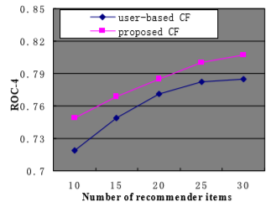
Figure 1: Comparing the proposed CF with user-based CF.

2.2.2. Item-based Approach
It is obvious that the preferences of a user remain similar or slightly changes over time so a similar approach as user-based is applied here. Items with similar ratings or content are recommended to the user. The same neighborhood method is applied to the items which recommends a similar item to the user’s preference [3].
Yifan Hu et. al proposed in [14] a model that does not consider any direct inputs from the users regarding their preferences. In their work, the dataset was treated as an indication of positive and negative indications of an item with varying confidence levels about an item towards a specific user. In this work, they have introduced a set of binary variables that indicate the user preference $p_{ui}$ to item $i$ about any specific item.
 | $$p_{ui}=\left\{\begin{aligned} 1 &r_{ui} >0 \\ 0 &r_{ui} =0\end{aligned}\right.$$ | (4)
In other words, if the user u has consumed the item $i$ then the user likes the item and if the user doesn’t consume the item then the user doesn’t prefer this item. Moreover, in this study confidence levels varies according to the behavior of the user. In the beginning, if the user liked the very first item then the confidence level will be much lower compared to a user who has liked the series of similar items. For example, a user may watch a TV show because he/she is staying on the same channel as the previously watched show. This model has a different confidence level for different users and items. But confidence level grows as the model has a stronger indication that the user likes the specific type of items. To measure the confidence level new variable was introduced. The value of confidence level increases with more user preferences about items.
The main purpose of this research was to find the vectors for each user and item. These factors are known as user-factors and item factors. This approach is similar to the Matrix Factorization technique which is also popular for explicit feedback data. In this work, two important distinctions are generated.
- Account for a varying confidence level.
- Optimization for all user and item pairs
Factors are computed by minimizing the following cost function:
 | $${\min_{x_{*},y_{*}}{\sum_{u,i}{c_{ui}(p_{ui}-x_{u}^{T}}y_{i})}}^{2}+λ\left(\sum_{u}{{\left\|x_{u}\right\|}^{2}+}{\sum_{i}{\left\|y_{i}\right\|}}^{2}\right)$$ | (5)

where $c_{ui}$ is the set of variables which measures the confidence level in observing the $p_{ui}.$The right part of the equation $λ\left(\sum_{u}{{\left\|x_{u}\right\|}^{2}+}{\sum_{i}{\left\|y_{i}\right\|}}^{2}\right)$ is designed for regularization purposes to avoid overfitting the data, $x_{u}$ is the user factor vectors and $y_{i}$ is the item factor vectors. The value of $λ$ is data-dependent. The implementation of the model was based on a different number of factors ranging from 10-200. The dataset was taken from digital television service. The collected data was about 300,000 set-top boxes.
Evaluation of the proposed approach was done by arranging an ordered list of TV shows, sorted from one predicted to be most preferred one to the least preferred one. For the prediction of user behaviors about TV shows $\overline{rank}$was used:
 | $$\overline{rank}=\frac{\sum_{u,i}{r_{ui}^{t}rank_{ui}}}{\sum_{u,i}{r_{ui}^{t}}}$$ | (6)
where $r_{ui}$ are the rating of the user $u$to the program $i$ and $rank_{ui}$ denotes the percentile-ranking of program $i$ within the ordered list of all programs prepared for user $u$. Lower values of rank are more desirable, as they indicate rankings of watched shows closer to the top of the recommendation lists. The results are illustrated below for the proposed approach.
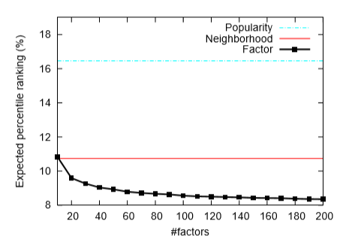
Figure 2: Comparing factor model with popularity ranking and neighborhood model.

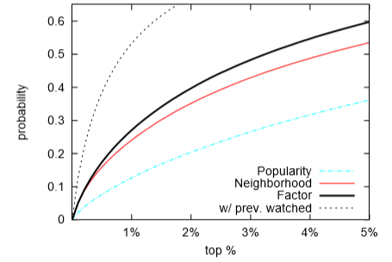
Figure 3: Cumulative distribution function of the probability that a show watched in the test set falls within the top x% of recommended shows.

2.2.3. Model-based Approach
This approach uses some machine learning and deep learning algorithms to learn new ratings by analyzing the previously given ratings. These methods are very fast in computation and they can predict more accurately. Once the model is trained it can make predictions very quickly on the new data entries in the database. Examples of these techniques are included in [6] and some of the techniques are listed below.
- Decision Trees
- Random Forest
- SVD
- Clustering
- Artificial Neural Networks
- Link Analysis
- Hybrid Approaches
- Link Prediction Approaches

Clustering and Random Forest
Ajesh et.al proposed a system that uses clustering and random forest algorithms for recommendation purposes [16]. The recommendation system was designed on user ratings and the recommender system was evaluated by computing accuracy and Mean Square Error. Moreover, the users were clustered based on ratings given by users for each movie. The results of the research are illustrated in the figure below. The X-axis represents the number of clusters and Y-axis represents RMSE.
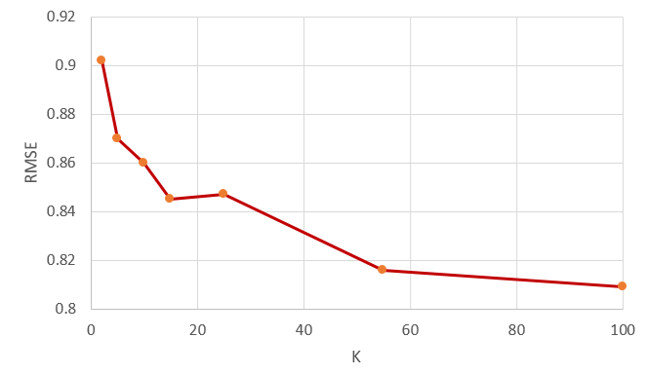
Figure 4: RMSE value for each cluster value.

Artificial Neural Networks
M. T. Ahamed proposed a collaborative filtering method which implies matrix factorization and deep neural networks under its framework [25]. This paper proposed a recommender system where a deep neural network is replacing the inner dot product of matrix factorization that can learn non-linearities of the system. Furthermore, to incorporate the non-linearities of the system matrix factorization is combined with deep neural networks. A single user can rate multiple items in the personalized recommender system. For this reason, unique users can be formulated against unique items and can be transformed into multidimensional space. So, user and item embeddings are used to represent the latent features of users and movies which determines the strength of the relationship for each user.

Matrix Factorization layer
In matrix factorization, the embedding for the user $u$ and item $i$ are denoted as $p_{u}$ and $q_{i}$ respectively. Then, the dot product of $p_{u}$ and $q_{i}$ is denoted by $y_{ui}$ and calculated as following:
 | $$\hat{y}=f\left(u,i :p_{i},q_{i}\right)= \sum_{k=1}^{K}{P_{uk}q_{ik}}$$ | (7)
where $p_{u}$ and $q_{i }$denotes the user and item embeddings respectively. Moreover, K denotes the number of latent features for the proposed embeddings.

Multilayer perceptron layer
Moreover, a multilayer perceptron with a hidden layer is used to comprehend the interaction of latent features between users and items. The layered model under the multilayer perceptron produces an output $\hat{y}$. The hidden layers are activated by $ReLu$ function denoted by $h$:

 | $$\hat{y}=R\left(h^{T}∅ \left(z_{L-1}\right)\right)$$ | (8)

where $∅(z_{L-1})$ is
 | $$∅\left(z_{L-1}\right)=a_{L}\left(W_{z_{L-1}}^{T} +b_{L}\right)a$$ | (9)
where $W_{x}, b_{x} and a_{x}$ are the weight matrix, bias vector, and activation function respectively.

Combine MF and MLP layer
Moreover, two models Matrix Factorization and Multilayer perceptron are combined in the final hidden layer to provide more accurate results. The output of the layer is denoted by $\hat{y}$:
 | $$\hat{y}=R\left(h^{T}a\left(p_{u} ⨀ q_{i}+W\left[\begin{matrix}p_{u} \\ q_{i}\end{matrix}\right]+b\right)\right)$$ | (10)
where the activation function is denoted by R in the output layer if $ReLU$ is used as an activation function. Furthermore, the following figure illustrates the general overflow of the model.
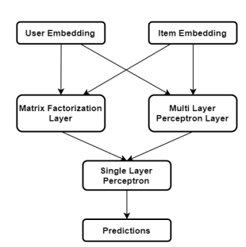
Figure 5: The illustration of the proposed model [25].
Xiangnan proposed a neural network approach for collaborative filtering [26]. In the proposed approach, they replaced the inner product of Matrix Factorization with a neural network architecture that can learn an arbitrary function from the data. Multiple layers were introduced in this research. The first layer maps the embeddings of users and items to learn more features about both entities to find a powerful relationship. Moreover, neural collaborative filtering layers are used to find the most promising relationships between the entities and prediction. The workflow of this method is illustrated in the figure below.
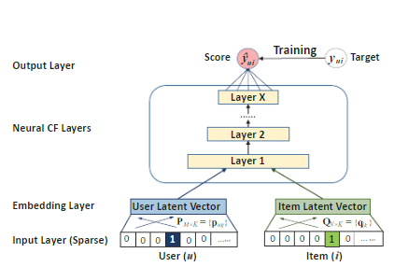
Figure 6: Illustration of the proposed model [26].

The Hybrid Approaches
Wide and diverse techniques have been used for the recommendation systems such as collaborative filtering, content-based filtering, etc. These techniques have been blended and used for better prediction and recommendation purposes. These hybrid techniques can be designed by a mixture of two or more techniques. These hybrid approaches can be used in different ways [5].
- Individual implementation of collaborative and content-based approaches and aggregating their outcome.
- Integration of some characters from one approach with another approach.

Weighted Approach
In this approach, the weight of the recommended item is calculated by applying all available approaches and aggerating the score. Mostly, additive aggregation is used to normalize the weight.

Mixed Approach
Different recommendation approaches recommend a different item for a user. This hybrid approach merges all those recommendations and recommends it to the user. This technique is very useful for the cold-start problem.

Link Prediction Techniques
Nowadays, the complexity of networks is increasing and it is hard to mine appropriate information from the network. For example, take an example of recommendation systems for Twitter or Facebook, the basic aim for these applications is to recommend preferred tweets and content for every user. Many online e-commerce applications and companies need to mine information according to the user’s preferences. It is very important to mine the appropriate information for these applications [8]. The main challenge is to represent a network into a low dimension. There are different techniques to overcome this problem. The main and basic challenges are the following.
- High non-linearity
- Structural preserving
- Sparsity
- Cold start
Daixin Wang et al. proposed the implementation of structural Deep Network Embedding (SDNE) to capture the high non-linear network structure [9]. This research proposed the semi-supervised deep learning model consists of multiple layers of non-linear functions to capture the high non-linearity of the network. Moreover, first and second-order proximity was used to preserve the network structure.
Carl Yang et al. proposed similarity modeling on heterogeneous networks via automatic path discovery to overcome meta-paths limited path problems [11]. In this work, the purpose was to properly model node similarity in terms of content-rich heterogeneous networks. For pairs of nodes, automatic path discovery was proposed for both structural and content information.
Chuan Shi et al. proposed another approach for heterogenous network embedding for HIN based recommendations called HERec [12]. To achieve meaningful node sequences for network a meta-path based random walk strategy is implemented. The node embeddings are transformed by a set of fusion functions and then integrated with matrix factorization (MF).

CHAPTER THREE

Preliminaries
In this chapter, we will introduce the background of user-items interaction in multiple studies using techniques such as decision trees, support vector machines, collaborative filtering, matrix factorization, and other link analysis techniques.

3.1 Decision Trees
The decision tree is based on the methodology of tree graphs which are constructed on training examples. There are known class labels for which analysis is done on training data, then it is applied on the unseen examples to classify the given item.
The decision tree forms are predictive models based on the input attributes and they predict a value. Each node in the tree corresponds to an attribute and the edge from parent to child node corresponds to the value of that attribute. The construction of the tree starts with the root node and the input data. An attribute is assigned to each node and edge as the tree grows according to the given input. The given input data is then split by the appropriate values so that each child node should get the appropriate value specified by the corresponding edge. This process is repeated recursively until there is no feasible splitting required according to the given input. The following figure illustrates the simple example of a decision tree.
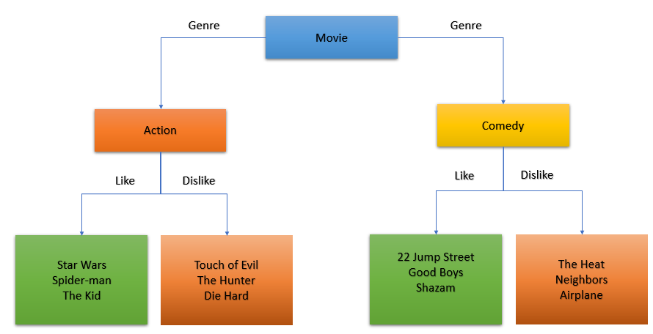
Figure 7: Example of Decision Tree

3.2 Random Forests
It’s a supervised learning method for classification and regression. It operates by constructing the multiple decision trees at training time and gives them out in the mode of classes (Classification) or mean prediction in case of (Regression) of the individual trees. In general, the more trees in the forest the better the robustness. It calculates the positive and negative predictions for a given item to be predicted. The decision depends upon the more values achieved by the algorithms by some set of rules or taking the average of results achieved. The following figures illustrate the behavior of a random forest algorithm.

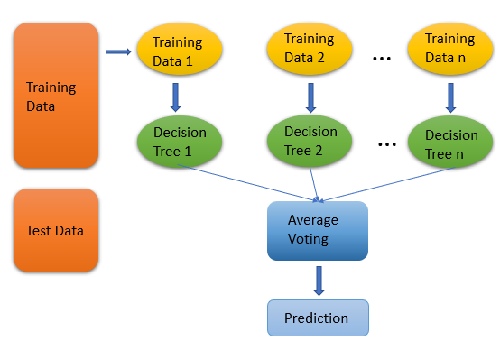
Figure 8: Illustration of Random Forest.

3.3 Support Vector Regression (SVR)
It is a machine learning algorithm used for regression problems. SVR is a little different from other regression techniques. In other regression techniques, the main goal is to minimize the sum of the squared error while in SVR, the goal is to fit the error in a certain threshold. The following are the fundamental parameters for the SVR.

Kernel
It is the function that is used to map one-dimensional data into high dimensional data.

Hyper Plane
It is the separation line between the data classes. The data points are aligned according to this line.

Boundary Lines
These are two different lines distant from hyperplane which creates a margin of error between the data points in the model. The support vectors can be within the boundary lines or outside these lines.

Support Vectors
These are the data points that are distributed across the hyperplane and boundary lines.
The following figure illustrates the example of SVR with boundary lines and data points scattered across hyperplane.

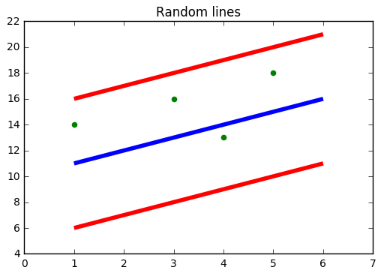
Figure 9: Illustration of SVR.
The red lines are the boundary lines, green dots are the data points and the blue line is the hyperplane. The main objective is to find the best fit line which contains the maximum number of data points.
Let’s say $ε$ is the distance of boundary lines from the hyperplane by assuming that hyperplane is a straight line going through $Y-axis$. Let’s say the equation of hyperplane is the following:
$$wx+b=0$$
Therefore, according to the above equation, we can say that the two-equation of boundary lines are the following:
$$wx+b=+ε$$
$$wx+b=-ε$$
Thus, for any linear hyperplane, the equation which satisfies SVR is:
-$ε ≤y-Wx-b≤+ε$

3.4 Clustering
Clustering techniques are used in multiple domains such as image processing, pattern recognition, and statistical analysis, etc. Moreover, clustering algorithms try to partition the data into sub-clusters to achieve meaningful groups with the highest similarity. Once the clusters are formed then the new user can be predicted according to the relevant cluster which contains similar users [7]. The illustration of clusters is given in the following figure.

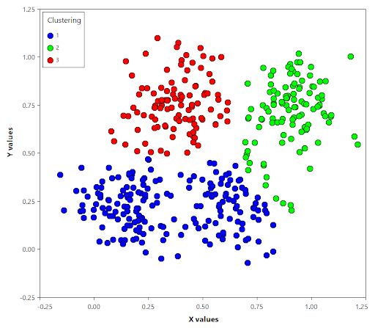
Figure 10: Illustration of Clustering.

3.5 Artificial Neural Networks
Artificial neural networks are used extensively in the field of computer vision, classification, image processing, etc. ANNs are inspired by the human mind which contains neurons. These neurons are responsible for receiving the input from outside, processing it, and giving output about a particular action. In the previous decade, researchers developed these artificial neural networks to process the data for classification and regression problems. ANNs contain layers of neurons that are connected in a symmetry. The connection between neurons has some weights to minimize the error. The ANN is robust and extensively used for the estimation of nonlinear functions and capturing complex relationships between the entities [36]. The following figure illustrates the single layer of a neural network.
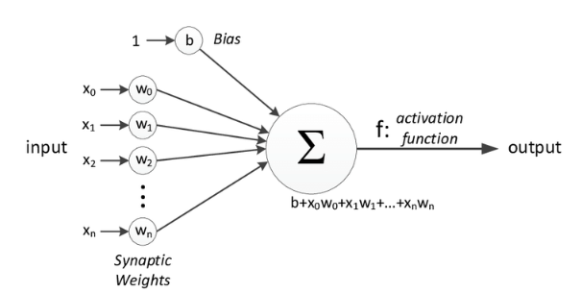
Figure 11: Illustration of a single-neuron layer.
In the figure above, the inputs $x_{0}, x_{1}, x_{2}, ... {,x}_{n}$ are given to the neural networks. The input layer can be composed of multiple neurons depending upon the input size. The weights $w_{0}, w_{1}, w_{2} ,…,w_{n}$ shows the strength of the particular node and $b$ is the bias which allows the control of the activation function. The purpose of the activation function is to decide whether the neuron should be activated or not after calculating the weighing sum and adding the bias value to it. In ANNs multiple activation functions are used such as sigmoid, hyperbolic, and ReLU (Rectified Linear Units).
The training process of ANNs includes forward propagation and backward propagation to minimize the cost function. Every neural network layer gives output to the next layer and the cost function is calculated. The main goal of the neural network is to minimize the cost function. The cost function is the difference between the actual value and the predicted value by the network. The resulting data is fed again and again to the neural network to minimize the cost function and this process is called backpropagation. The figure below illustrates the concept of the forward propagation and backpropagation.
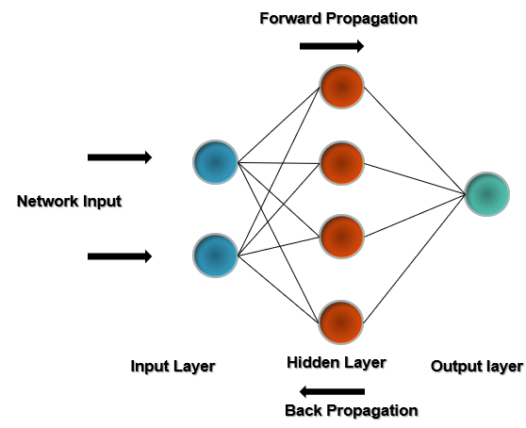
Figure 12: Illustration of forward and backpropagation in ANNs.

3.6 Collaborative Filtering
For $M$ items and $K$ users, the profile of the users is represented in a $K$ x $M$ user-item matrix $X$. Each entry in the matrix $X$ such as $X_{k,m}=r$ indicates that user $k$ rated item $m$ by $r$, where $r ∈\{1,…,\left|r\right|\}$ if the item has been rated, and $X_{k,m}= ∅$ means that the rating for the movie is unknown for a specific user. The user-item matrix can be decomposed into vectors of rows: $X={\left[U_{1},…{,U}_{k}\right]}^{T}$, $u_{k}={\left[X_{k,1},...{,X}_{k,m}\right]}^{T}$, $k=1,…,k$. where $T$ denotes the transpose of the given matrix. Given each row factor $u_{\begin{aligned}k,t \\ \end{aligned}}$ corresponds to a user profile and represents a rating of an item for a particular user.

3.7 Matrix Factorization
Recently, in the user-item factorization models are based on Matrix Factorization. The rating matrix $R$ is the approximation of the dot product of two matrices $P and Q$, where $P ∈ R^{n x k}$ is the user latent matrix and $Q ∈ R^{m x k}$ is the item latent matrix, where $k$ is the total number of latent factors and $k≪n,m$. The prediction score of user $u$ and item $i$is predicted as follows:
 | $$\hat{r_{ui}}=p_{u}q_{i}^{T}$$ | (11)
where $p_{u}$ is the latent vector associated with the user $u$ and $q_{i}$ is the latent vector associated with the item $i$.

3.8 Heterogeneous information network and embeddings
A heterogeneous information network is a form of a graph, which contains sets of nodes and edges. The set of nodes and edges in such networks consist of multiple types. The following graph illustrates the heterogenous information network.
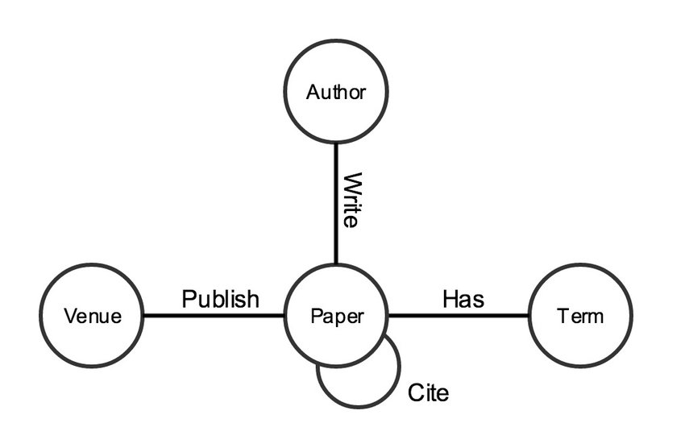
Figure 13: An example of a heterogeneous network.
The HIN use embeddings to project the nodes and edges into a low dimensional vector space. The purpose of HIN embedding is to learn a mapping function for each node in a low-dimensional space by preserving the properties of original network.

CHAPTER FOUR

The proposed approach
This chapter describes the proposed approaches which are conducted for this research. Firstly, the description of the dataset is discussed in detail. It includes the file structures of different files present in the dataset. Further, different analyses have been described to better understand the data. Furthermore, primitive approaches are described in detail. Later in the chapter, different machine learning and deep learning techniques are discussed.

4.1. Dataset Description
The dataset used for this research is titled as “MovieLens” [17]. It has been collected over multiple times of duration and contains 25 million entries of ratings of movies rated by users. It includes over 62,000 movies and 162,000 users. Users have been selected randomly and every user has rated at least 20 movies. Each user and movie are represented by userId and movieId. It includes the following files listed below.
- ratings.csv
- movies.csv
- tags.csv
- links.csv

User Ids
User ids are randomly selected in the dataset and ids are anonymous. User ids are same and consistent across all the files.

Movie Ids
A unique Movie id is assigned for each movie and only those movies are attached in the dataset which is rated by at least one user. Moreover, Movie ids are consistent across all the files.

4.1.1. Data files structure
In this section, a detailed description of different data files is given. Multiple files contain information for the users and movies.

Ratings Data File Structure (ratings.csv)
The ratings given by all the users are in the ratings.csv file. Each entry in this file represents the rating of the specific movie given by a specific user. The format of this file is given below with an example:

userId | movieId | Rating | timestamp
1 | 296 | 5 | 1.15E+09
1 | 306 | 3.5 | 1.15E+09
1 | 307 | 5 | 1.15E+09

Table 1: Ratings data file format.
The data in this file is ordered by userId. The scale of ratings is from (0.5 stars – 5 stars). The minimum rating for any movie is at least 0.5. The timestamp column represents the time of given ratings in seconds since the midnight Coordinated Universal Time (UTC).

Tags Data File Structure (tags.csv)
This file contains the tags created by the users. Tags are the metadata of the movies generated by users. All the tags given by the user comprises of a single word or single phrase. Each user knows the actual meaning of his tags. The file has the following format.

userId | movieId | Tag | Timestamp
3 | 260 | Classic | 1.44E+09
3 | 260 | Sci-fi | 1.44E+09
4 | 1732 | Dark comedy | 1.57E+09

Table 2: Tags data file format.
The data in this file are ordered by userId. The timestamp represents the seconds since the midnight Coordinated Universal Time (UTC).

Movies Data File Structure (movies.csv)
The information about all the movies is given in this file. Movies titles are imported from [18] and include release year of the movies. The file has the following format.
movieId | Title | genres
1625 | The Game (1997) | Drama | Mystery | Thriller
1645 | The Devil’s Advocate (1997) | Drama | Mystery | Thriller
1653 | Gattaca (1997) | Drama | Sci-Fi | Thriller

Table 3: Movies data file format.
There are total of 17 genres in this file. Genres are selected from the following list.
- Action
- Adventure
- Animation
- Children's
- Comedy
- Crime
- Documentary
- Drama
- Fantasy
- Film-Noir
- Horror
- Musical
- Mystery
- Romance
- Sci-Fi
- Thriller
- War
- Western
- (no genres listed)

Links Data File Structure (links.csv)
This file includes different ids that can be used to link these movies to other sources and has the following format.
movieId | IMDb Id | tmdb Id
1 | 114709 | 862
2 | 113497 | 8844
3 | 113228 | 15602

Table 4: Links data file format.
- movieId is an identifier used by movielens organization [17].
- ImdbId is an identifier used by IMDb [19].
- tmdbId is an identifier used by TMDB (The Movie Data Base) [18].

4.1.2. Data Set for Proposed Research
For convenience, we have merged all the necessary information into a single file to conduct this research. The data is consistent through all the rows and columns. The following columns are included in our dataset for analysis.
- UserId: The unique id of users who rated the movies.
- MovieId: The unique movie ids.
- Title: The title of the movie.
- Year: The release year of a specific movie.
- Genre: The category of the movie (i.e.) Action, Comedy, etc.
- Rating: The rating out of 5 which users rated the specific movie.
- Timestamp: The date at which the user rated the specific movie.
- ImdbId: The id for the same movies generated by IMDb sources.
- IMDb rating: The rating is the average ratings of a specific movie and the scale of the rating is (0 – 10 stars).
The combined data file illustration is given below in the table.
UserId | movieId | rating | title | year | genres | ImdbId | Imdb rating
1 | 3 | 4 | Grumpier Old Men | 1995 | Comedy | Romance | 114709 | 6.5
1 | 6 | 4 | Heat | 1995 | Action | Crime | Thriller | 113277 | 8.3
1 | 47 | 5 | Seven | 1995 | Mystery | Thriller | 114369 | 8.7
1 | 50 | 5 | The Usual Suspects | 1995 | Crime | Mystery | Thriller | 114814 | 8.7

Table 5: Proposed method data file format.

Data for the Processing (Subset of Data)
The total dataset consists of 25 million rating entries. For our initial analysis, a small dataset of Movielens 100K entries is used. This dataset was obtained from [17] and it is consistent. On the other hand, for machine learning approaches such as Support Vector Regression, Decision Trees, and Random Forest, another subset of 25M entries dataset is used in which this subset consists of the 1st one million and the 2nd one million entries approximately [37]. We have tested the above-mentioned approaches on both of these sub-datasets. Moreover, the results mentioned in the respective approaches belong to the 2nd one million entries of the original dataset of 25M entries. The subset of the data is sequential and consistent throughout the implementation. The results for both of these subsets of the data were almost the same.
A similar dataset is used for approaches such as Collaborative Filtering, Matrix Factorization, and Artificial Neural Networks. The results obtained in this research from these approaches were also obtained by the 2nd one million entries of the original dataset.

4.1.3. Analysis of Dataset
In this part of the chapter, multiple analyses have been conducted to better understand the data for learning purposes.

The number of movies each year
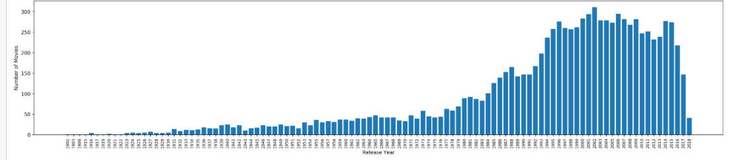
The dataset contains movies from the year 1902-2018. There are a different number of movies released in different years. In the graph below, we can determine easily which year was more productive in releasing the total number of movies.
Figure 14: Number of movies each year.

Popular Genre in every year
The popularity of the genre is considered based on the number of movies released in a specific year for a specific genre. In the dataset, some movies belong to more than one genre so, we have considered those movies in every mentioned genre. In the graph below, every popular genre is mentioned in every year.
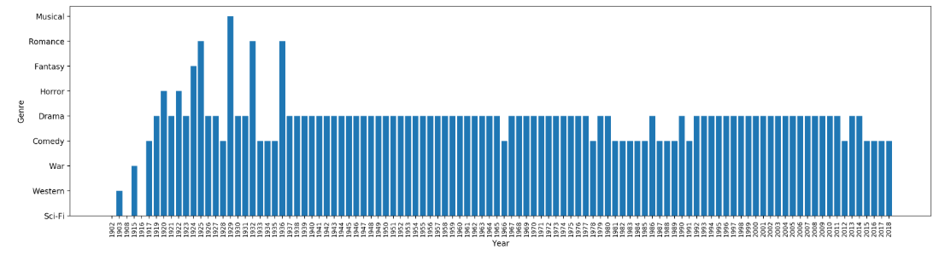
Figure 15: Popular Genre in each year.
The above figure illustrates that people always have loved drama movies in previous decades. If we look at recent years it is obvious that producers are making comedy movies. These trends show that drama and comedy movies were always popular among users. These trends help to recommend items to the users in the cold-start problem.

Best years for each Genre
The popularity of the genre is considered based on ratings given by each user to each movie. Afterward, the mean of all given ratings for each genre movie was calculated. The highest mean value of ratings indicates that the specific genre was popular in that specific year. As in the dataset, one movie belongs to multiple genres, so we have considered that movie in every genre. In the graph below, every popular genre is illustrated for every year.
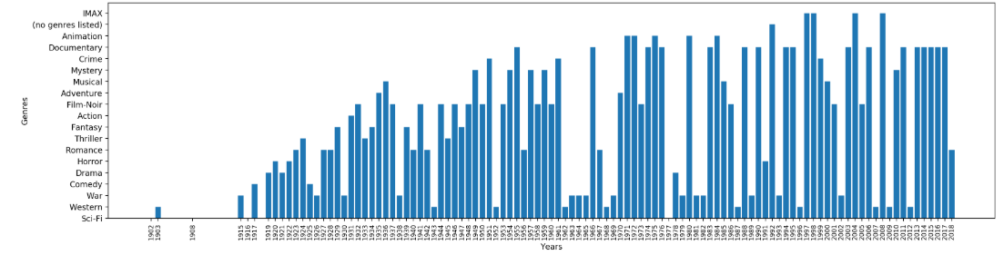
Figure 16: Best years for each genre

4.2. Primitive Approaches
In this section, different primitive approaches are described to achieve the similarity index between the users, based on common movies. The goal is to achieve maximum positive prediction for a user movie rating. During the time of research, multiple approaches were considered to achieve better results. Further below, we will discuss all the primitive approaches that were applied to this dataset for a better understanding of the data.

4.2.1First Approach
In this scenario, we are predicting the similarity between different users with respect to different random movies. Our goal is to achieve the maximum similarity between the users based on movie ratings. For this purpose, we assume the following approach.
- Pick two random movies $M_{1} and M_{2}$.
- Determine the corresponding common users for these two movies.
- If the number of such users is not at least 3, then go back to step (1).
- Otherwise, take 3 common users.
- Use their ratings to determine similar behaviors.
Let’s say for $M_{1}$ the users are $A, B, and C$ with corresponding ratings $r_{A}, r_{B} and r_{C}$, respectively. Similarly, for $M_{2}$ the same users $A, B, and C$ have the corresponding ratings $r_{A1}, r_{B1} and 1$, respectively. For each movie and set of users, assign $1$ $if \left|r_{A}-r_{B}\right|≤ \left|r_{B}-r_{C}\right| and (|r_{A1}-r_{B1}| ≤ |r_{B1}-r_{C1}|)$ and $0$ otherwise. Then, compare these assigned numbers for $M_{1} and M_{2}$. Then, count the positive cases and negative cases according to the mentioned approach.

4.2.2 Second Approach
In this scenario, we predict the similarities between two users with respect to different random movies. Our goal is to achieve the maximum similarity between the users on the ratings of movies. For this purpose, we assume the following approach.
- Take two random users $A and B$.
- Find all common movies for them.
- Take the difference of ratings between these two users for $M_{1}$, call it as $D_{AB}^{1}$.
- Take the average difference of ratings between these two users for $M_{1}$and $M_{2}$.
- Take the average of differences between the rating for $n-1$ movies.
- Compare the last movie rating difference with the average difference between two users for all movies.
Let’s say for $M_{1}$ the users are $A and B$ with corresponding ratings $r_{A} and r_{B}$, respectively. Similarly, for$M_{2}$, same users $A and B$ have the corresponding ratings $r_{A1} and r_{B1},$ respectively. The difference between $r_{A}-r_{B}$is called $D_{AB}^{1}$ and the last common movie is$D_{AB}^{n}$, respectively and the average difference between two users across all movies is $Avg (D_{AB}^{n-1})$. If the difference of last common movie $D_{AB}^{n}$ between $A and B$ is somewhere between $0 ≤D_{AB}^{n} ≤ Avg (D_{AB}^{n-1}).$ Then, take it as a positive case, otherwise negative.

4.2.3 Third Approach
In this scenario, we predict the similarities between two users with respect to multiple random movies$(k=1,2,3,…,10)$. Our goal is to achieve maximum similarity between the users on the ratings of movies as we increase the number of common movies between the two users $(k= 1,2,…,10)$. For this purpose, we assume the following approach.
- Take two users A and B with common movies.
- Look at their difference of ratings for $M_{1}$, call it $D_{AB}^{1}$.
- Look at their difference of ratings for $M_{2}$, call it $D_{AB}^{2}$.
- Look at their difference of ratings for $M_{3}$, call it $D_{AB}^{3}$.
- Then if their difference of ratings for $M_{4}$ is somewhere between $0 ≤D_{AB}^{4} ≤ Avg \left(D_{AB}^{1,2,3}\right)$ count it as a positive, otherwise negative.
Let’s say for $M_{1}$ the users are $A and B$ with corresponding ratings $r_{A}, r_{B}$ respectively. Similarly, for $M_{2}$ the same users $A and B$ have the corresponding ratings $r_{A1}, r_{B1}$respectively. The difference between $r_{A}-r_{B}$is called $D_{AB}^{1}$ and the last common movie is $D_{AB}^{k}$ respectively and the average difference between two users across all movies is $Avg (D_{AB}^{k-1})$. If the difference of last common movie $D_{AB}^{k}$ between $A and B$ is somewhere between $0 <=D_{AB}^{k} <= Avg (D_{AB}^{k-1}).$ Then take it as a positive case, otherwise negative. The concept here is by increasing the number of common movies between them we can achieve more positive predictions.

4.2.4 Fourth Approach
In this scenario, we predict the similarities between two random users with respect to different common movies within range of k, where$(k=1,2,3,…,10)$. The concept here is to increase the number of movies in every iteration. Furthermore, a specific genre is selected to maximize the similarities between two users based on the given information in the above-mentioned combined dataset. As the data is heterogeneous, the goal is to achieve better results by including useful and necessary information. The main purpose is to achieve maximum similarity between the users on the ratings of movies. For this purpose, we assume the following approach.
- Take two users A, B with different number of common movies. In this particular scenario common movies belong to the same genre.
- Look at their difference of ratings for $M_{1}$, call it $D_{AB}^{1}$.
- Look at their difference of ratings for $M_{2}$, call it $D_{AB}^{2}$.
- Look at their difference of ratings for $M_{3}$, call it $D_{AB}^{3}$.
- Then if their difference of ratings for $M_{4}$ is somewhere between $0 ≤D_{AB}^{4} ≤ Avg \left(D_{AB}^{1,2,3}\right)$ count it as a positive, otherwise negative.
Let’s say for $M_{1}$ the users are $A and B$ with corresponding ratings $r_{A}, r_{B}$ respectively. Similarly, for $M_{2}$ the same users $A and B$ have the corresponding ratings $r_{A1}, r_{B1}$ respectively. The difference between $r_{A}-r_{B}$is called $D_{AB}^{1}$ and the last common movie is $D_{AB}^{k}$ respectively and the average difference between two users across all movies is $Avg (D_{AB}^{k-1})$. If the difference of last common movie $D_{AB}^{k}$ between $A and B$ is somewhere between $0 ≤D_{AB}^{k} ≤ Avg (D_{AB}^{k-1}).$ Then, take it as a positive case, otherwise negative. The concept here is by increasing the number of common movies between them we can achieve more positive predictions.

4.2.5 Fifth Approach (Inclusion of IMDb ratings)
In this particular approach, the IMDb ratings are included in the original dataset. The key concept is to compare user ratings with IMDb ratings. The IMDb ratings are rated from the scale of 1 star to 10 stars [19]. These ratings are given by the users on the IMDb platform. These ratings are the average ratings for a specific movie. The original dataset rating scale is (1-5 star) and the IMDb rating scale is (1-10 star). It is necessary to normalize the original ratings with IMDb ratings. After including IMDb ratings and normalizing the original data is illustrated in the table below.

userId | movieId | rating | Imdb rating | title | genres | Imdb Id
2 | 318 | 6 | 9.3 | Shawshank redemption | Crime | Drama | 111161
2 | 106782 | 10 | 8.4 | The wolf of wall street | Comedy | Crime | Drama | 993846
2 | 89774 | 10 | 8.3 | Warrior | Drama | 1345836

Table 6: Fifth approach file format.

Average Users
The concept of average users originates with a comparison of user original rating and IMDb rating. To decide whether the user is average or non-average, the dataset is tested on multiple values for optimization.

Non-Average Users
The non-average users’ ratings are different from overall IMDb ratings of the movies given by the users. These users contain different behavior while rating the movies.

Criteria
The criteria is selected in such a way that it includes at least 10% of the total users in average users. Average users are selected according to the following criteria.
- The difference between user rating and IMDb rating should be $≤$ 1.5. For example, the user $A$ has rated k many movies. We calculate the difference of movies$M_{1},M_{2},…{,M}_{k}$ rated by user $A$ with respect to IMDb ratings such that$r_{A→M_{1} }- r_{imdb→M_{1}} ≤1.5$.
- The number of movies satisfying the above criteria should be at least 80%.
- All the users who are not satisfying the above two criteria belong to non-average people.
Below, the figures illustrate the number of people changing with the number similarity percentage. As we increase the similarity percentage from ($10,…,100)$ the number of users is decreasing as expected for the specific difference mentioned above.
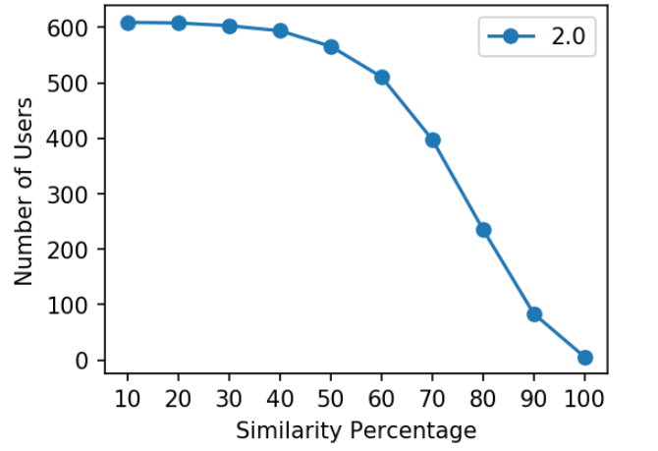 | 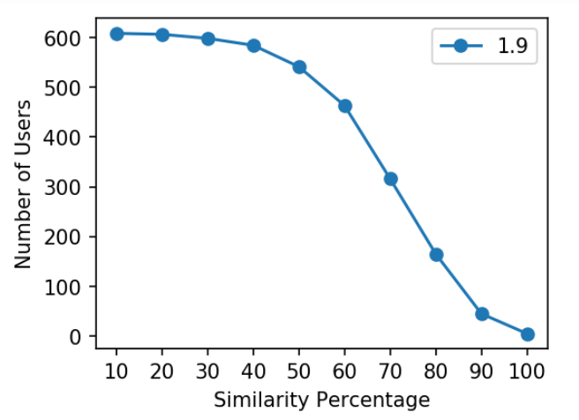
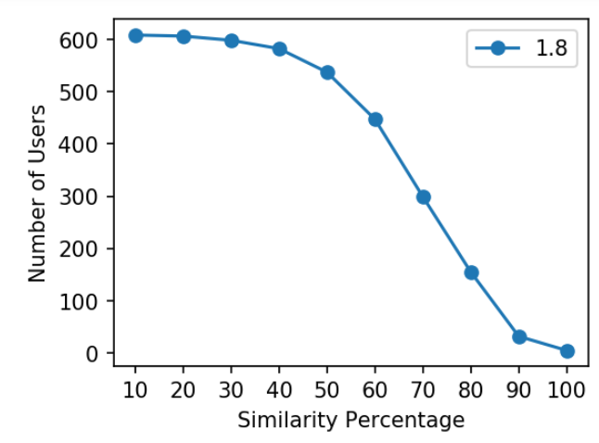 | 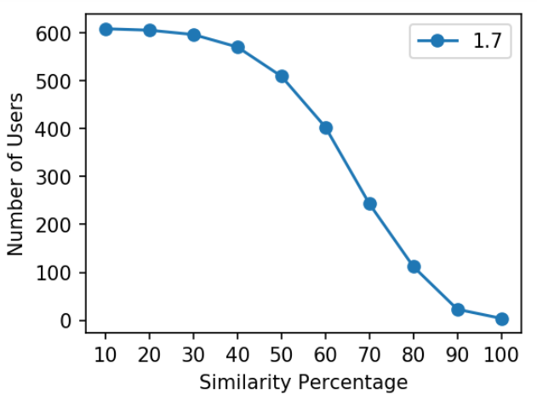
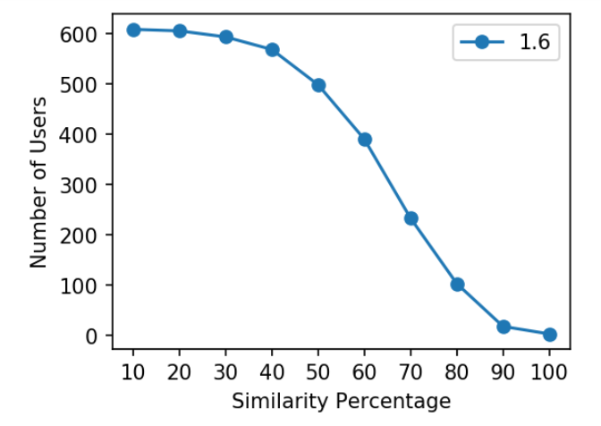 | 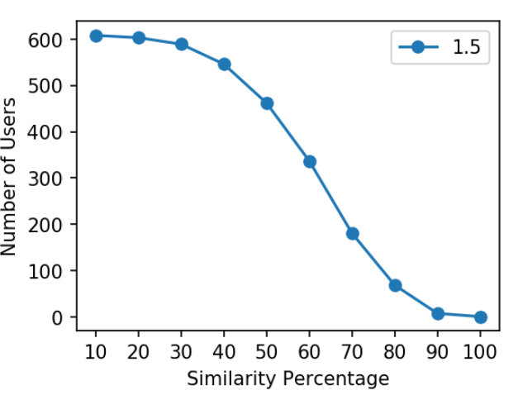
Figure 17: Similarity percentage between different values.
- Take two random users $A$ and $B$ from the set of average and non-average people separately in different intervals $(i.e.$ $I_{90-100}, I_{80-90},…,I_{0-10})$.
- Take $k$ common movies$(i.e. M_{1}, M_{2}, M_{3},M_{4},…,M_{k})$.
- Look at their difference of ratings for $M_{1}$, call it as $D_{AB}^{1}$.
- Look at their difference of ratings for $M_{2}$, call it as $D_{AB}^{2}$.
- Look at their difference of ratings for $M_{k-1},$ call it as $D_{AB}^{k-1}$.
- Then if their difference of ratings for $M_{k}$ is somewhere between $0 ≤D_{AB}^{k} ≤ Avg \left(D_{AB}^{1,2,…,k-1}\right)$ count it as a positive, otherwise negative.
Let’s say for $M_{1}$ the users are $A and B$ with corresponding ratings $r_{A}, r_{B}$ respectively. Similarly, for $M_{2}$ the same users $A and B$ have the corresponding ratings $r_{AA}, r_{BB}$ respectively. The difference between $r_{A}-r_{B}$is called $D_{AB}^{1}$ and the last common movie is $D_{AB}^{k}$ respectively and the average difference between two users across all movies is $Avg (D_{AB}^{k-1})$. If the difference of last common movie $D_{AB}^{k}$ between $A and B$ is somewhere between $0 ≤D_{AB}^{k} ≤ Avg (D_{AB}^{k-1}).$ Then, take it as a positive case, otherwise negative. Repeat this process for each interval.

4.2.6 Sixth Approach
This approach is similar to the above (fifth approach) but the genre is included. The ideology remains the same that by including more information better results can be achieved. The results of some main genres are included below.
- Take two random users $A$ and $B$ from the set of average and non-average people at different intervals $(i.e.$ $I_{90-100}, I_{80-90},…,I_{0-10})$ with one genre (i.e. Action, Comedy, Drama, etc.).
- Take $k$ common movies $(i.e. M_{1}, M_{2}, M_{3},M_{4},…,M_{k})$.
- Look at their difference of ratings for $M_{1}$, call it as $D_{AB}^{1}$.
- Look at their difference of ratings for $M_{2}$ call it as $D_{AB}^{2}$.
- Look at their difference of ratings for $M_{k-1}$ call it as $D_{AB}^{k-1}$.
- Then if their difference of ratings for $M_{k}$ is somewhere between $0 ≤D_{AB}^{k} ≤ Avg \left(D_{AB}^{1,2,…,k-1}\right)$ count it as a positive otherwise negative.
Let’s say for $M_{1}$ the users are $A and B$ with corresponding ratings $r_{A}, r_{B}$ respectively. Similarly, for $M_{2}$ the same users $A and B$ have the corresponding ratings $r_{AA}, r_{BB}$ respectively. The difference between $r_{A}-r_{B}$is called $D_{AB}^{1}$ and the last common movie is $D_{AB}^{k}$ respectively and the average difference between two users across all movies is $Avg (D_{AB}^{k-1})$. If the difference of last common movie $D_{AB}^{k}$ between $A and B$ is somewhere between $0 ≤D_{AB}^{k} ≤ Avg (D_{AB}^{k-1}).$ Then, take it as a positive case, otherwise negative. Repeat this process for each interval.
The implementation of all the above primitive approaches shows that better results can be achieved by filtering the data. Moreover, the results indicate that it is very hard to achieve accuracy by more than 60% in any above-mentioned approaches.
In the next section, multiple machine learning methods are implemented to achieve better results. We will compare the results of our approach to other approaches.

4.3. Machine Learning Methods
In this section, we will discuss different machine learning methods implemented in the dataset. As mentioned in the above section the dataset is divided into two categories: Average users and Non-average users. We implement different machine learning algorithms on both average and non-average users.
We apply three machine learning algorithms for testing purposes.
- Decision Trees
- Random Forest
- Support Vector Regression (SVR)
We then calculate Mean Square Error as well as Mean Absolute Error as an evaluation matrix.
Decision trees have been used in recommender systems as a model-based approach. Decision trees work on the parent-child node methodology for decision making. We implement this methodology for both average and non-average users for each difference$(i.e. 2.0 – 1.5$) between user rating and IMDb ratings. From the dataset, 70% of the dataset is used for training the model and 30% of the data is applied for testing purposes. We compute both MSE and MAE for model evaluation.
Random forest is a supervised machine learning algorithm that is used for classification and regression problems. In this research, the implementation of random forest is applied both on average and non-average users as mentioned in the earlier section. From the dataset, 70% of the dataset is used for training the model and 30% of the data is applied for testing purposes. A total of 300 estimators are used for the model evaluation. Moreover, Mean Absolute Error and Mean Squared Error is calculated for the accuracy of the model.
SVR is a machine learning algorithm used for regression problems. SVR is a little different from other regression techniques. In other regression techniques, the main goal is to minimize the sum of the squared error while in SVR, the goal is to fit the error in a certain threshold. A total of 70% dataset is used for training purposes and 30% of the data is used for testing purposes. To evaluate the model, Mean Absolute Error and Mean Squared Error metrics are used.

4.4. Collaborative Filtering
In this section, we discuss the implementation of collaborative filtering methods applied to the dataset. Collaborative filtering has been very popular in the e-commerce market and the results obtained are competitive with advanced methods such as neural networks, etc. In this methodology, user-based collaborative filtering is considered. It is a technique that filters the items for users with respect to the behaviors of the user. It works by searching the large set of users from the database and find a smaller set of users who have similar behaviors towards items.
This methodology personalizes the score for each user with respect to each given item. Firstly, we have to calculate the average rating of a specific item given by all users. The average rating will help to calculate the deviation of the user rating from the average rating of a specific item. The average rating $s\left(j\right)$ of an item is calculated as follows:
 | $$s\left(j\right)=\sum_{i∈Ω_{j}}{r_{ij}}$$ | (12)

where $Ω_{j}$ set of all users who rated movie $j$ and $r_{ij}$ is the rating that the user $i$ rated the item $j$. User can rate multiple items so we have to personalize the score of each item for a specific user $s\left(i,j\right)$as follows:
 | $$s\left(i,j\right)=\frac{\sum_{i∈Ω_{j}}{r_{i^{'}j}}}{|Ω_{j}|}$$ | (13)
where $s(i,j)$ is dependent on both user $i$ and item $j$, $r_{i^{'}j}$ is the rating user $i$ rated to item $j$, $i=1,…,N,$ and $j=1,…,M$. Our rating matrix $R_{N x M}$ is a user-item rating matrix of size $N x M$. Afterward, we have to calculate the predicted rating for item $j$ which is not rated by user $i$. As we are dealing with a real number then our objective is to calculate Mean Squared Error.
 | $$MSE=\frac{1}{|Ω|}+\sum_{i,j∈Ω}{\left(r_{ij}-\hat{r_{ij}}\right)}$$ | (14)

where $r_{ij}$ is the original rating and$\hat{{ r}_{ij}}$ is the predicted rating of the specific movie.

The above approach has a problem with the average rating as it treats every user rating equally. For example, user $A$ rating $s(i, j)$ equally depends on user $B$ and user $C$ even though user $A$ doesn’t agree with both of the users $B and C$ ($i.e.$ user $A$ didn’t like the specific movie $j$ and user $B$ and $C$ liked). Moreover, user $A$ interpretation can be different from user $B$ in rating the movies. For example, user $A$ rated 5 for liked movies and 3 for unliked movies. Whereas, user $B$ rated 4 for liked movies and 1 or 2 for unliked movies.

The above problem can be minimized by introducing weights. For example, if user $A$ does not agree with other users for item $j$ then the weight will be small otherwise large. It means that we should not care about the absolute rating but we should consider how much user $A$ deviates from its average rating. For example, if the user $A$ average rating is 2.5 and his rating for item $j$ is 4, it means he likes that item. We can calculate the deviation $dev \left(i,j\right)$ for a specific item as follows:
 | $$dev \left(i,j\right)=r\left(i,j\right)- \hat{r_{i}}$$ | (15)
where $r\left(i,j\right)$ is the original rating given by the user and $\hat{r_{i}}$ is the average rating of the user.
Further, we can calculate the average deviation of all users for specific movie $j$ as $\hat{dev}\left(i,j\right)$ . This will give us the prediction deviation of the specific movie $j$:
 | $$\hat{dev}\left(i,j\right) = \frac{1}{|Ω_{j}|}+\sum_{i^{'}∈Ω}{r\left(i^{'},j\right)-{\overline{r}}_{i^{'}}}$$ | (16)

where ${\overline{r}}_{i^{'}}$ is the average rating of every user. Afterward, predicted rating for item $j$ can be calculated by adding user $i$ average rating and average deviation for item $j$ as follows:
 | $$s\left(i,j\right)={\overline{r}}_{i^{'}}+\frac{\sum_{i^{'}∈Ω_{j}}{r(i^{'},j)-{\overline{r}}_{i^{'}}}}{|Ω_{j}|}= {\overline{r}}_{i^{'}}+\hat{dev}\left(i,j\right)$$ | (17)
Furthermore, we can add this idea of deviations with the idea of weighting to our approach by taking the absolute value of weights as it can be negative.
 | $$s\left(i,j\right)= {\overline{r}}_{i^{'}} + \frac{\sum_{i^{'}∈Ω}{w_{ii^{'}}\left\{ {\overline{r}}_{i^{'}j}- {\overline{r}}_{i^{'}}\right\}}}{\sum_{i^{'}∈Ω}{|w_{ii^{'}}|}}$$ | (18)
The weights can be calculated using the Pearson Correlation Coefficient defined as follows:
 | $$w_{ii^{'}}=\frac{\sum_{j∈ψ_{ii^{'}}}{\left(r_{ij}- {\overline{r}}_{i}\right)\left(r_{i^{'}j}- {\overline{r}}_{i^{'}}\right)}}{\sqrt{\sum_{j∈ψ_{i}}{{\left(r_{ij} - {\overline{r}}_{i}\right)}^{2}}}\sqrt{\sum_{j∈ψ_{i^{'}}}{{\left(r_{i^{'}j} - {\overline{r}}_{i^{'}}\right)}^{2}}}}$$ | (19)
where $ψ_{i}$ is the set of movies that user $i$ has rated, $ψ_{ii^{'}}$ is the set of movies both user $i$ and $i^{'}$ have rated the item meaning that $ψ_{ii^{'}}= ψ_{i} ∩ ψ_{i^{'}}$. Moreover, to find the correlation between users 30 neighbors have been considered.

4.5. Matrix Factorization
Matrix factorization belongs to the collaborative class algorithm family which is extensively used in recommender systems. It decomposes the user-item interaction matrix into the product of lower dimensionality matrices. Matrix factorization model maps both user and items to a combined latent factor space $f$ in such a way that user-item interactions are modeled as inner products of that space [21]. In user-item interaction, matrix rows represent each user, and columns represent each item. It is obvious that sparsity will increase as the number of items increase in the database (i.e. The matrix will be filled with zeros as one user can’t interact with all items in the real scenario).
The matrix factorization is a highly successful model as it contains implicit feedback, the information which is not directly given by the user towards the item but it can be derived by analyzing the behavior of the user towards the items by utilizing user-item interaction matrix. This technique is useful for the estimation or prediction of user ratings towards any specific item.
Accordingly, each item $i$ associated with a vector $m_{i} ϵ R^{f},$and each user $u$ is associated with a vector $n_{u} ϵ R^{f}$. For a given item $i$the element of $m_{i}$ measures that how much this item possesses those factors, positive or negative and for given user $u$ the element of $n_{u}$ measures how much user $u$ has an interest in the specific item. The resulting dot product $m_{i} .n_{u}$ captures the interaction between the user and the item given in the following equation:
 | $${\hat{r}}_{ui} =m_{i}^{T}n_{u}$$ | (20)
In the earlier research, the previous systems relied on imputation to fulfill the missing values to make the matrix dense but new studies [23] and [24] show that it’s better to model the observed ratings directly. To learn the factor vectors of $m_{i} and n_{u}$, the system minimizes the regularized squared error on the given known ratings:
 | $$\min_{m^{*},n^{*}} \sum_{(u,i)∈k}^{n}{{\left(r_{ui}-m_{i}^{T}n_{u}\right)}^{2}+ λ{\left(\left\|m_{i}\right\|\right)}^{2}+λ{\left(\left\|n_{u}\right\|\right)}^{2}}$$ | (21)
where the right term is a regularization term, it is added to avoid overfitting of decomposed matrix $m$ and $n$ to the original matrix and $K$ is the set of ($u,i)$ pair for which $r_{ui}$ is known. As our goal is to predict future ratings based on previously known ratings. Furthermore, we can add bias to the above equation as some items are perceived better than the other items in the matrix. For example, a movie can be biased on genre, production company, director, or the user can be biased while rating the items. Now, we can extend the rating equation as follows:
 | $${\hat{r}}_{ui} ={μ+b_{i}+b_{u}+m}_{i}^{T}n_{u}$$ | (22)

where $μ$ denote the overall average rating, $b_{i }and b_{u}$ denotes the observed deviation of item $i$ and user $u$ respectively. Now, the squared error function will be updated as follows:
 | $$\min_{m^{*},n^{*},b^{*}} \sum_{(u,i)∈k}^{n}{{\left(r_{ui}-μ-b_{i}-b_{u}-m_{i}^{T}n_{u}\right)}^{2}+ λ({\left\|m_{i}\right\|}^{2}+{\left\|n_{u}\right\|}^{2}+b_{u}^{2}+b_{i}^{2} )}$$ | (23)
So far, the above model is static and item popularity can change by the passage of time, or user preferences changes over time. We can change the above equation with time-varying parameters to make it dynamic as follows:
 | $${\hat{r}}_{ui}(t) ={μ+b_{i}\left(t\right)+b_{u}\left(t\right)+m}_{i}^{T}n_{u}(t)$$ | (24)

The following figure illustrates the example of matrix factorization.

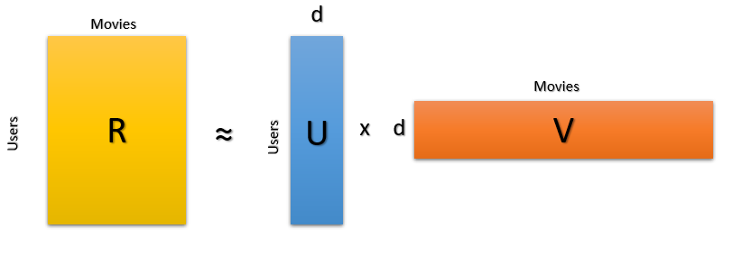
Figure 18: Illustration of Matrix Factorization.
where R is the rating matrix, U is the user matrix, V is the item matrix and d represent the latent features.

4.6. Artificial Neural Networks
In recent years, neural networks have shown immersive success in the field of image processing and computer vision. However, it’s not been widely adopted in the field of recommender systems. Neural networks for collaborative filtering are being used in recent years. For the neural network collaborative filtering, we adopt multi-layer representation to model a user-item interaction. In this method, we have replaced the inner product of Matrix Factorization with neural network architecture. In the first layer, user and item embeddings are concatenated and given to the first layer as an input feature. As this is a regression problem the output layer only consists of one layer. In the beginning, a dense layer of 600 neurons with batch normalization and $ReLU$ activation function. Afterward, a dropout of 0.3 and 200 neurons are used. The proposed model is represented in the figure below.
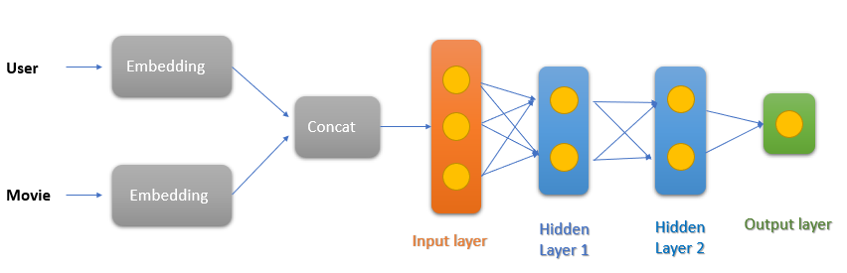
Figure 19: Illustration of the proposed Artificial Neural Network.
The activation function $ReLu$ is used mostly in the ANNs which ranges from zero to infinity. The $ReLU$ function can be represented as follows:
 | $$f(x)=\left\{\begin{aligned} 0 &for x <0 \\ x &for x ≥0\end{aligned}\right.$$ | (25)

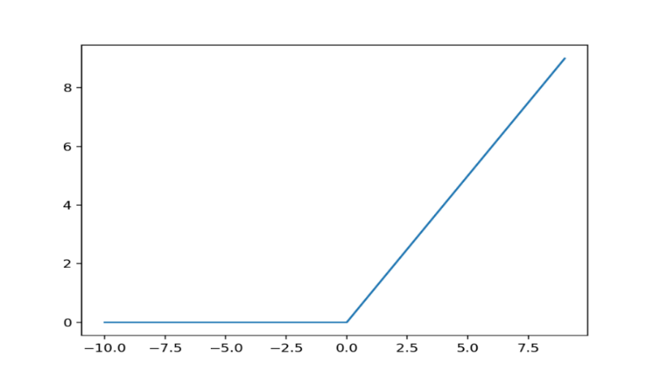
Figure 20: Illustration of ReLU function.

CHAPTER FIVE

5. Results
In this chapter, the results of all approaches and techniques are discussed. The first approach was tested for multiple iterations (i.e. 10000). The positive predictions for this approach were around 50% - 55%. The same approach was tested multiple times to find an average result for the suggested approach. The second approach was again tested with multiple iterations (i.e. 10000) to achieve the maximum accuracy for rating prediction. The positive prediction results were around 50% - 55%.
The results of the third approach were slightly better than the two above mentioned approaches. The following graph illustrates the positive predictions according to the proposed approach. The $x-axis$ illustrate the number of $k$ values starting from $(k=1,...,10)$ and $y-axis$ illustrate the positive percentage of the predictions for (10000) iterations among random users.
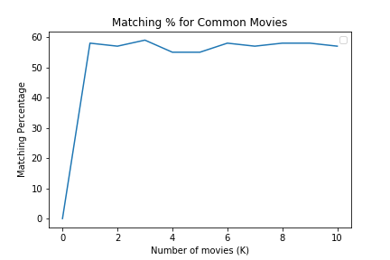
Figure 21: Matching percentage of positive prediction with k number of movies.
The fourth approach is the extension of the third approach as it includes genres. The following graph illustrates the positive predictions according to the mentioned approach for each specific genre. The$x-axis$illustrates the number of $k$ values starting from $(k=1,…,10)$ and $y-axis$ illustrates the positive percentage of the predictions for (10000) iterations among random users. Popular genre graphs are illustrated below. As we can see from the graphs given below the results are slightly better than the above approaches for some genres at a specific number of movies. We can achieve better accuracy if we can determine the optimal value of k.

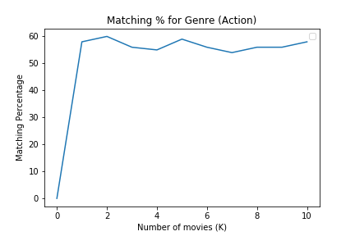 | 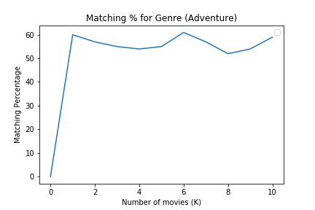
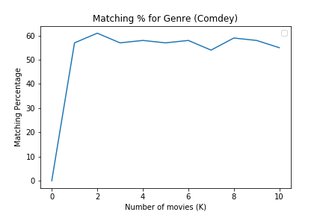 | 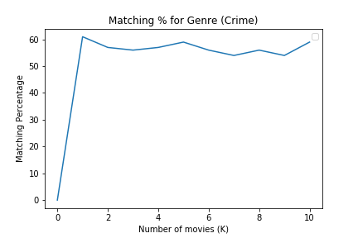

Figure 22: Matching percentage w.r.t. Genre and number of movies.

5.1. Performance Evaluation
For the evaluation of the performance, we have calculated Mean Absolute Error and Mean Squared Error.

Mean Squared Error
It measures the average of the squares of the error meaning that the average squared difference between the estimated value and the actual value.
 | $$MSE=\frac{1}{n}{\sum_{i=1}^{n}{{( y}_{i}-y_{i}^{'} )}}^{2}$$ | (26)

Here $n$ is the number of observations, $∑$ indicates the sum of all observation from 1 to $n$, $y_{i}$ is the actual observation and $y_{i^{'}}$ is the estimated observation.

Mean Absolute Error
It measures the average of the absolute error between the estimated value and the actual value.
 | $$MAE=\frac{1}{n}{\sum_{i=1}^{n}{\left|{( y}_{i}-y_{i}^{'} )\right|}}^{2}$$ | (27)
Here $n$ is the number of observations, $∑$ indicates the sum of all observations from 1 to $n$, $y_{i}$ is the actual observation and $y_{i^{'}}$ is the estimated observation.

The table below illustrates the results of the fifth approach at each interval with the number of users. The value $Nan$indicates that the number of users was too small for computation. The difference of 1.5 is taken as it was the optimize value in our testing scenarios and people more than 80% similarities are taken as average people as mentioned above. Moreover, from the following table, we can conclude that as we increase the similarity percentage (interval) the results are more positive.
Interval | Number of Users | Positive Cases
0-10 | 2 | Nan
10-20 | 5 | Nan
20-30 | 14 | Nan
30-40 | 46 | 54% (500 iterations)
40-50 | 93 | 54% (3000 iterations)
50-60 | 125 | 55% (5000 iterations)
60-70 | 160 | 56% (5000 iterations)
70-80 | 117 | 56% (5000 iterations)
Average People | - | -
80-90 | 61 | 60% (1000 iterations)
90-100 | 8 | Nan

Table 7: Results of the fifth approach.
The results of the sixth approach are illustrated in the tables given below. Each interval contains the number of users which belong to that specific category. Moreover, these results include different genres meaning that results can be different for different genres. The Nan value indicates that the number of users was too small for computation. The difference of 1.5 is taken as it was the optimize value in our testing scenarios and people more than 80% similarities are taken as average people as mentioned above. Moreover, from the following table, we can conclude that as we increase the similarity percentage (interval) the results are more positive.
Genre: Action, Difference 1.5
Interval | Number of Users | Positive Cases
0-10 | 14 | Nan
10-20 | 13 | Nan
20-30 | 25 | Nan
30-40 | 40 | Nan
40-50 | 108 | 56% (2000 iterations)
50-60 | 133 | 57% (3000 iterations)
60-70 | 132 | 57% (3000 iterations)
70-80 | 108 | 58% (3000 iterations)
Average People | - | -
80-90 | 129 | 58% (3000 iterations)
90-100 | 33 | Nan

Table 8: Results of the sixth approach with the Action genre.
Genre: Drama, Difference 1.5
Interval | Number of Users | Positive Cases
0-10 | 5 | Nan
10-20 | 7 | Nan
20-30 | 17 | Nan
30-40 | 54 | 54% (1000 iterations)
40-50 | 99 | 54% (2000 iterations)
50-60 | 117 | 56% (3000 iterations)
60-70 | 140 | 56% (3000 iterations)
70-80 | 139 | 59% (3000 iterations)
Average People | - | -
80-90 | 74 | 60% (2000 iterations)
90-100 | 28 | Nan
Table 9: Results of the sixth approach with the Drama genre.
Genre: Thriller, Difference 1.5
Interval | Number of Users | Positive Cases
0-10 | 13 | Nan
10-20 | 9 | Nan
20-30 | 31 | Nan
30-40 | 38 | Nan
40-50 | 99 | 49% (2000 iterations)
50-60 | 131 | 54% (3000 iterations)
60-70 | 146 | 55% (3000 iterations)
70-80 | 106 | 55% (3000 iterations)
Average People | - | -
80-90 | 81 | 59% (3000 iterations)
90-100 | 35 | Nan
Table 10: Results of the sixth approach with the Thriller genre.
The implementation of primitive approaches shows that better results can be achieved by filtering the data. Moreover, the results indicate that it is very hard to achieve accuracy by more than 60% in any above-mentioned approaches.
The following table shows the results of the decision tree on both average and non-average people with the difference between actual and IMDb ratings. The results are normalized as the IMDb rating scale is 10-stars and the original rating scale is 5-stars. The difference is from 10-star ratings and MSE and MAE belong to a 5-star rating. Moreover, the subset of data was included containing 1 million ratings. There were around 7000 users in the dataset. In the dataset, 70% of data is used for training purposes and 30% is used for testing purposes.

Model Name | Difference | No. of Avg People | Mean Square Error | Mean Absolute Error
Decision Tree | 2.0 | 2519 | 1.0 | 0.74
- | 1.9 | 1575 | 0.92 | 0.71
- | 1.8 | 1461 | 0.91 | 0.70
- | 1.7 | 1019 | 0.82 | 0.67
- | 1.6 | 879 | 0.80 | 0.65
- | 1.5 | 612 | 0.76 | 0.64

Table 11: Results of Decision Tree with Average people.

Model Name | Difference | No. of Non-Avg People | Mean Square Error | Mean Absolute Error
Decision Tree | 2.0 | 4229 | 2.1 | 1.08
- | 1.9 | 5173 | 2.03 | 1.08
- | 1.8 | 5287 | 2.01 | 1.07
- | 1.7 | 5729 | 1.89 | 1.03
- | 1.6 | 5869 | 1.88 | 1.03
- | 1.5 | 6136 | 1.84 | 1.02

Table 12: Results of Decision Tree with Non-Average people.
The following table shows the results of the random forest algorithm on both average and non-average people with the difference between actual and IMDb ratings. The results are normalized as the IMDb rating scale is 10 stars and the original rating scale is 5-stars. The difference is from 10-star ratings and MSE and MAE belong to a 5-star rating. Moreover, the subset of data was included containing 1 million ratings. There were around 7000 users in the dataset. For Evaluation purposes, 70% of data is used for training purposes and 30% is used for testing purposes.

Model Name | Difference | No. of Avg People | Mean Square Error | Mean Absolute Error
Random Forest | 2.0 | 2519 | 0.66 | 0.62
- | 1.9 | 1575 | 0.62 | 0.60
- | 1.8 | 1461 | 0.60 | 0.59
- | 1.7 | 1019 | 0.54 | 0.56
- | 1.6 | 879 | 0.53 | 0.55
- | 1.5 | 612 | 0.51 | 0.54

Table 13: Results of Random Forest with Average people.

Model Name | Difference | No. of non-Avg People | Mean Square Error | Mean Absolute Error
Random Forest | 2.0 | 4229 | 1.40 | 0.92
- | 1.9 | 5173 | 1.29 | 0.89
- | 1.8 | 5287 | 1.28 | 0.88
- | 1.7 | 5729 | 1.26 | 0.87
- | 1.6 | 5869 | 1.25 | 0.87
- | 1.5 | 6136 | 1.23 | 0.86

Table 14: Results of Random Forest with Non-Average people.
The following table shows the results of the SVR algorithm on both average and non-average people with the difference between actual and IMDb ratings. The results are normalized as the IMDb rating scale is 10 stars and the original rating scale is 5-stars. The difference is from 10-star ratings and MSE and MAE belong to a 5-star rating. Moreover, the subset of data was included containing 1 million ratings. There were around 7000 users in the dataset. For evaluation, 70% of data is used for training purposes and 30% is used for testing purposes.

Model Name | Difference | No. of Avg People | Mean Square Error | Mean Absolute Error
SVR | 2.0 | 2519 | 0.69 | 0.68
- | 1.9 | 1575 | 0.69 | 0.67
- | 1.8 | 1461 | 0.67 | 0.66
- | 1.7 | 1019 | 0.63 | 0.64
- | 1.6 | 879 | 0.60 | 0.62
- | 1.5 | 612 | 0.59 | 0.60

Table 15: Results of SVR with Average people.
Model Name | Difference | No. of non-Avg People | Mean Square Error | Mean Absolute Error
SVR | 2.0 | 4229 | 1.38 | 0.94
- | 1.9 | 5173 | 1.29 | 0.89
- | 1.8 | 5287 | 1.27 | 0.89
- | 1.7 | 5729 | 1.18 | 0.85
- | 1.6 | 5869 | 1.18 | 0.85
- | 1.5 | 6136 | 1.17 | 0.84

Table 16: Results of SVR with Non-Average people.
For the collaborative filtering approach, the non-average people dataset has been used for the evaluation of this method. Non-average people, dataset consists of more than 80% of the original data. We have trained the model on 70% of available data and 30% is evaluated for testing purposes. After training the model, we achieved Mean Squared Error and Mean Absolute Error of 0.66 and 0.61 respectively. Moreover, we achieved Mean Squared Error and Mean absolute error of 0.91 and 0.73 respectively after testing the model.
For the Matrix Factorization approach, the non-average people dataset has been used for the evaluation of this method. Non-average people’s dataset consists of more than 80% of the original data. We have trained the model on 70% of available data and 30% is evaluated for testing purposes. Keras embedding layers are implemented to learn the embeddings for both users and movies. Moreover, user and items embeddings $\left(k=10\right)$ are used for learning features, epoch size of 15 is considered and the learning rate of 0.07 is used after parameter tuning. After training the model, we achieved Mean Squared Error and Mean Absolute Error of 0.53 and 0.53 respectively. Moreover, we achieved Mean Squared Error and Mean absolute error of 0.78 and 0.53 respectively after testing the model.
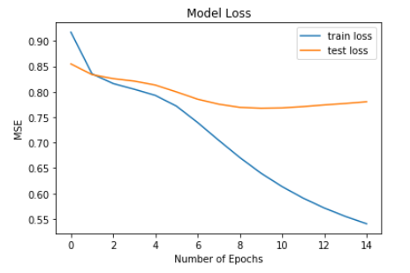 | 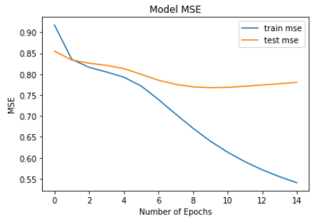
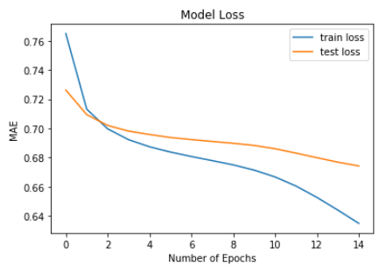 | 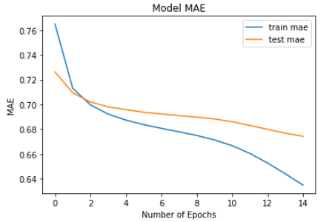

Figure 23: Results of Matrix Factorization.
For the Neural Network approach, the non-average people dataset has been used for the evaluation of this method. Non-average people’s dataset consists of more than 80% of the original data. We have trained the model on 70% of available data and 30% is evaluated for testing purposes. Keras embedding layers are implemented to learn the embeddings for both users and movies. Moreover, user and items embeddings $\left(k=15\right)$ are used for learning features, epoch size of 15 is considered and the learning rate of 0.07 is used after parameter tuning. After training the model, we achieved Mean Squared Error and Mean Absolute Error of 0.68 and 0.62 respectively. Moreover, we achieved Mean Squared Error and Mean absolute error of 0.80 and 0.67 respectively after testing the model.
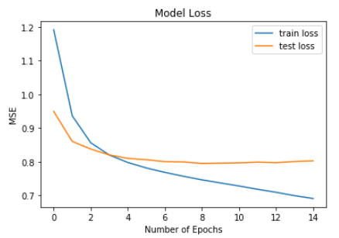 | 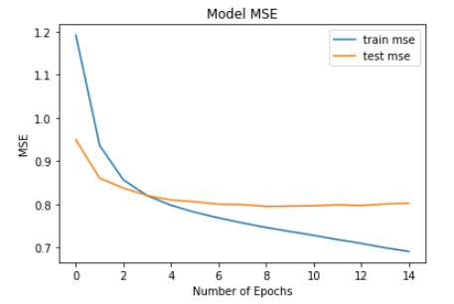
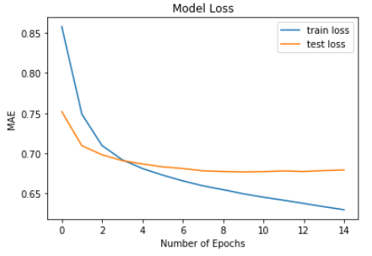 | 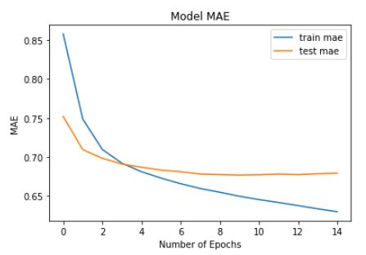

Figure 24: Results of the Deep Learning Method.

CHAPTER SIX

6. Discussion and Future Work
In this chapter, we will discuss the results of our proposed method and other similar approaches in the literature. In the machine learning approaches described in Chapter 4, we have evaluated all methods on MAE and MSE. The proposed method is categorized into average and non-average users. To decide whether the user is average or non-average, the dataset was tested on the multiple values to achieve the optimized results. The criterion is selected in such a way that at least 10% of the total users belong to average users. Average users are selected according to this criterion. The difference between user rating and IMDb rating should be $≤$ 1.5. For example, the user $A$ has rated k number of movies. We calculated the difference of movie $M_{1},M_{2}…M_{k}$, rated by user $A$ with respect to the IMDb ratings such as $(r_{A→M_{1} }- r_{imdb→M_{1}} ≤1.5)$. The percentage of such ratings for the specific user should be at least 80%. Moreover, the IMDb ratings are from scale 1-10 and we have normalized the original ratings accordingly.
The following figure illustrates the workflow of the algorithm proposed in this research. In the beginning, the model will decide either the user is average or non-average. After taking a decision it will run the appropriate method for a specific user. For example, if the new user is average then it will evaluate SVR and if the new user is non-average then it will evaluate different methods such as Matrix Factorization, Collaborative Filtering (user-based), and Deep Learning method.
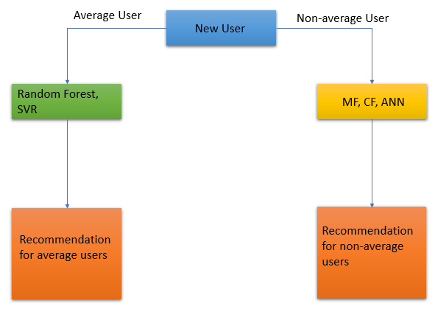
Figure 25: Illustration of the workflow of the proposed method.
In our research, for average users Support Vector Regression produced the best results and for non-average users, the Matrix Factorization method produced the best results. Although the results of Matrix Factorization and Artificial Neural Network are almost similar. We believe that better results can be achieved by tuning the different parameters.
The experiments in our proposed research suggest that for a new user the possibility of being an average user is at least 10% and the non-average user is 90% approximately. For the average user, the MSE value in the case of Random Forest is around 0.50, which means that the possibility of liking the recommended movie is around 85-90%. The MAE value for the non-average user is 0.67 in the case of ANNs and MF, meaning that the chances of liking the recommended movie are above 80%.
The following table illustrates the results of our method and other similar approaches. Our results shown in the table are based on non-average people.

Paper Title | Collaborative Filtering (User-Based) |  | Matrix Factorization |  | Artificial Neural Network |  | Reference
Paper Title | MAE | MSE | MAE | MSE | MAE | MSE
User's Interests-Based Movie Recommendation in Heterogeneous Network | 0.84 | - | - | - | - | - | [31]
Movie Recommender System | - | - | - | - | - | 0.81 | [32]
A Recommendation Model Based on Deep Neural Network | - | - | - | - | - | 0.77 | [33]
A Recommender System Based on Deep Neural Network and Matrix Factorization for Collaborative Filtering | 0.78 | - | 0.74 | - | 0.69 | - | [25]
A New Similarity Computation Method in Collaborative Filtering Based Recommendation System | 0.81 | - | - | - | - | - | [34]
Improved Collaborative Filtering Algorithm in The Research and Application of Personalized Movie Recommendations | 0.84 | - | - | - | - | - | [35]
Our Model (non-average people) | 0.73 | 0.91 | 0.67 | 0.78 | 0.67 | 0.80 | -

Table 17: Comparison of the proposed method with similar methods in the literature.
For comparing the results, MSE and MAE are calculated and compared as an evaluation matrix. It is clear from the above table that our model produced better results than the previous approaches. Moreover, our results on average people are much better than the above-shown results. Furthermore, our results are also even better on non-average people than the compared models. The overall performance of the proposed method has improved significantly.
In the future, we will focus on the implementation of some link prediction methods such as [12][13] to better understand the correlation between users and their behaviors. Link prediction techniques such as meta-paths can achieve better results if we categorize the users as proposed in our research. Autoencoder and Decoder have also shown promising improvement in this field of research. Moreover, sparsity and cold start problems are still difficult to resolve even in this decade. Our goal is to handle the sparsity and cold start problems suitably. Furthermore, we can learn different methods for the vector representation of the features in the user-item matrix which can be helpful to improve the results.

References
- S. Jain, A. Grover, P. S. Thakur, and S. K. Choudhary, "Trends, problems, and solutions of a recommender system," International Conference on Computing, Communication & Automation, Noida, 2015, pp. 955-958.

- Z. Zhao and M. Shang, "User-Based Collaborative-Filtering Recommendation Algorithms on Hadoop," 2010 Third International Conference on Knowledge Discovery and Data Mining, Phuket, 2010, pp. 478-481.

- L. Sharma, A. Gera, “A Survey of Recommendation System: Research Challenges,” International Journal of Engineering Trends and Technology (IJETT) – Volume 4 Issue 5- May 2013 ISSN: 2231-5381, Page 1989.

- D. Asanov, “Algorithms, and Methods in Recommender Systems,” Berlin Institute of Technology, Berlin, Germany, 2011.

- S., K. Salunke, A. Dongare, S. & Antala, K. (2017). “Recommender systems: An overview of different approaches to recommendations,” 2017 International Conference on Innovations in Information, Embedded, and Communication Systems (ICIIECS).

- U. Kużelewska “Advantages of information granulation in clustering algorithms Agents and artificial intelligence,” Springer, NY (2013), pp. 131-145.

- P.A.G. Calero, P. Funk (Eds.), “Proceedings of the European conference on case-based reasoning (ECCBR-04),” Springer, Madrid (Spain) (2004), pp. 317-330.

- S. Chang, W. Han, J. Tang, G.-J. Qi, C. C. Aggarwal, and T. S. Huang. “Heterogeneous network embedding via deep architectures,” in Proceedings of the 21th ACM SIGKDD International Conference on Knowledge Discovery and Data Mining, pages119–128.ACM,2015.

- D. Wang, P. Cui, and W. Zhu. 2016. “Structural Deep Network Embedding,” in Proceedings of the 22nd ACM SIGKDD International Conference on Knowledge Discovery and Data Mining (KDD ’16). Association for Computing Machinery, New York, NY, USA, 1225–1234.

- S. Chang, W. Han, J. Tang, G. Qi, C. Aggarwal, and T. S. Huang. 2015. “Heterogeneous Network Embedding via Deep Architectures,” in Proceedings of the 21th ACM SIGKDD International Conference on Knowledge Discovery and Data Mining (KDD ’15).
- C. Yang., M. Liu., F. He., X. Zhang, J. Peng, J. Han, (2019) “Similarity Modeling on Heterogeneous Networks via Automatic Path Discovery,” in Berlingerio M., Bonchi F., Gärtner T., Hurley N., Ifrim G. (eds) Machine Learning and Knowledge Discovery in Databases. ECML PKDD 2018. Lecture Notes in Computer Science, vol 11052. Springer, Cham.

- C. Shi, B. Hu, W. X. Zhao and P. S. Yu, "Heterogeneous Information Network Embedding for Recommendation," in IEEE Transactions on Knowledge and Data Engineering, vol. 31, no. 2, pp. 357-370, 1 Feb. 2019.

- B. Hu, C. Shi, W. Xin Zhao, and P. S. Yu. 2018. “Leveraging Meta-path-based Context for Top- N Recommendation with A Neural Co-Attention Mode,” in Proceedings of the 24th ACM SIGKDD International Conference on Knowledge Discovery & Data Mining (KDD ’18).

- Y. Hu, Y. Koren and C. Volinsky, "Collaborative Filtering for Implicit Feedback Datasets," 2008 Eighth IEEE International Conference on Data Mining, Pisa, 2008, pp. 263-272, DOI: 10.1109/ICDM.2008.22.

- P. Wang and H. Ye, "A Personalized Recommendation Algorithm Combining Slope One Scheme and User-Based Collaborative Filtering," 2009 International Conference on Industrial and Information Systems, Haikou, 2009, pp. 152-154, DOI: 10.1109/IIS.2009.71.

- A., A & Nair, Jayashree & Jijin, P. (2016). A random forest approach for rating-based recommender systems. 1293-1297. 10.1109/ICACCI.2016.7732225.

- https://grouplens.org/datasets/movielens/

- https://www.themoviedb.org

- https://www.kaggle.com/stefanoleone992/imdb-extensive-dataset

- J. Vig, S. Sen, and J. Riedl. 2012. “The Tag Genome: Encoding Community Knowledge to Support Novel Interaction,” ACM Trans. Interact. Intell. Syst. 2, 3, Article 13 (September 2012), 44 pages.

- Y. Koren, R. Bell, and C. Volinsky, "Matrix Factorization Techniques for Recommender Systems," in Computer, vol. 42, no. 8, pp. 30-37, Aug. 2009, DOI: 10.1109/MC.2009.263.

- T. Nghe, N. Nhut-Tu, M. Nguyen, H. Hoa. (2017). An Approach for Multi-Relational Data Context in Recommender Systems. 709-720. 10.1007/978-3-319-54472-4_66.

- S. Funk, “Netflix Update: Try This at Home,”, http://sifter.org/~simon/journal/20061211.html.

- Y. Koren, “Factorization Meets the Neighborhood: A Multifaceted Collaborative Filtering Model,” Proc. 14th ACM SIGKDD Int’l Conf. Knowledge Discovery and Data Mining, ACM Press, 2008, pp. 426-434.

- M. T. Ahamed and S. Afroge, "A Recommender System Based on Deep Neural Network and Matrix Factorization for Collaborative Filtering," 2019 International Conference on Electrical, Computer and Communication Engineering (ECCE), Cox'sBazar, Bangladesh, 2019, pp. 1-5, DOI: 10.1109/ECACE.2019.8679125.

- X. He, L. Liao, H. Zhang, L. Nie, Xia Hu, and Tat-Seng Chua. 2017. “Neural Collaborative Filtering”, in Proceedings of the 26th International Conference on World Wide Web (WWW ’17). International World Wide Web Conferences Steering Committee, Republic and Canton of Geneva, CHE, 173–182.

- G. Adomavicius and A. Tuzhilin, “Towards the Next Generation of Recommender Systems: A Survey of the State-of-the-Art and Possible Extensions”, IEEE Transactions on Knowledge and Data Engineering 17 (2005), 634–749.

- J. Bennet and S. Lanning, “The Netﬂix Prize”, KDD Cup and Workshop, 2007. www.netflixprize. com.

- G. Adomavicius and A. Tuzhilin, “Toward the next generation of recommender systems: a survey of the state-of-the-art and possible extensions,” IEEE Transactions on Knowledge and Data Engineering, vol. 17, no. 6, pp. 734-749, 2005.

- P., M. Nadia & Sarnè, Giuseppe M. L. (2010). “A Neural Network Hybrid Recommender System,” Frontiers in Artificial Intelligence and Applications. 226. 180-187. 10.3233/978-1-60750-691-1-180.

- W. Yang, X. Cui, J. Liu, Z. Wang, W. Zhu and L. Wei, "User's Interests-Based Movie Recommendation in Heterogeneous Network," 2015 International Conference on Identification, Information, and Knowledge in the Internet of Things (IIKI), Beijing, 2015, pp. 74-77, DOI: 10.1109/IIKI.2015.23.

- M. Saadati, S. Shihab, M. S. Rahman, “Movie Recommender Systems: Implementation and Performance Evaluation,” arXiv:1909.12749.

- L. Zhang, T. Luo, F. Zhang, and Y. Wu, "A Recommendation Model Based on Deep Neural Network," in IEEE Access, vol. 6, pp. 9454-9463, 2018.

- X. Wu, Y. Huang and S. Wang, "A New Similarity Computation Method in Collaborative Filtering Based Recommendation System," 2017 IEEE 86th Vehicular Technology Conference (VTC-Fall), Toronto, ON, 2017, pp. 1-5.

- X. Peng, S. Liangshan, and L. Xiuran, "Improved Collaborative Filtering Algorithm in the Research and Application of Personalized Movie Recommendations," 2013 Fourth International Conference on Intelligent Systems Design and Engineering Applications, Zhangjiajie, 2013, pp. 349-352, DOI: 10.1109/ISDEA.2013.483.

- https://towardsdatascience.com/introduction-to-artificial-neural-networks-ann-1aea15775ef9

- https://github.com/sanwal-1852/Thesis-DataSets

Appendices

Appendix 1
The link for the dataset used in this research is attached below.
https://github.com/sanwal-1852/Thesis-DataSets

Appendix 2
The code of the Decision Tree is attached in the following figure.
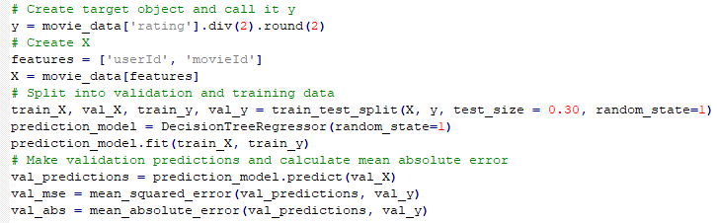

Appendix 3
The code of Random Forest is attached in the following figure.
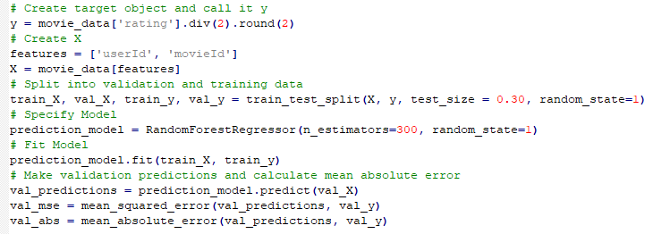

Appendix 4
The code of Support Vector Regression is attached in the following figure.
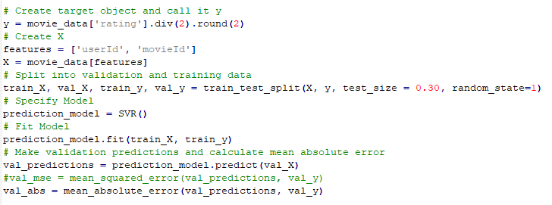

Appendix 5
All the codes used in this research can be obtained in the following link.
https://github.com/sanwal-1852/Thesis-DataSets

