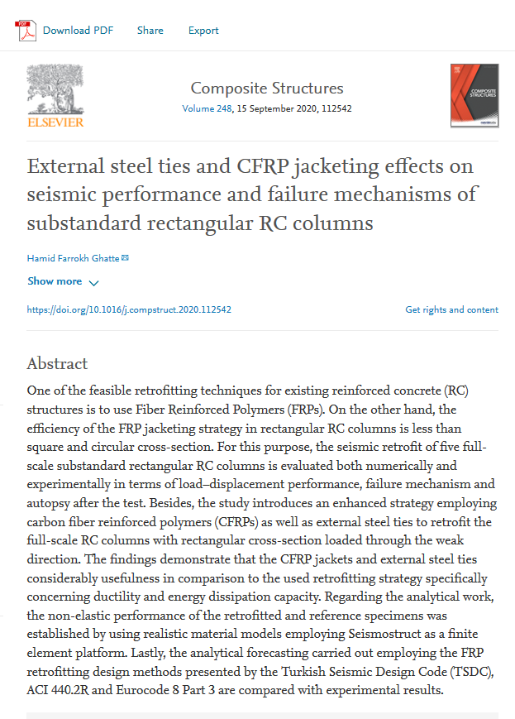
https://www.sciencedirect.com/science/article/pii/S026382232031206X

