UAV BOOK CHAPTER

Energy-Efficient UAV Routing Optimization Using Genetic Algorithms in Dynamic Logistics Systems

Keywords: Operational Research, Dynamic Logistics, Optimization, Design of Experiment (DOE), Surrogate Modelling, Global Optimization, Heuristic Algorithms, Route Optimization, Genetic Algorithm, Travelling Salesman Problem (TSP), Vehicle Routing Problem (VRP), Unmanned Aerial Vehicles (UAV), Cargo Drones

ABSTRACT

The trend of e-commerce and the development of drone technology have increased the global demand for cargo transportation, starting with the impact of the pandemic. To satisfy this demand, unmanned aerial vehicles (UAVs) have emerged as potential solutions to logistics needs. This study focuses on optimizing the routes of cargo UAVs, which is expected to be crucial in recent logistics systems. The proposed methodology integrates the unique requirements and constraints of cargo UAVs into the routing process using randomized locations with a minimized energy consumption objective. A modified Genetic Algorithm (GA) specializing in solving vehicle routing problems (VRPs) is used as an optimization algorithm to find an optimal route that meets the constraints.
Unlike conventional routing practices that often assume fixed points for service requests, this methodology accommodates the assumption of random points to better mirror real-world scenarios. The algorithm is designed to handle varying numbers of service-requesting points, providing scalable solutions for different operational contexts. The results of the experiments conducted with varying numbers of service-requesting points demonstrate the effectiveness of the proposed methodology. A comparative analysis between the GA and exact solutions shows a high degree of accuracy, particularly in scenarios with a limited number of points. Moreover, the algorithm's performance in terms of energy efficiency remains robust, even as the number of service-requesting points increases. Overall, this study developed a different approach to UAV routing optimization methods to determine the best possible paths in dynamic and evolving logistics environments using a particular objective.

- Introduction
An unmanned aerial vehicle (UAV), often referred to as a pilotless aircraft, is a type of aircraft that lacks an onboard human pilot or passenger. The term "unmanned" highlights the absence of a human actively controlling an aircraft. These aircraft may be controlled either onboard or remotely through off-board mechanisms, such as remote control [1].
The origin of UAVs can be traced back to the First and Second World Wars, where they were primarily used for military purposes. In the 1980s, UAVs were preferred for surveillance and intelligence missions [2]. In the 21st century, there has been a significant change in the role of UAVs, as they have found applications beyond military and civil use.
With the latest developments, UAVs are categorized according to their features, such as their usage areas, types, take-off and landing mechanisms, sensors, and endurance [3].

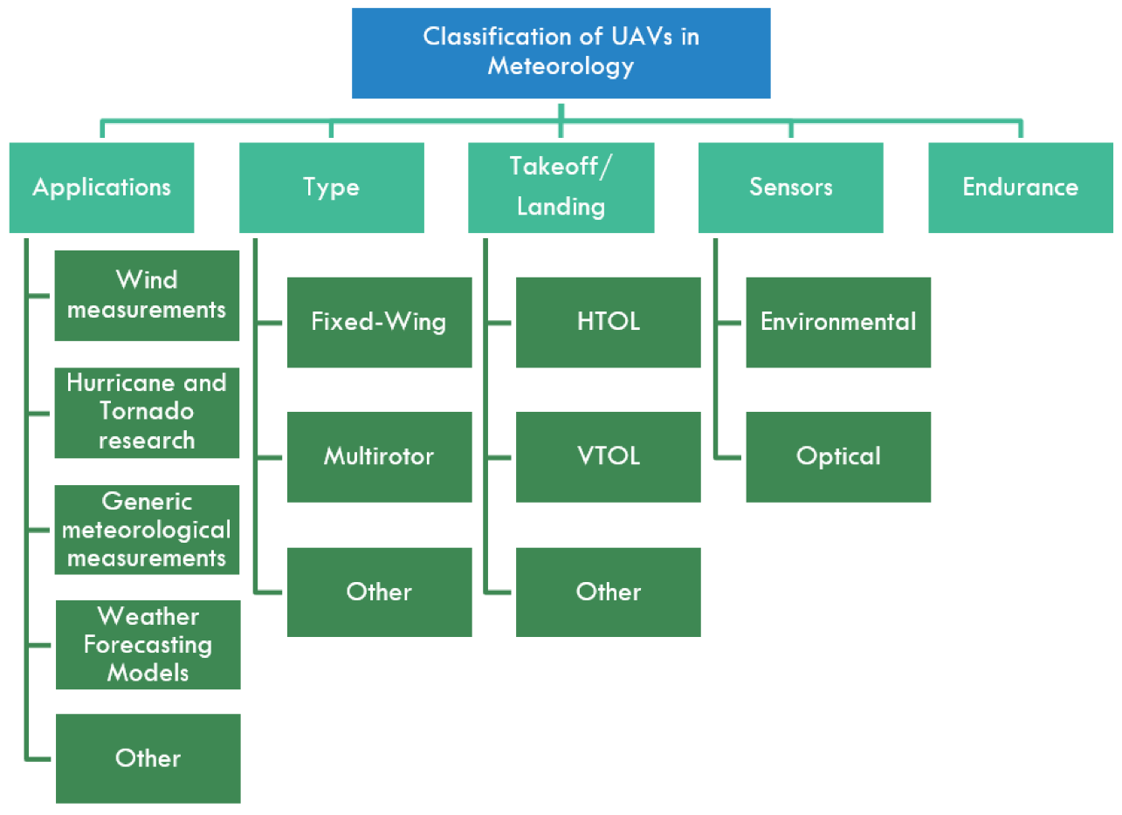
Figure 1: Classification of UAVs [3]
This study is developed for multi-rotor UAVs (drones). In this context, the UAV presented in this study is called a drone or multicopter. In the early 21st century, drones were primarily used in civilian photography and video shooting. Since then, their use has become widespread in various sectors, such as civil security, industrial inspections, and agriculture [3]. In recent years, there has been a significant increase in drone applications, as shown in the figure below.
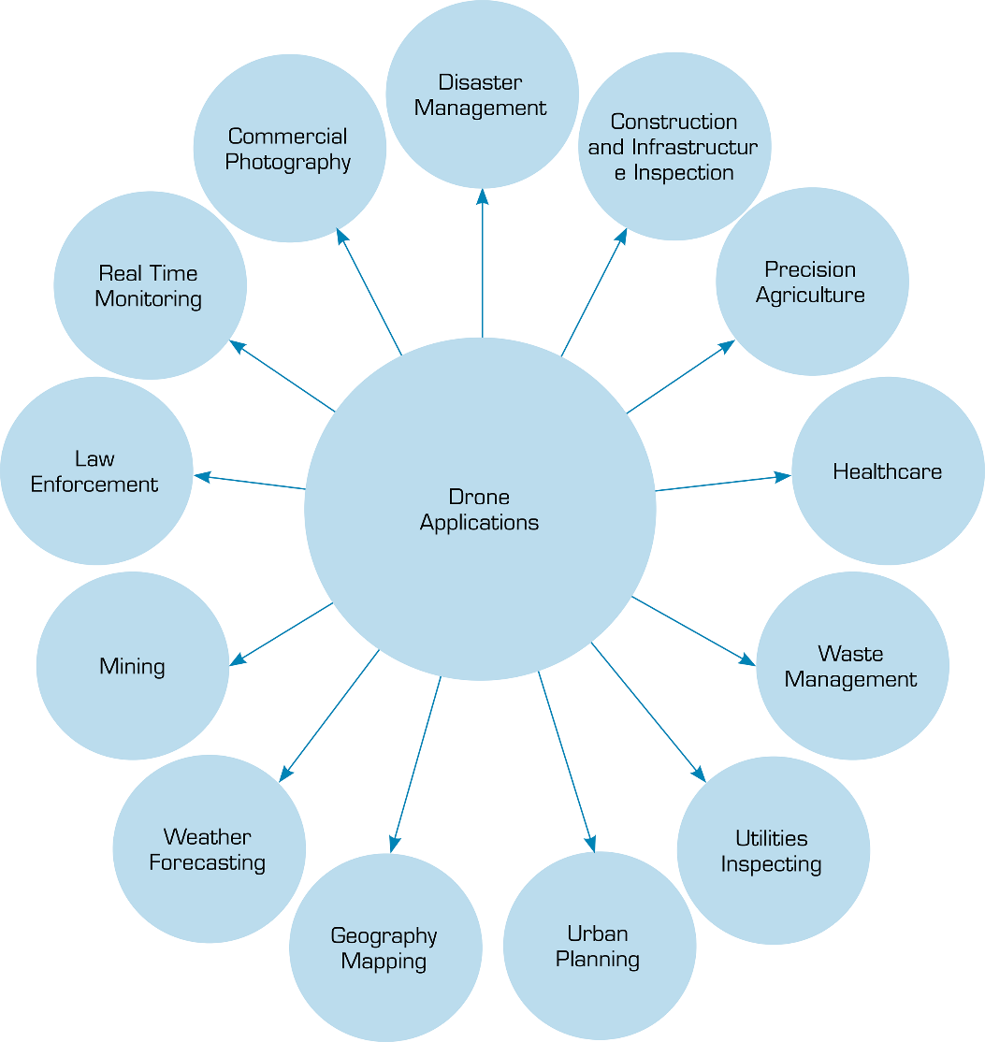

Figure 2: Drone Applications [4]

  - Traveling Salesman Problem (TSP)
TSP was initially examined during the 18th century by Irish mathematician Sir William Rowan Hamilton and English mathematician Thomas Penyngton Kirkman. The general form of TSP was established by Karl Menger in the 1930s [5].
TSP involves devising an itinerary for a single salesperson who originates from a central warehouse and is required to visit a predefined set of points without revisiting any of them. The primary objective of this plan was to determine the shortest possible distance [6].
TSP involves a single salesperson fulfilling a specified set of R customer requests, represented by R = {1, ..., R}, often identified as a city. In this routing problem, the request set aligns with the relevant locations denoted by V within the directed graph G = (V, A), where V = {1, ..., R}. The salesperson commences the route from one of the customer request locations and is mandated to visit each customer location precisely once before returning to the initial starting point [6].
  - Vehicle Routing Problem (VRP)
VRP is a well-known problem in the field of operations research, which was first introduced by Dantzig and Ramser in 1959 [7]. It involves a set number of customers, each with varying demand for goods supplied by a central distribution center. The goal is to devise optimal driving routes for a fleet of vehicles that will satisfy customer demands while minimizing factors such as distance, cost, and time consumption while adhering to specific constraints.
VRP can be described as the process of designing the optimal route from one or more initial points to multiple customer points in various locations, subject to certain constraints. The objective is to determine a set of routes with minimum total cost. To achieve this, certain conditions must be met, such as each city or customer being visited only once per vehicle, and all vehicles starting and ending their journey at the initial point. Additionally, various constraints may be applied, including capacity and time window constraints [8].

1.2.1) Vehicle Routing Problem with Drones (VRP-D)
With the increasing utility of UAVs over time and their expanding application in civilian domains, routing problems have become a subject of concern. The integration of routing problems with UAVs is a significant area of interest in operations research.
Owing to the presence of several variations, the drone routing problem has been categorized into two main groups, which are further divided into four subcategories [9], as shown in Figure 3.
The problems within the first main group, which include TSP-D and VRP-D, may involve other delivery vehicles, such as trucks. In the second main group, comprising problems such as DDP and CVP-D, deliveries are only performed by drones [9].
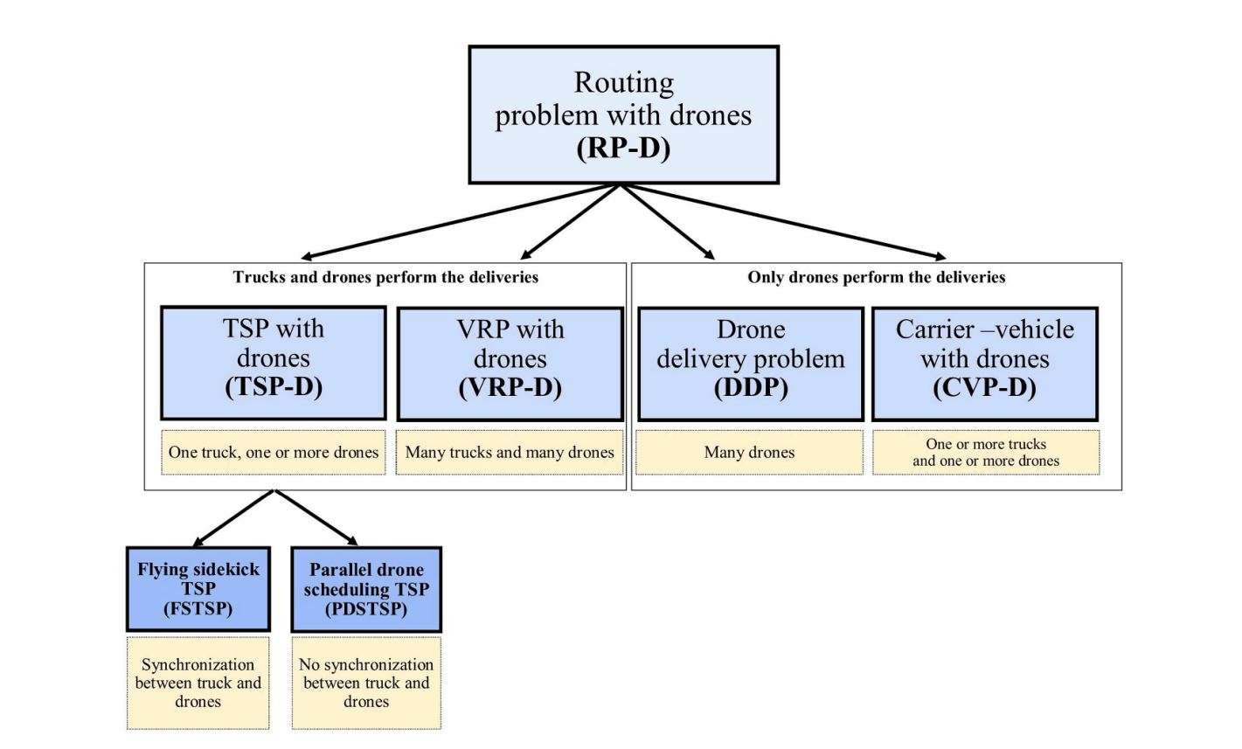
Figure 3: Classification of Routing Problems with Drones [9]

1.2.1.1) TSP with Drones (TSP-D)
TSP-D variant incorporates drones into its framework to plan the optimal route. This variation allows the utilization of multiple drones or vehicles. TSP-D has the following characteristics:
- Delivery Points: Like the standard TSP model, this involves predetermined delivery points.
- Delivery Vehicles: Both trucks and drones can be used as delivery vehicles in this variation.
- Drone Constraints: Drones have specific constraints such as payload capacity and speed.
- Objective Function: Generally, the objective is to reduce distance or cost. However, in certain studies, the objective function aims to minimize energy consumption [9,10,11,12].
1.2.1.2) VRP with Drones (VRP-D)
VRP-D serves as an extension or broadening of TSP-D, characterized by a fleet comprising multiple trucks and one or more drones. It encapsulates the fundamental components inherent in TSP-D, such as the objective function, constraints, and other essential attributes [9].

1.2.1.3) Drone Delivery Problem (DDP)
DDP is a variation of VRP, wherein the fleet exclusively comprises drones. Typically, this problem considers various specific factors associated with drones, including energy consumption, battery capacity, and restricted flying range [9].

1.2.1.4) Carrier–Vehicle Problem with Drones (CVP-D)
The carrier-vehicle problem integrates TSP-D, VRP-D, and DDP, encompassing a collective of cooperative vehicles with complementary functionalities dedicated to autonomous delivery operations [9].

- Problem Definition
With the impact of the COVID-19 pandemic, global e-commerce spending reached $5.2 trillion by the end of 2022. Additionally, forecasts anticipate that this figure will reach $8.1 trillion by the end of 2026 [13]. With an increase in global e-commerce, the need for cargo transportation has also increased.
Furthermore, UAV-based cargo transportation offers advantages, such as cost reduction and shorter waiting times for customers. Consequently, companies that constitute most of the e-commerce volume are engaged in research and development processes for drone-based cargo transportation. In 2020, 9.5% of commercially sold UAVs intended for civilian purposes were designated for cargo transportation [14]. For instance, Amazon, which holds 21% of the global e-commerce volume, established a company called Prime Air in 2022 and is currently conducting delivery trials using drones [15,16].
When assessing these data, UAVs for cargo will be omnipresent in various facets of our lives in the foreseeable future. Therefore, routing cargo UAVs is of even greater importance. However, when devising routes, considerations should encompass the characteristics of UAVs and the factors that influence them.
The objective of this study is to determine the optimal route for UAVs, which is expected to become prevalent in various aspects of our lives in the near future. In this context, attempts have been made to incorporate the limitations of UAVs into the real world.
In conventional routing practices, service-requesting points are often considered fixed. However, this study assumes that these points are random, aiming to enhance the applicability of the research to real-world scenarios.
- The Utilized UAV and Its Characteristic
In this study, a multicopter UAV was employed instead of a specific industrial UAV. Furthermore, the UAV utilized in this research may be referred to as multicopters or drones. Instead of employing a particular UAV designed for industrial purposes, a hypothetical UAV tailored for cargo functions was conceptualized, and its limitations were established. This approach has facilitated the development of a methodology applicable to a broad spectrum of UAVs.
Multicopters primarily comprise numerous components including motors, electronic speed controllers (ESCs), propellers, batteries, autopilots, GPS, telemetry systems, body structures, and other materials necessary for cargo mechanisms [17].

3.1.1) Weight of the UAV
Specific materials were utilized in the construction of the UAV, each with corresponding weights, as detailed in the table below:

Table 1: Materials and Weights
According to theoretical calculations, the estimated weight of the multicopter (excluding the payload) is approximately 20kg. Nonetheless, the material selection can be adjusted based on the desired payload.

3.1.2.) Energy Consumption of UAV

The energy consumption of a UAV/multicopter depends predominantly on the motors that provide thrust power [18], and to a lesser extent, on the weight of the multicopter. The other components consume energy at relatively consistent rates, regardless of weight. Consequently, to calculate the energy consumption of the UAV, the energy consumed by the motors alone is considered.
In the field of UAVs, electric brushless motors are the motor type of choice. Manufacturers provide information tables that specify motor specifications. The data obtained from the test setup reveal the energy consumption of the motor, which is proportional to the thrust generated at different voltages and amperage levels.

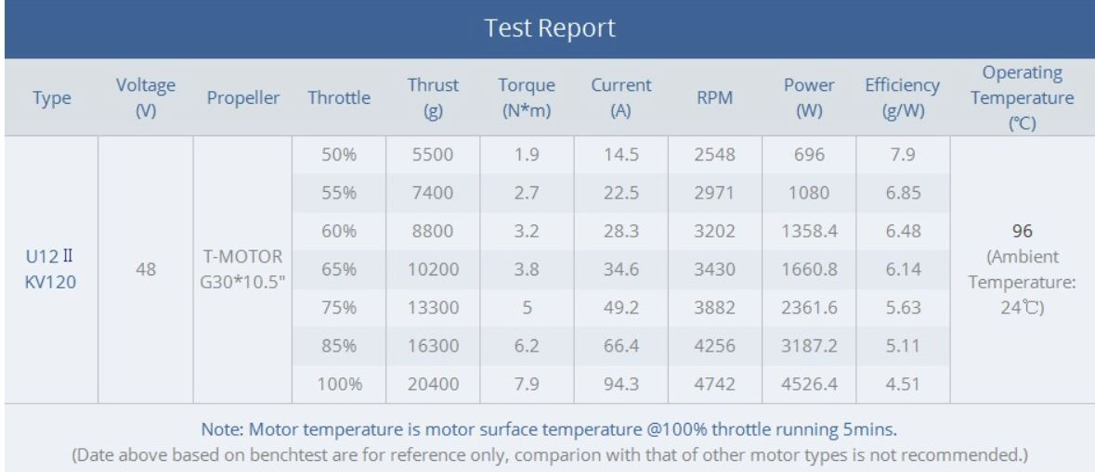
Table 2: The motor specifications for the selected T-Motor U12 II KV120 [19]

Data affecting motor performance are supplied in discrete segments, and intermediate values are generated using surrogate modeling. The data were processed using MATLAB to find the characteristic functions that fit to represent the responses used in the optimization. Following the creation of these graphs, the Curve Fitting Toolbox in MATLAB was used to determine the most appropriate functional format for the data. After conducting numerous trials, the quadratic polynomial graph yielded the best statistical simulation results for the power and thrust relationships. Intermediate values are also observed in this context. The Power-Thrust graph is provided in Graph 1 with statistical metrics.
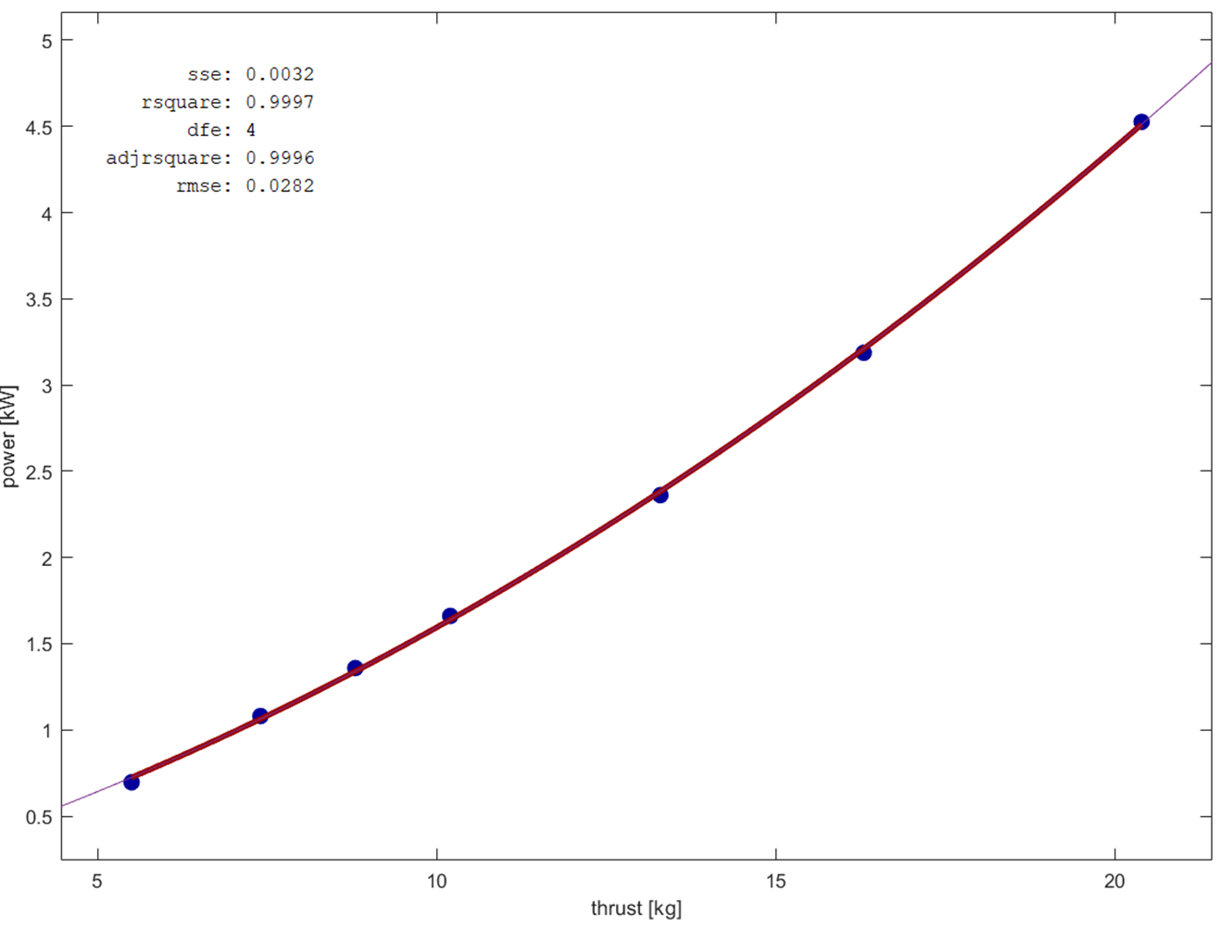
Graph 1: Thrust – Power Graph

After creating this chart, a visual representation was developed to demonstrate the correlation between the weight of the multicopter and the power (energy) required to maintain a constant velocity of 60 km/h. Subsequently, studies have been conducted on energy consumption calculations for multicopters. The resulting graph closely resembles those reported in other studies [20]. The total power-total weight graph is provided in Graph 2 with statistical metrics.
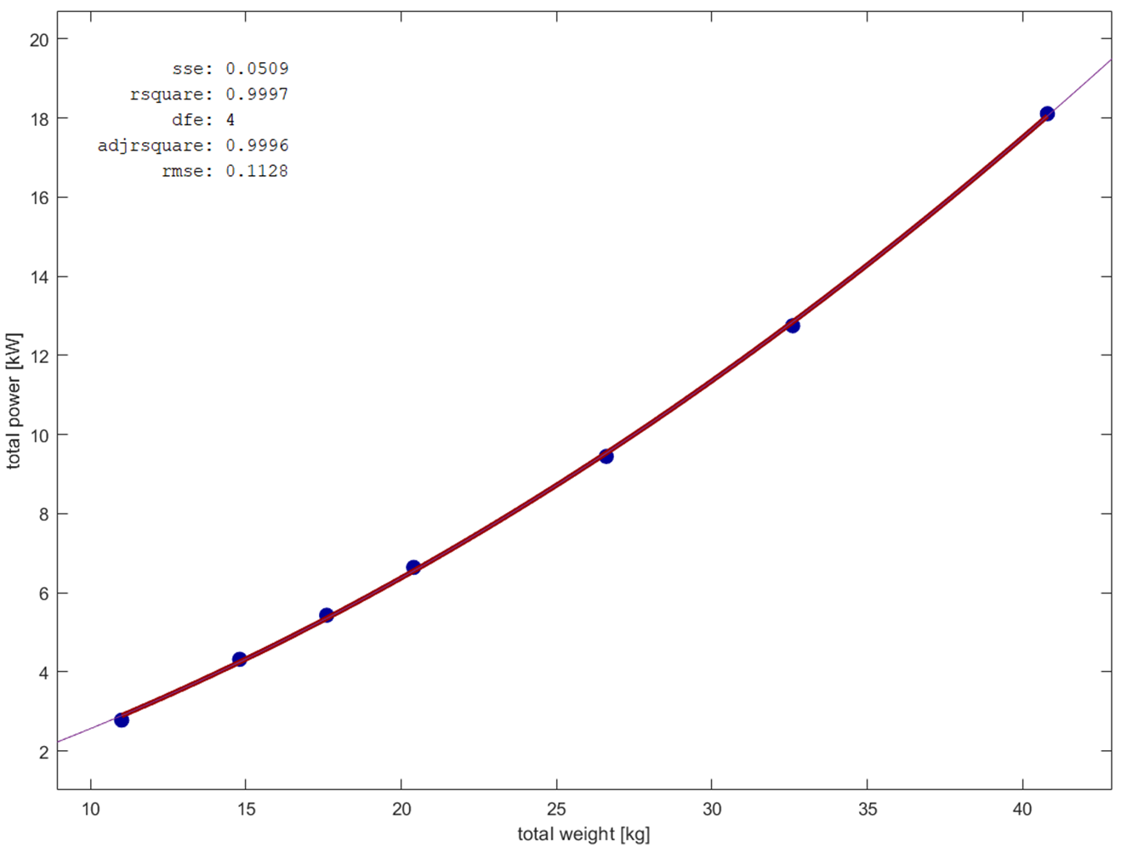

Graph 2: Total Weight – Total Power Graph
3.2) Optimization Model
In this study, UAV routing optimization is applied as shown in Equation 1. Abbreviations used in this equation are: i,j are the path index of locations, Χ denotes the path array, ${\text{Χ}}_{\text{0}}$ is a warehouse, β`s are coefficients, ${\text{n}}_{\text{stop}}$ states the number of stops, Ε is energy consumption [kWh], ${\text{Ε}}_{\text{total}}$ is total energy consumption [kWh], ${\text{Ε}}_{\text{a,b}}$ denotes energy consumption from a to b [kWh], δ is the distance [km], ${\text{δ}}_{\text{total}}$ is the total traveled distance [km], ${\text{δ}}_{\text{a,b}}$ is traveled distance from a to b [km], Μ is mass [kg], ${\text{Μ}}_{\text{total}}$ is total mass [kg], ${\text{Μ}}_{\text{max}}$ is maximum mass [kg], ${\text{Μ}}_{\text{instant}}$ is instantaneous mass [kg], ${\text{Μ}}_{\text{UAV}}$ is drone mass [kg], ${\text{Μ}}_{\text{payload}}$ is instantaneous payload mass [kg], Ρ denotes power consumption [kW], ν is speed [km/h], ${\text{ν}}_{\text{avg}}$ is average speed [km/h], ρ is range [km], and ${\text{ρ}}_{\text{max}}$ is the maximum range [km].

$$\begin{aligned}\begin{matrix}\underset{i={\left[1:n_{stop}\right]∧∀i∈Z}^{+}}{find}{:} & Χ={\left[Χ_{0},⋯Χ_{i},⋯Χ_{0}\right]}_{1×2+n_{stop}} \\ minimize: & Ε_{total}\left(Χ,M\right)=Ε_{0,1}+\sum_{j=1}^{n_{stop}-1}{Ε_{j,j+1}}+Ε_{n_{stop},0} \\ subject to: & \begin{matrix}\begin{matrix}δ_{a,b}\left(Χ\right)=\sqrt{{\left(Χ_{a,x}-Χ_{b,x}\right)}^{2}+{\left(Χ_{a,y}-Χ_{b,y}\right)}^{2}} \\ Ρ\left(Μ\right)={β_{2}M}^{2}+β_{1}Μ+β_{0}\end{matrix} \\ \begin{matrix}Ε_{a,b}\left(Χ,Μ_{instant}\right)=\frac{δ_{a,b}\left(Χ\right)×Ρ\left(Μ_{instant}\right)}{ν_{avg}} \\ \begin{matrix}ρ\left(Χ\right)≤ρ_{max}≡\sqrt{{\left(Χ_{0,x}-Χ_{i,x}\right)}^{2}+{\left(Χ_{0,y}-Χ_{i,y}\right)}^{2}}-ρ_{max}≤0 \\ Μ_{total}\left(Χ\right)≤Μ_{max}≡Μ_{UAV}+Μ_{payload}-Μ_{max}≤0\end{matrix}\end{matrix}\end{matrix}\end{matrix}\#\left(1\right)\end{aligned}$$

The design variable is a permutation array of locations that start and end the warehouse. Moreover, these locations are not repetitive, and the drone passes through every location only once during its travel. The objective function of this study is the minimization of the total energy consumption, a function of the path and payload of the UAV, which is a different approach than the general total distance objective. Distances are calculated with Euclidian locations, the power function is generated using a second-order polynomial curve fitting, which is one of the statistically optimum options for consumption data, and the energy consumption is calculated using these distance and power functions and the average velocity of the drone. Constraints and requirements include the range of all possible locations because the coverage distance of the drone is limited radially, and the total weight promotes the maximum weight that the drone can carry.
3.3) Limitations of UAV
UAVs are subjected to various additional limitations. The constraints considered in this study include thrust-to-weight ratio, range limitations, battery constraints, and speed restrictions.

3.3.1) Thrust to Weight Ratio
Multicopters must generate thrust from their motors, which surpasses their overall weight, for successful flight. For stable flight conditions, it is advised that the thrust should be at least 1.5 times the total weight. Hence, a thrust-to-weight ratio of 1.5 was chosen in this context. Consequently, it is anticipated that the theoretically designed UAV would maintain stable flight.

3.3.2) Range Limitations
Communication modules are employed for interactions with multicopters [17]. These devices commonly communicate via radio signals and are typically piloted through remote controls or computer systems. The range of the multicopters can vary depending on the communication system utilized. In this study, a range of 1.5 kilometers has been chosen for the multicopter. Expanding the range increases the distance between the distribution points, consequently elevating the probability of incomplete route coverage. This range can be adjusted in conjunction with different theoretical multicopter calculations.

3.3.3) Battery Limitations
The motors used in multicopters are electric, which necessitates the use of batteries. The battery voltage must align with the motor specifications, and its capacity directly influences the multicopter's flight duration. Thus, the selected battery capacity significantly affects flight time. In the developed theoretical UAV, a battery with a voltage of 48.1 volts and a capacity of 62000 mAh was utilized. Additionally, the battery efficiency was assumed to be a commonly accepted value of 85%. Finally, the capacity of our battery is calculated to be 2.53 kWh.

3.3.4) Speed Limitations
Each multicopter has its own specific maximum speed. The theoretically developed multicopter could achieve a maximum speed of 100 km/h. In this study, an average speed of 60 km/h was chosen as the constant velocity of the multicopter [21].

3.3.5) Distance Limitations
It is anticipated that the theoretical altitude reached by the multicopter will not encounter any obstacles. Consequently, a flight altitude between 50 m and 100 m was designated. Furthermore, the multicopter will traverse the distance between two points based on Euclidean distance.

3.3.6) Number of Multicopters
In this study, it is assumed that a single multicopter provides this service.

3.3.7) Warehouse Placement
The starting point of the multicopter is located precisely at the midpoint of the serviceable area (range) of the warehouse.

3.3.8) Quantity of the Payload
In this study, considering the thrust-to-weight ratio, the maximum payload capacity was determined as 20 kg. The constraints existing in the original TSP model, as outlined in the Introduction, are also incorporated here.

- Solution Methodology
VRP / TSP-D formulated with UAVs presents various solutions [22]. Three primary methodologies are identified in the figure, which serve as the basis of this study. In this study, GA, a metaheuristic approach, was employed to derive the solution. The algorithm developed in this study offers separate solutions for the two objective functions of minimizing energy and distance. However, the primary focus of this study is to prioritize the minimization of energy.

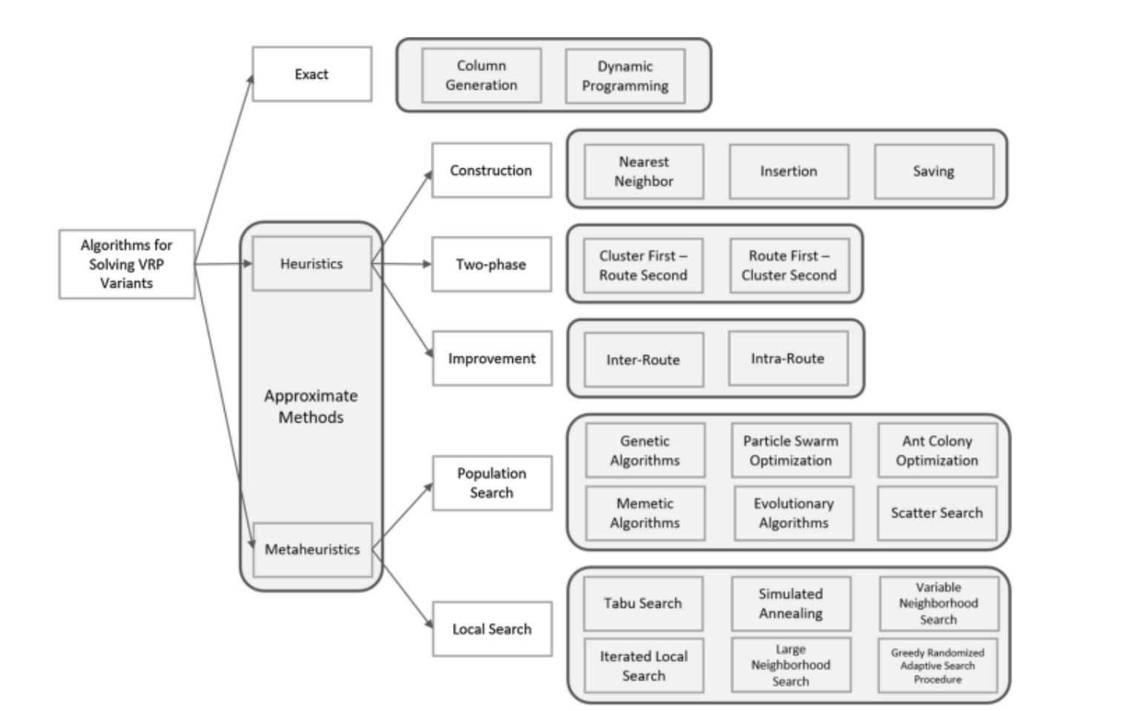
Figure 4: Solution Methods for VRPs [22]

4.1) Genetic Algorithm (GA)
GA represents an approach utilized for resolving constrained and unconstrained optimization quandaries, emulating a natural selection mechanism akin to biological evolution. The methodology iteratively adjusts a pool of individual solutions. In each iteration, the algorithm randomly picks individuals from the prevailing population, employing them as progenitors to generate the succeeding generation's offspring. Across consecutive generations, the populace progressively advances toward an optimal resolution.
In this study, GA is customized for custom data types. The default operation of the GA solver is centered on optimizing problems utilizing data types such as double and binary strings. The intrinsic functions for generating, performing crossover, and mutation operations assume that the population conforms to a matrix structure of type double, or a logical format in the case of binary strings. However, the GA solver is adaptable to optimization problems involving diverse data types. The data type is delineated utilizing a cell array maintains the flexibility to employ any preferred data structure for defining the population. To utilize the GA with a population structured as a cell array, it is imperative to provide custom creation, crossover, and mutation functions tailored to operate on the specified data type, such as a cell array. There are three essential functions requisite for addressing the TSP-VRP using GA. In this problem domain, an individual within the population corresponds to an ordered collection, thereby facilitating representation via a cell array. The bespoke creation function for the TSP-VRP fabricates a cell array wherein each constituent embodies an ordered sequence of locations in the form of a permutation vector. Hence, the drone traverses the locations according to the sequence delineated. This creation function furnishes a cell array of dimensions equal to location size. Subsequently, the custom crossover function accepts a cell array, constituting the population, and yields another cell array representing the progeny engendered through crossover. Similarly, the custom mutation function operates on an individual, represented as an ordered city set, and yields a mutated ordered set. Additionally, a fitness function tailored to the TSP-VRP is requisite. Herein, the fitness of an individual denotes the cumulative energy or distance traversed across the locations within the ordered set. This fitness computation necessitates access to the distance matrix for calculating the total distance and energy consumption. Despite GA invoking the fitness function with a sole argument of design variable, the fitness function necessitates two arguments which are design variables and objective function. To accommodate this requirement, an anonymous function encapsulates the supplementary argument, i.e., the distances matrix and energy consumption function. Preliminarily, GA specialized to signify the utilization of a custom data type and delineate the range of the population. Subsequently, the custom creation, crossover, and mutation functions are designated, alongside the specification of certain termination conditions [23, 24, 25, 26].

This solution utilizes the MATLAB programming language. Demand points representing service-requesting locations were depicted on a two-dimensional coordinate plane, employing x and y values for positioning

4.2) Assigning Points and Weight/Payload Distributions
In studies involving TSP, the demand/visit points are typically fixed, and the solutions are derived from these constant demand/visit points.
However, in this study, the service/visit points are not fixed, and demand points exhibit continuous variability. These points are generated randomly and can also be created using different distributions. This approach aims to make the study more realistic.
After each random point generation, a corresponding random weight/payload is also assigned. In other words, each demand point has a random weight. Since fixed weights are not realistic in real-world applications, random assignment is used to model potential scenarios. Nevertheless, the summation of these weight assignments does not surpass the payload capacity of the multicopters.

4.3) Relationship Between Weight and Energy Consumption
As previously mentioned, the energy consumption of the multicopter increases with its weight. In the context of our developed solution, computations vary between each point. This means that the multicopter flies with the maximum payload weight when delivering to the initial point, consuming energy accordingly. At this initial point, it has delivered a payload of 1kg. While traveling from this point to subsequent locations, it carries a payload of 20kg, and energy calculations have been conducted considering this scenario.
- Results
The developed algorithm was subjected to a varying number of demand points as input. Additionally, experiments conducted with a limited number of demand points (<9) yielded exact solutions. A comparative analysis of the results was carried out, focusing particularly on scenarios with a small number of demand points. Point 0 (Location 0/Warehouse) is the starting point.
- Solution with 4 Points

location x-coordinate [km] y-coordinate [km] payload [kg]
________ _________________ _________________ ____________

0 1.5 1.5 20
1 1.6527 1.7813 2.5483
2 2.1852 2.643 7.3623
3 2.2249 1.7941 5.218
4 0.78979 2.6458 4.8714

Table 3: Randomly Generated x, y Coordinates, and Random Weights for 4 Demand Points

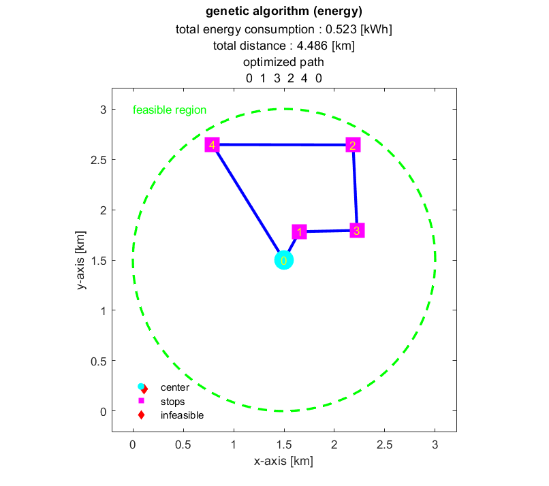
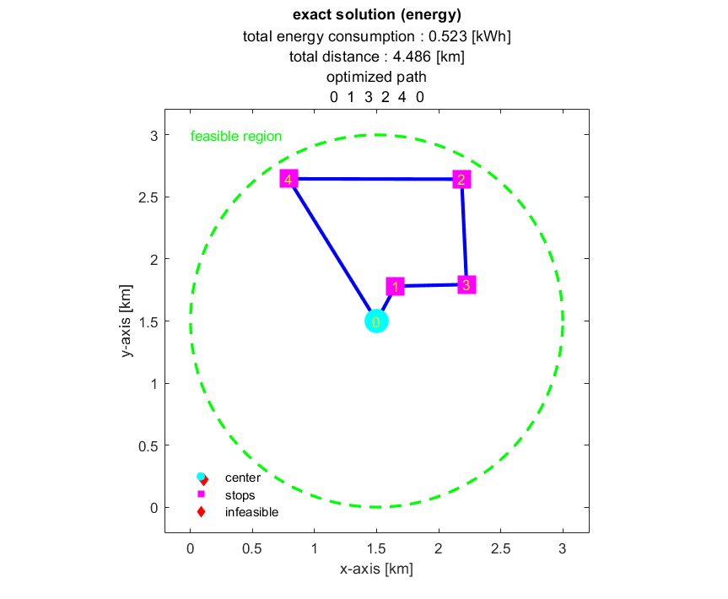
Figure 6: Exact and GA Solutions for the Problem with 4 Demand Points

Both the GA solution and the exact solution for the 4 points yielded identical results. Consequently, it has been calculated that the multicopter will consume 0.523 kWh of energy along this route.
- Solutions with 7 points

location x-coordinate [km] y-coordinate [km] payload [kg]
________ _________________ _________________ ____________

0 1.5 1.5 20
1 1.2179 2.3582 4.057
2 1.5486 0.54199 1.5967
3 0.92124 2.109 4.9924
4 1.7263 2.2132 1.506
5 1.1153 2.4306 1.5175
6 2.5052 2.4768 1.7613
7 2.427 1.6096 4.5692

Table 4: Randomly Generated x, y Coordinates, and Random Weights for 7 Demand Points

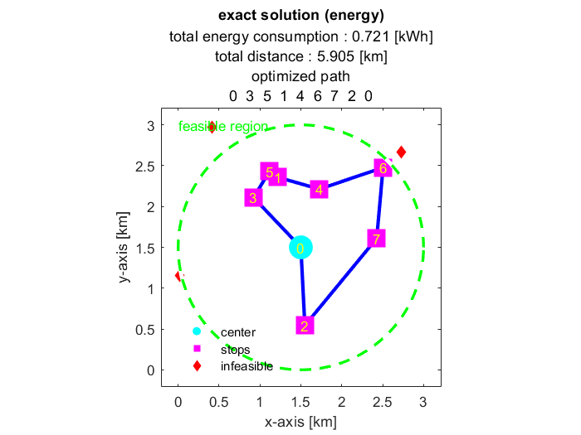
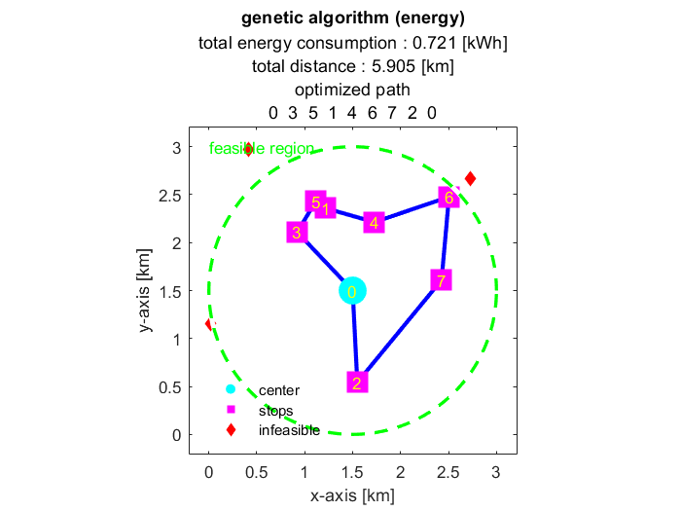

Figure 7: Exact and GA Solutions for the Problem with 7 Demand Points

In the case of 7 points, both the exact solution and the GA solution produced identical outcomes. Therefore, it has been calculated that the multicopter will consume 0.721 kWh of energy along this route.
- Solutions with 9 Points

location x-coordinate [km] y-coordinate [km] payload [kg]
________ _________________ _________________ ____________

0 1.5 1.5 20
1 1.7049 1.3772 1.5281
2 2.1841 0.46444 1.9126
3 2.6322 2.1703 2.1367
4 0.9909 2.3646 3.1325
5 2.4209 2.3385 2.6087
6 1.6812 2.4307 0.96517
7 0.76267 2.5462 1.8268
8 1.0982 1.806 2.3175
9 1.5219 0.050366 3.5719

Table 5: Randomly Generated x, y Coordinates, and Random Weights for 9 Demand Points

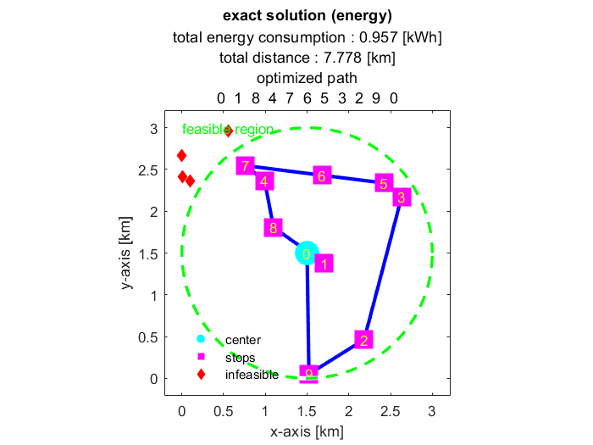
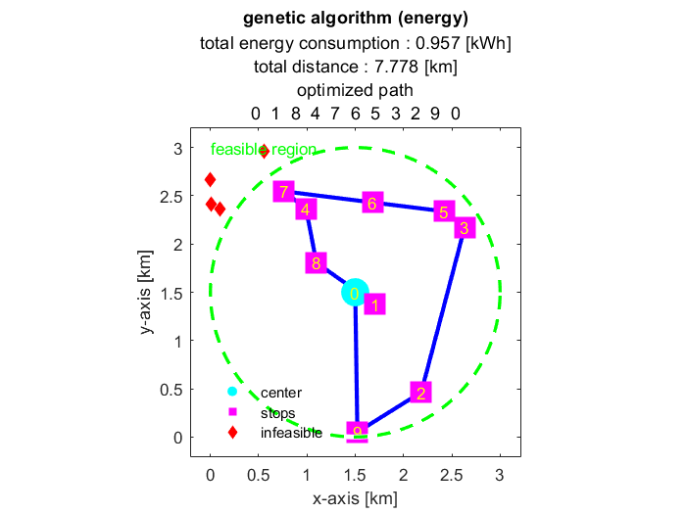

Figure 8: Exact and GA Solutions for the Problem with 9 Demand Points

In the case of 7 points, both the exact solution and the GA solution produced identical outcomes. Therefore, it has been calculated that the multicopter will consume 0.957 kWh of energy along this route.
- Solutions with 12 Points

location x-coordinate [km] y-coordinate [km] payload [kg]
________ _________________ _________________ ____________

0 1.5 1.5 20
1 1.6814 0.44797 1.8912
2 2.7461 0.81552 2.034
3 1.2747 0.45785 1.4497
4 0.76963 0.3313 1.5879
5 0.37646 2.3234 1.1205
6 1.4906 1.0157 2.1769
7 1.1095 2.228 2.082
8 1.4176 1.984 1.6203
9 0.62582 1.6959 1.5139
10 1.7901 2.7372 1.2319
11 0.40762 2.3789 1.9108
12 1.082 2.546 1.3807

Table 6: Randomly Generated x, y Coordinates, and Random Weights for 12 Demand Points

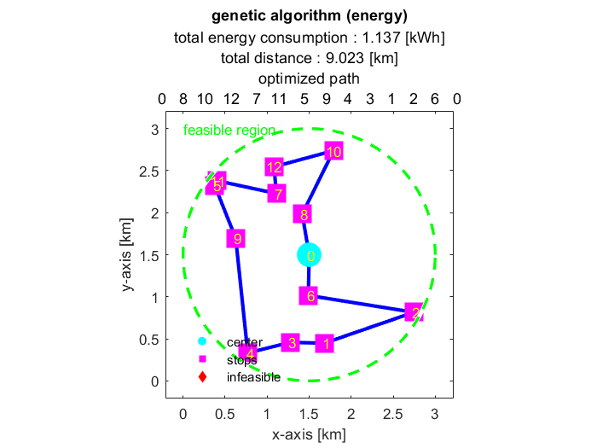

Figure 9: GA Solution for the Problem with 12 Demand Points

Due to the number of points exceeding 9, an exact solution was not feasible. Hence, for this experiment involving 12 points, it has been calculated that the multicopter will consume 1.137 kWh of energy.
- Solutions with 15 Points

location x-coordinate [km] y-coordinate [km] payload [kg]
________ _________________ _________________ ____________

0 1.5 1.5 20
1 0.64739 1.7947 1.8956
2 1.4858 1.3361 1.2902
3 1.8075 2.0845 1.4687
4 1.6276 0.47675 2.0112
5 1.1331 2.3853 0.69762
6 0.6678 1.76 0.59814
7 1.8766 2.2168 1.3514
8 1.0652 0.61827 0.83809
9 1.3263 0.55668 1.6956
10 2.1611 0.94852 1.8989
11 0.75532 0.47438 1.8012
12 1.2908 1.1061 2.026
13 1.3083 2.2024 1.0878
14 0.81409 1.5352 0.56718
15 1.5492 2.5033 0.77236

Table 7: Randomly Generated x, y Coordinates, and Random Weights for 15 Demand Points

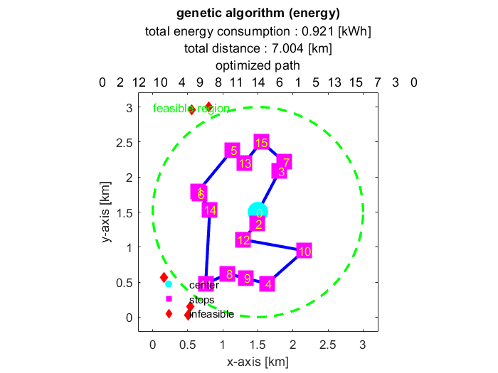

Figure 10: GA Solution for the Problem with 15 Demand Points

In this experiment involving 15 points, the distance between points was comparatively lower than in the experiment with 12 points. Therefore, for this 15-point experiment, it has been calculated that the multicopter will consume 0.921 kWh of energy.

- Solutions with 20 Points

location x-coordinate [km] y-coordinate [km] payload [kg]
________ _________________ _________________ ____________

0 1.5 1.5 20
1 2.6048 1.1547 0.85521
2 1.5601 2.3742 1.2703
3 0.44185 1.8724 0.77462
4 2.3446 1.2803 0.79394
5 0.79645 2.6207 0.72551
6 1.3962 0.48826 1.1826
7 1.8393 0.8067 0.99396
8 0.46642 1.53 0.79703
9 2.0207 2.3817 0.96612
10 0.93302 0.42971 1.4005
11 1.8859 1.0416 0.82518
12 0.99489 0.81869 1.1885
13 2.8455 1.4013 1.1872
14 1.8177 0.60744 1.0439
15 0.79735 0.38026 1.0294
16 1.2959 2.6194 1.0411
17 2.448 0.94039 1.0855
18 0.99942 2.7764 0.57836
19 1.8537 2.8184 1.3948
20 0.60232 0.46113 0.86624

Table 8: Randomly Generated x, y Coordinates, and Random Weights for 20 Demand Points
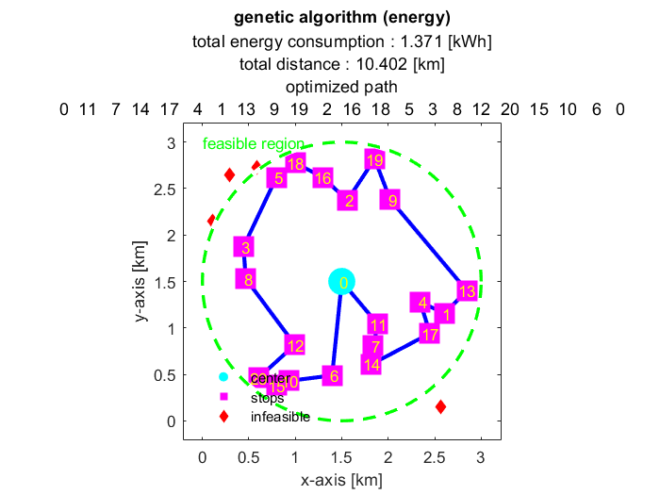

Figure 11: GA Solution for the Problem with 20 Demand Points

In this experiment involving 20 points, it has been calculated that the multicopter will consume 1.371 kWh of energy.
- Solutions with 30 Points

location x-coordinate [km] y-coordinate [km] payload [kg]
________ _________________ _________________ ____________

0 1.5 1.5 20
1 0.84995 1.2325 0.66558
2 1.2735 2.0045 1.0182
3 2.1592 2.5186 0.64132
4 0.22161 2.004 0.86894
5 0.60727 1.5781 0.75745
6 0.32139 2.2954 0.78188
7 1.7917 2.1914 0.79216
8 1.3632 1.4338 0.28046
9 1.2137 2.019 0.7307
10 0.77325 1.0447 0.45095
11 0.64073 0.5818 0.74397
12 1.5769 0.39277 0.80849
13 2.1613 1.8387 0.76479
14 1.764 0.55868 0.70857
15 0.34729 0.63586 0.49973
16 2.6817 1.1612 0.96876
17 0.80605 2.8151 0.81373
18 1.1236 0.73903 0.34969
19 2.7973 1.2453 0.86495
20 0.77904 1.3038 0.77491
21 1.4114 0.10017 0.59715
22 1.7516 0.61239 0.769
23 0.49965 1.0502 0.40706
24 0.93668 1.2921 0.89398
25 1.9693 2.4158 0.6629
26 1.8934 1.6722 0.36858
27 2.0933 0.60793 0.54426
28 0.95825 2.2603 0.45114
29 0.69734 1.0219 0.58501
30 2.1903 0.43955 0.43573

Table 9: Randomly Generated x, y Coordinates, and Random Weights for 30 Demand Points

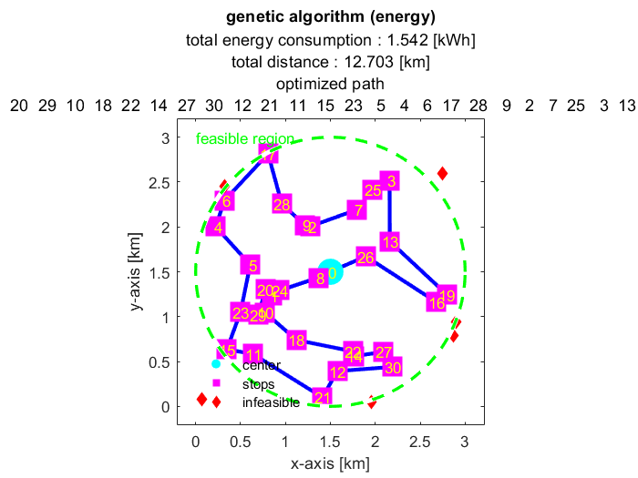
Figure 12: GA Solution for the Problem with 30 Demand Points

In this experiment involving 30 points, it has been calculated that the multicopter will consume 1.542 kWh of energy.

- Solutions with 40 Points

location x-coordinate [km] y-coordinate [km] payload [kg]
________ _________________ _________________ ____________

0 1.5 1.5 20
1 1.5483 1.7188 0.30287
2 1.166 0.53342 0.78689
3 0.95507 1.9921 0.58872
4 1.8893 1.3537 0.49431
5 1.9518 2.0672 0.47384
6 1.8941 0.65493 0.2604
7 2.3611 1.8414 0.58763
8 0.23669 0.89248 0.44239
9 1.9108 0.34845 0.57571
10 0.52804 0.87231 0.79327
11 0.76656 2.0481 0.85557
12 1.6648 0.79732 0.31871
13 2.5342 2.247 0.58009
14 1.4077 2.9496 0.36239
15 1.5008 2.0898 0.33914
16 2.5191 1.9668 0.62749
17 1.3231 0.21314 0.25109
18 1.2797 1.862 0.44243
19 2.1367 1.5691 0.60804
20 1.4973 0.19266 0.29777
21 0.90449 0.59993 0.32588
22 1.4874 1.3256 0.22281
23 1.9083 1.2185 0.21272
24 0.83458 2.8426 0.81727
25 1.3337 1.95 0.52302
26 1.5791 2.8181 0.9012
27 0.75541 1.9343 0.3969
28 0.25702 0.73509 0.60355
29 1.8898 0.51434 0.58348
30 0.78045 0.54463 0.49276
31 2.3205 1.6765 0.24439
32 0.56263 1.8107 0.53904
33 0.041353 1.7087 0.76258
34 0.73826 1.0441 0.59811
35 0.55773 0.60221 0.22829
36 0.96206 1.1431 0.258
37 0.3719 1.529 0.56399
38 2.1484 1.6132 0.71805
39 1.7936 0.039727 0.60574
40 2.9696 1.4536 0.41346

Table 10: Randomly Generated x, y Coordinates, and Random Weights for 40 Demand Points

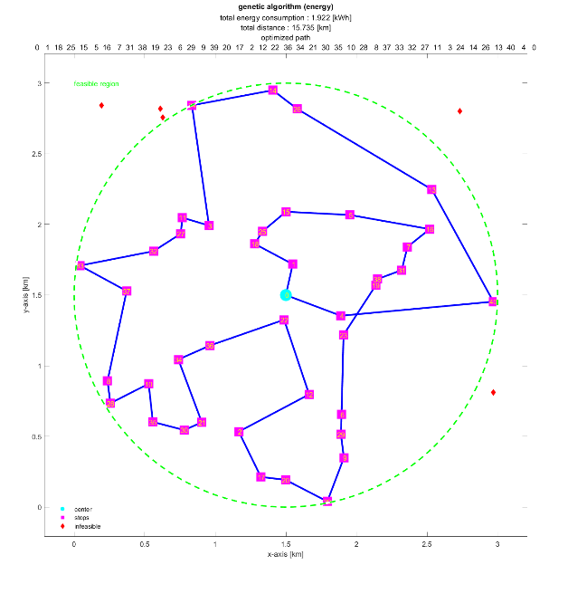

Figure 13: GA Solution for the Problem with 40 Demand Points

In this experiment involving 40 points, it has been calculated that the multicopter will consume 1.922 kWh of energy.
On average, experiments with up to 40 points demonstrated a total energy consumption below 2.53 kWh, the maximum battery capacity. More than 40 points, total energy consumption approached or exceeded this value. Therefore, the developed solution algorithm runs for service demands up to 40 points using this battery.
- Conclusion
This study examines the incorporation of UAVs into contemporary logistics and cargo transportation systems. The growth of global e-commerce has highlighted the potential for UAVs to enhance delivery processes and reduce costs. By employing a metaheuristic approach, specifically GA, this study effectively navigates routing challenges while considering the operational limitations of UAVs.
In the proposed algorithm, the input factors include various fundamental UAV characteristics. Consequently, the industrial, amateur, or similar categories of cargo UAVs can be effortlessly integrated into our solution algorithm. The solution algorithm randomly determines the locations, catering to all users interested in multicopter delivery. Additionally, predetermined locations can be manually input, if desired. An increase in the average speed decreases the route completion time and consequently reduces the overall energy consumption.
Further technological advances are expected to occur in the near future. The integration of UAVs into logistics systems is a technical challenge and a complex process that requires regulatory frameworks. Ongoing R&D activities play a crucial role in the effective implementation of these new technologies. The expansion of UAVs' roles in logistics in this manner will shape transformations within the sector and determine the trajectory of future innovation.
- References
[1] Handbook of unmanned aerial vehicles. (2015). In Springer eBooks. https://doi.org/10.1007/978-90-481-9707-1
[2] Giones, F., & Brem, A. (2017). From toys to tools: The co-evolution of technological and entrepreneurial developments in the drone industry. Business Horizons, 60(6), 875–884. https://doi.org/10.1016/j.bushor.2017.08.001
[3] Mourgelas, C., Micha, E., Chatzistavrakis, E., & Voyiatzis, I. (2023). Classification of Unmanned Aerial Vehicles in Meteorology: A Survey. 16th International Conference on Meteorology, Climatology and Atmospheric Physics—COMECAP 2023). https://doi.org/10.3390/environsciproc2023026135
[4] Sivakumar, M., & Tyj, N. M. (2021). A Literature Survey of Unmanned Aerial Vehicle Usage for Civil Applications. Journal of Aerospace Technology and Management, 13. https://doi.org/10.1590/jatm.v13.1233
[5] David L. Applegate; Robert E. Bixby; Vašek Chvátal; William J. Cook, The Traveling Salesman Problem: A Computational Study , Princeton University Press, 2007.
[6] Ferrucci, F. (2013). Pro-active dynamic vehicle routing. In Contributions to management science. https://doi.org/10.1007/978-3-642-33472-6
[7] Dantzig, G. B., & Ramser, J. H. (1959). The truck dispatching problem. Management Science, 6(1), 80–91. https://doi.org/10.1287/mnsc.6.1.80
[8] Zhang, H., Ge, H., Yang, J., & Tong, Y. (2021). Review of Vehicle Routing Problems: models, classification and solving Algorithms. Archives of Computational Methods in Engineering, 29(1), 195–221. https://doi.org/10.1007/s11831-021-09574-x
[9] Macrina, G., Di Puglia Pugliese, L., Guerriero, F., & Laporte, G. (2020). Drone-aided routing: A literature review. Transportation Research. Part C, Emerging Technologies, 120, 102762. https://doi.org/10.1016/j.trc.2020.102762
[10] Murray, C. C., & Raj, R. (2020). The multiple flying sidekicks traveling salesman problem: Parcel delivery with multiple drones. Transportation Research. Part C, Emerging Technologies, 110, 368–398. https://doi.org/10.1016/j.trc.2019.11.003
[11] Cheng, C., Adulyasak, Y., & Rousseau, L. (2020). Drone routing with energy function: Formulation and exact algorithm. Transportation Research. Part B: Methodological/Transportation Research. Part B, Methodological, 139, 364–387. https://doi.org/10.1016/j.trb.2020.06.011
[12] Thibbotuwawa, A., Bocewicz, G., Nielsen, P., & Banaszak, Z. (2020). Unmanned Aerial Vehicle Routing Problems: A literature review. Applied Sciences, 10(13), 4504. https://doi.org/10.3390/app10134504
[13] Global retail e-commerce sales 2014-2027 | Statista. (2024, February 6). Statista. https://www.statista.com/statistics/379046/worldwide-retail-e-commerce-sales/
[14] Ковалев, И. В., Voroshilova, A. A., & Карасева, М. В. (2019). Analysis of the current situation and development trend of the international cargo UAVs market. Journal of Physics. Conference Series, 1399(5), 055095. https://doi.org/10.1088/1742-6596/1399/5/055095
[15] Statista. (2024b, February 5). Global e-commerce market share of leading e-retailers 2022. https://www.statista.com/statistics/664814/global-e-commerce-market-share/
[16] Staff, A. (2022, June 13). Amazon Prime Air prepares for drone deliveries. US About Amazon. https://www.aboutamazon.com/news/transportation/amazon-prime-air-prepares-for-drone-deliveries
[17] Kardasz, P., Doskocz, J., Hejduk, M., Wiejkut, P., & Zarzycki, H. (2016). Drones and possibilities of their using. Journal of Civil & Environmental Engineering, 6(3). https://doi.org/10.4172/2165-784x.1000233
[18] Thibbotuwawa, A., Nielsen, P., Banaszak, Z., & Bocewicz, G. (2018). Energy consumption in unmanned aerial vehicles: A review of energy consumption models and their relation to the UAV routing. Advances in Intelligent Systems and Computing, 173–184. https://doi.org/10.1007/978-3-319-99996-8_16
[19] U12II Efficiency Type UAV Motor KV120_U Efficiency Type_U Type_Motors_UAV Power_T-MOTOR Official Store - UAV Power System, Robot Power System, Model Power System. (n.d.). https://store.tmotor.com/product/u12-v2-kv120-u-efficiency.html
[20] Liu, Z., Sengupta, R., & Kurzhanskiy, A. A. (2017). A power consumption model for multi-rotor small unmanned aircraft systems. 2017 International Conference on Unmanned Aircraft Systems (ICUAS). https://doi.org/10.1109/icuas.2017.7991310
[21] eCalc - xcopterCalc - Multicopter Calculator on the Web. https://www.ecalc.ch/xcoptercalc.php
[22] Konstantakopoulos, G. D., Gayialis, S. P., & Kechagias, E. P. (2020). Vehicle routing problem and related algorithms for logistics distribution: a literature review and classification. Operational Research, 22(3), 2033–2062. https://doi.org/10.1007/s12351-020-00600-7
[23] Katoch, S., Chauhan, S. S., & Kumar, V. (2020). A review on genetic algorithm: past, present, and future. Multimedia Tools and Applications, 80(5), 8091–8126. https://doi.org/10.1007/s11042-020-10139-6
[24] Travelling Salesman Problem - A genetic algorithm approach. (2015, December 11). Travelling Salesman Problem - a Genetic Algorithm Approach - File Exchange - MATLAB CentralFile Exchange - MATLAB Central. https://www.mathworks.com/matlabcentral/fileexchange/54420-travelling-salesman-problem-a-genetic-algorithm-approach
[25] Genetic algorithm. (n.d.). MATLAB & Simulink. https://www.mathworks.com/discovery/genetic-algorithm.html
[26] Find minimum of function using genetic algorithm - MATLAB ga. (n.d.). https://www.mathworks.com/help/gads/ga.html

